

PROJECT OBJECTS\Contract Management

New functionalities for Enel

|  |  |  |  |
| --- | --- | --- | --- |
| **Revision** | **Date** | **Description** | **Author** |
| 0 | 23/11/2020 | First issue | P.Gaudioso |

© 2015 Project Objects Srl

Via Pellettier, 4 – 20900 Monza (MB) - Italy

Tel. +39 039 - FAX +353-46-9282099

Table of contents

1. Automatic cost element creation 2

2. New procurement plan dates user control (Ref. Task 25) 3

3. Contract form Milestones UC (Ref. Task 38/39) 5

4. Contract form Penalties UC (Ref. Task 45/46) 6

5. Contract form Obligations UC (Ref. Task 53/55) 9

6. Contract form Clauses Library UC (Ref. Task 50/52) 10

7. Procurement Plan Form, Automatic Filling of Contract Details fields and Creation of New Contract Objects and automatic filling of new Contract Object fields 12

8. Alert 15

9. Contract form Clauses Library “Type LIST” 19

10. Procurement Plan Purchase Request (PR) Field Update 20

11. Procurement Plan Creation from Widget 21

12. Procurement Plan Scope of Work Creation 22

13. UC Sow from Procurement Plan in Contract Form 31

14. Contract form Guarantees UC 33

15. CLAIM FORM, AUTOMATIC FILLING OF CONTRACT DETAILS FIELDS 38

16. CLAIM FORM, AUTOMATIC FILLING OF PROJECT DETAILS FIELDS 39

17. CLAIM FORM, Fields Logic Specs 40

18. ACTIONS UC, CLAIM FORM 42

19. Framework agreement Calculations (Work in Progress please Ignore this point) 44

20. Call-offs Calculations 45

21. (Multple Forms) UC to calculate amount converted in currency 45

22. XXXXXX 46

23. XXXXXX 46

# Automatic cost element creation

* **Business Requirement**

While creating the new object “procurement plan”, the new cost item must be created under the CBS specific node.

* **Implementation logic**

There is already a CBS define it for the company. The CBS are will be assigned to the while creating ether, The CBS consists of two nodes, contracts and call offs.

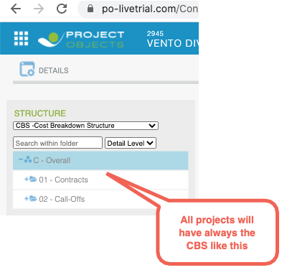

The new cost item must be created under the proper node based on a field choose while creating the new object procurement plan.

* **Operational steps**

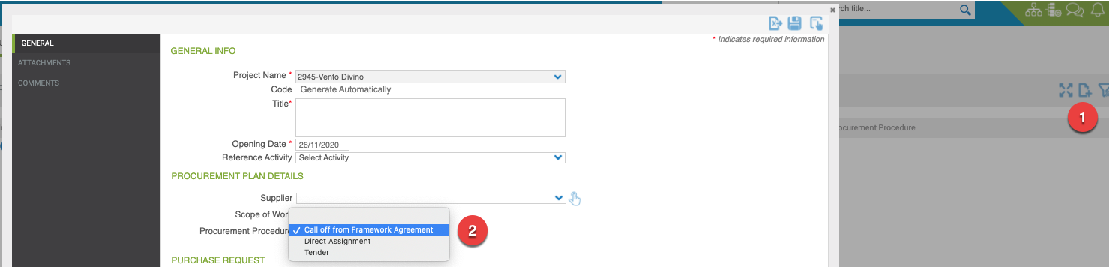

The user will select the procurement plan widget available in project workspace.

The user will select the CBS node where he wants to create the new element, then he will click the add button **(1)**.

* The new object form will open, after the enter of the mandatory fields, the procurement procedure value filed **(2) must be automatically set to:**
  + **“call off a from framework agreement”**,if the node selected was “**call-Offs**”
    - In this case Procurement Procedure field must be not be editable
  + If the node selected was **contracts** then the Procurement Procedure field will be available for selection, but the “**call off a from framework agreement”** value must not be visible (or in Grey and not selectable) in the dropdown values list

After saving the form, the new item must be visible in the CBS relevant node.

The new cost item must have as a code a progressive number and as a description the scope of work as entered in the form.

The SoW must be set to mandatory.

* **General implementation requisite**
  1. It's required to implement the new UC to add cost item to the structure based on selected node and made it available not only for the specific form in case we may need to use it in other forms.

# New procurement plan dates user control (Ref. Task 25)

* **Business Requirement**

To manage all the procurement phase dates, it is required to have a single section in the procurement plan form where all the dates can be displayed. The dates for each of the procurement phase must have three columns, **“target date, forecast date and actual date”**

* **Implementation logic**

The new user control must be implemented as per the picture below, the new user control dates filed must be automatic calculated or Manual entered, according to a predefined logic, based on a new configuration table.

**New UC**

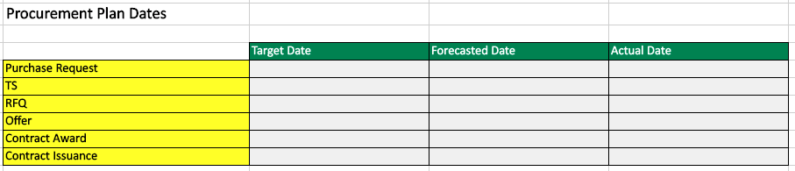

**Configuration Table**

|  |  |  |  |  |  |  |  |  |  |  |
| --- | --- | --- | --- | --- | --- | --- | --- | --- | --- | --- |
| **Lead Time:** | **Tender Spot** | **Tender Light** | **Tender Full** | **Tender Mega** | **Direct Assignment Spot** | **Direct Assignment Light** | **Direct Assignment Full** | **Direct Assignment Mega** | **Public Law Spot + Light** | **Public Law Full + Mega** |
| **Purchase Request** | 0 | 0 | 0 | 0 | 0 | 0 | 0 | 0 | 0 | 0 |
| **TS** | 0 | 0 | 0 | 0 | 0 | 0 | 0 | 0 | 0 | 0 |
| **RFQ** | 10 | 15 | 30 | 40 | 5 | 10 | 30 | 40 | 30 | 40 |
| **Offer** | 10 | 35 | 60 | 70 | 15 | 40 | 60 | 70 | 60 | 70 |
| **Contract Award** | 4 | 20 | 30 | 40 | 4 | 20 | 30 | 40 | 30 | 40 |
| **Contract Issuance** | 4 | 10 | 20 | 30 | 4 | 10 | 20 | 30 | 20 | 30 |

Criteria for which the value is selected in the Configuration Table (it is related to the value in the Field “**Estimated Amount”** which should be mandatory):

|  |  |  |
| --- | --- | --- |
| Tender Type |  | Estimated Amount |
| Lead Time Tender | Spot | < 0,2 M |
| Light | 0,2 M - 1,5 M |
| Full | 1,5 M - 25 M |
| Mega | > 25 M |
| Lead Time Direct Assignment | Spot | < 0,2 M |
| Light | 0,2 M - 1,5 M |
| Full | 1,5 M - 25 M |
| Mega | > 25 M |
| Lead Time Public Law | Spot + Light | < 1,5 |
| Full + Mega | > 1,5 M |
|  |  |  |

* **Operational steps**

The System Administrator will manage the configuration table by entering all the lead duration for the procurement phases. (PO10 Admin Area - Custom Table??)

The contract administrator will have few options to manage the new user control dates:

* The contract administrator enters the “Contract issuance” Target Date
  + The expected result will be the calculation of the previous procurement phases “target dates” based on the “Estimated Amount” criteria and the “Configuration table”
  + Then all those calculated dates will be copied in the “Forecast Date” column
* The contract administrator enters the forecast date **for any** of the procurement phases step
  + The expected result will be the calculation of the subsequent procurement phases “Forecast dates” based on the “Estimated Amount” criteria and the “Configuration table”
* The contract administrator enters the actual dates for any of the procurement phases step
  + The expected result will be that the “Forecast Date” (related to the Procurement Phase “Actual Date” inserted) should be blocked. (the Actual Date do not overwrite the Forecast Date but it blocks the Forecast Date cell so it cannot be edited anymore). and the calculation of the subsequent procurement phases “Forecast dates” based on the “Estimated Amount” criteria and the “Configuration table”

Logical Scheme

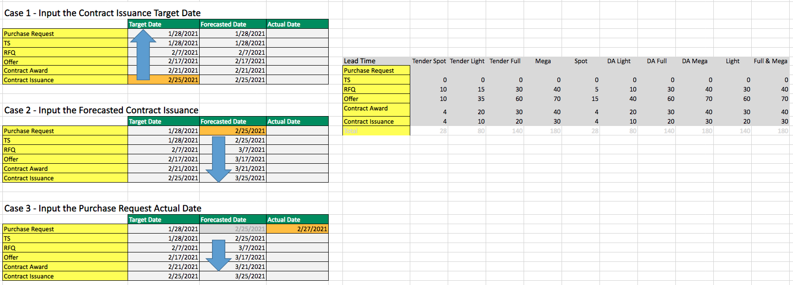

* **General implementation requisite**
  + UC labels should be configurable
  1. It is required that the information contained in the new UC available will not be made available only for the specific form in case we may need to use them it in other forms.
  2. Some of the dates will be gathered by other systems or Other PO Forms (this will be discussed Later)

# Contract form Milestones UC (Ref. Task 38/39)

* **Business Requirement**

To Manage Contract Milestones in a dedicated section in the Contract Form

* **Implementation logic**

The new user control must be implemented as per the Fields Required as shown in the Table Below:

The fields should be by default in the order indicated by the client

Field Required Table



the new user control has field Automatically calculated or Manual entered, according to a predefined logic.

In the table below you can find the Logic (Column Data logic) and the details for all the Fields.

Field details (Format, length and Mandatory Y/N) should be set as per requirement.

Field Logic Table

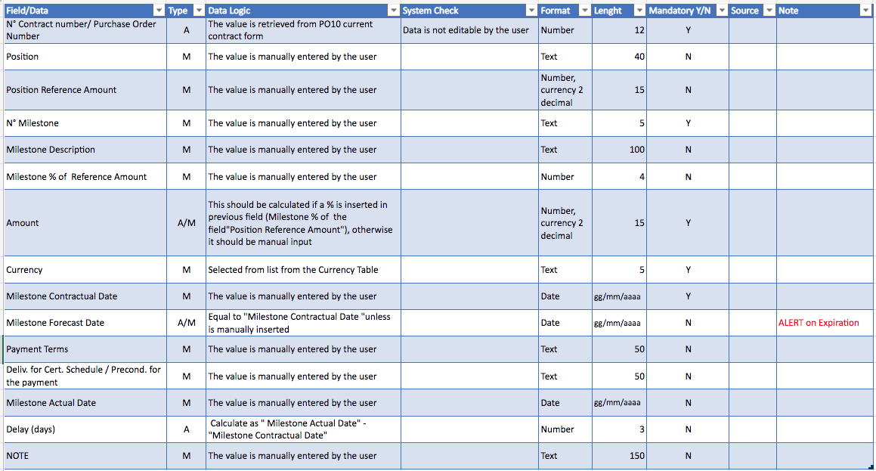

* **Operational steps**

The User will be able to Add Contract Penalties from the dedicated tab in the Contract Form.

To create a milestone line, the user should be able to:

1. For the specific project, access the project workspaces
   1. Select the contract
   2. Select the tab “Milestones”
   3. Click the add icon and enter all mandatory fields
   4. Save the new Milestone line
2. Once saved the Milestone will be available for editing/delete
3. The User will have the possibility to expand the view full screen and to export to Excel the milestones table/register.

* **General implementation requisite**

1. Calculation of the “Amount” based on the “Milestone % of Reference Amount” and the “Position Reference Amount”
2. Calculation of “Delay (days)” Calculate as " Milestone Actual Date" - "Milestone Contractual Date"
3. EXCEL Export functionality
4. Full Screen Functionality

# Contract form Penalties UC (Ref. Task 45/46)

* **Business Requirement**

To Manage Contract Penalties in a dedicated section in the Contract Form.

Penalties can be related to a Contract Milestones or can be related to Other Aspects (therefore managed not referenced to any Milestone)

* **Implementation logic**

The new user control must be implemented as per the Fields Required as shown in the Table Below:

The fields should be by default in the order indicated by the client

Field Required Table



the new user control has field Automatically taken from Milestones, or Automatically calculated or Manual entered, according to a predefined logic.

In the table below you can find the Logic (Column Data logic) and the details for all the Fields.

Field details (Format, length and Mandatory Y/N) should be set as per requirement.

Field Logic Table

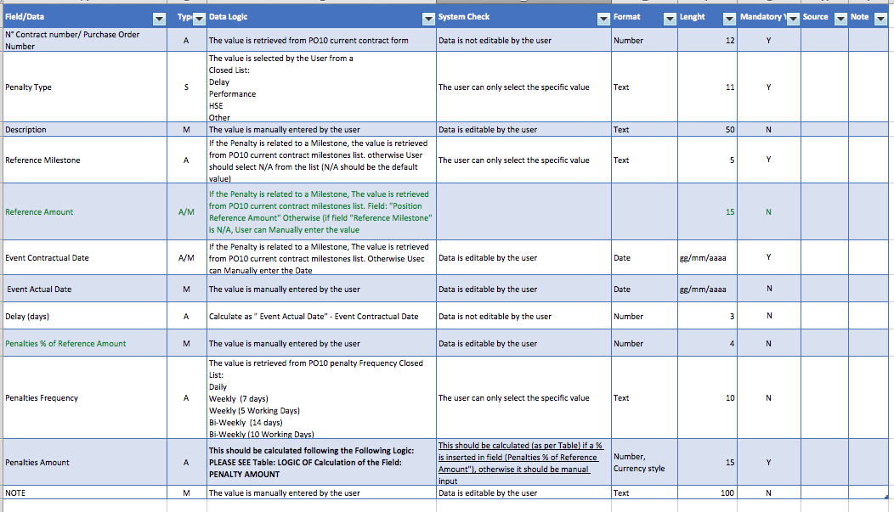

Additional Calculation Logic table for the Field “Penalties Amount” is necessary to explain how to calculate the value.

Logic of Calculation of the Field: **PENALTIES AMOUNT**

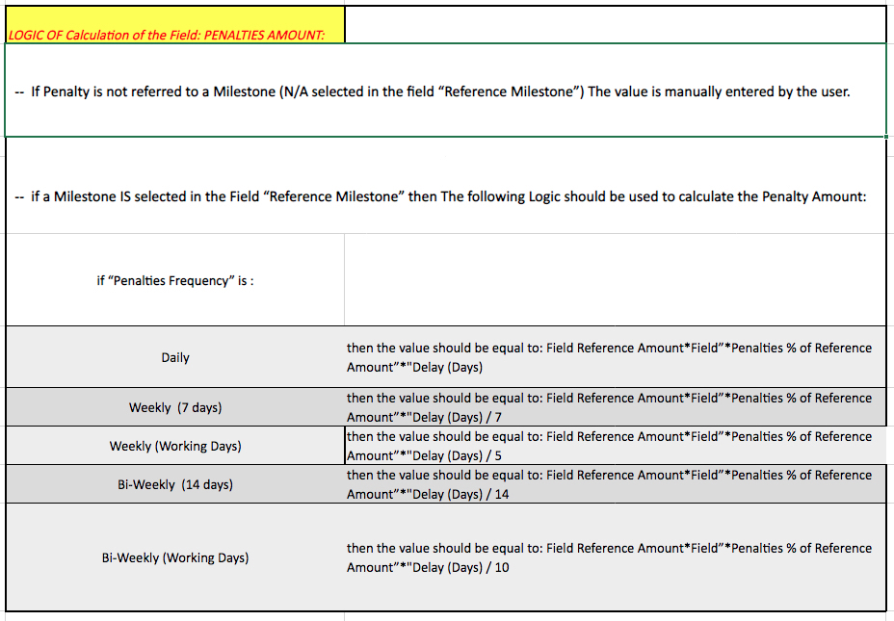

* **Operational steps**

The User will be able to Add Contract Penalties from the dedicated tab in the Contract Form.

To create a Penalty line, the user should be able to:

1. For the specific project, access the project workspaces
   1. Select the contract
   2. Select the tab “Penalties”
   3. Click the add icon and enter all mandatory fields
   4. Save the new Penalty line
2. Once saved the Penalty will be available for editing/delete
3. The User will have the possibility to expand the view full screen and to export to Excel the Penalties table/register.

* **General implementation requisite**

1. Ability to manage Penalty NOT related to a Contract Milestone
2. Dropdown “Reference Milestone”: If the Penalty is related to a Milestone, the value is retrieved from PO10 current contract milestones list. Field “Milestone No” otherwise, User should select N/A from the list (N/A should be the default value)
3. “Event Contractual Date” If the Penalty is related to a Milestone, the value is retrieved from PO10 current contract milestones list. otherwise, User should Manually enter the Date
4. in case the Penalty is referred to a Milestone, Calculation of the “Penalties Amount” based on the Reference Amount in milestones UC, Penalties Frequency and Penalties % of Contract Price
5. EXCEL Export functionality
6. Full Screen Functionality

# Contract form Obligations UC (Ref. Task 53/55)

* **Business Requirement**

To Manage Contract Obligations in a dedicated section in the Contract Form

* **Implementation logic**

The new user control must be implemented as per the Fields Required as shown in the Table Below:

The fields should be by default in the order indicated by the client

Field Required Table



the new user control has field Automatically calculated or Manual entered, according to a predefined logic.

In the table below you can find the Logic (Column Data logic) and the details for all the Fields.

Field details (Format, length and Mandatory Y/N) should be set as per requirement.

Field Logic Table

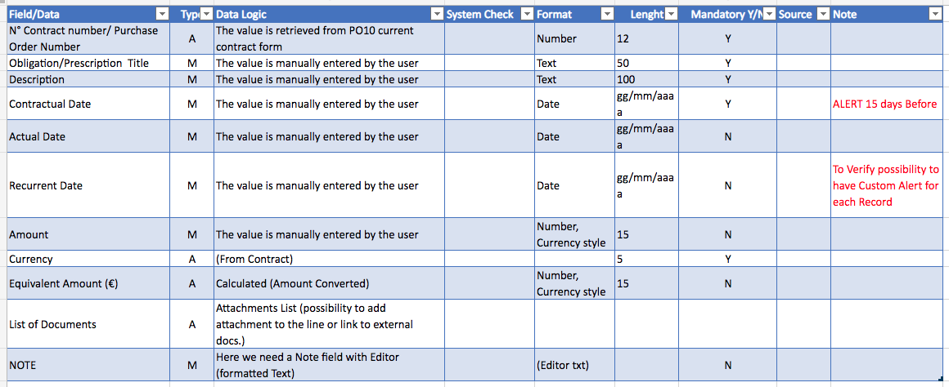

* **Operational steps**

The User will be able to Add Contract Obligations from the dedicated tab in the Contract Form.

To create an Obligation line, the user should be able to:

1. For the specific project, access the project workspaces
   1. Select the contract
   2. Select the tab “Obligations”
   3. Click the add icon and enter all mandatory fields
   4. Save the new Obligation line
2. Once saved the Obligation will be available for editing/delete
3. The User will have the possibility to expand the view full screen and to export to Excel the Obligations table/register.

* **General implementation requisite**

1. Attachments List (possibility to add attachment to the line or link to external docs.)
2. The Note field with Editor (formatted Text)
3. EXCEL Export functionality
4. Full Screen Functionality

# Contract form Clauses Library UC (Ref. Task 50/52)

* **Business Requirement**

To Manage Contract Clauses Library in a dedicated section in the Contract Form

* **Implementation logic**

The new user control must be implemented as per the Fields Required as shown in the Table Below:

The fields should be by default in the order indicated by the client

Field Required Table

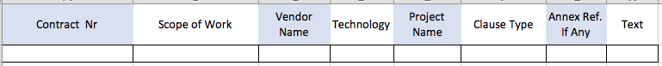

the new user control has field Automatically calculated or Manual entered, according to a predefined logic.

In the table below you can find the Logic (Column Data logic) and the details for all the Fields.

Field details (Format, length and Mandatory Y/N) should be set as per requirement.

Field Logic Table

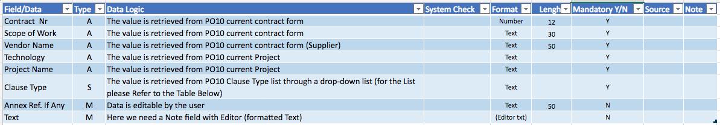

Clause Type List Table

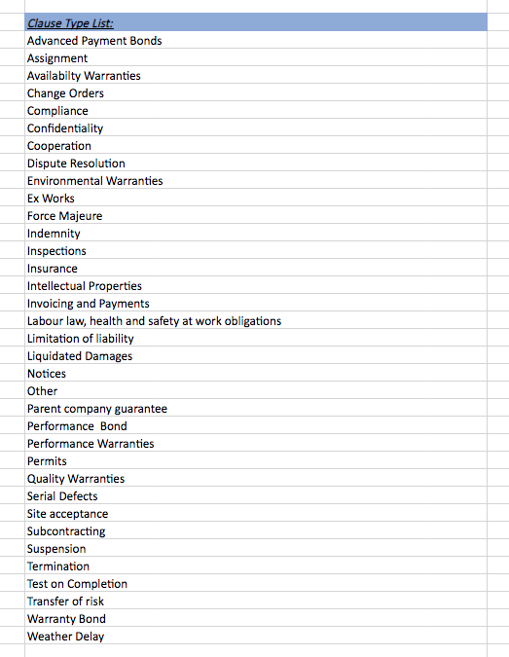

* **Operational steps**

The User will be able to Add Contract Clauses from the dedicated tab in the Contract Form Called Clauses Library.

To create a Clause line, the user should be able to:

1. For the specific project, access the project workspaces
   1. Select the contract
   2. Select the tab “Clauses Library”
   3. Click the add icon and enter all mandatory fields
   4. Save the new Clause line
2. Once saved the Clause will be available for editing/delete
3. The User will have the possibility to expand the view full screen and to export to Excel the Clauses Library table/register.

* **General implementation requisite**

1. The Note field with Editor (formatted Text)
2. EXCEL Export functionality
3. Full Screen Functionality

# Procurement Plan Form, Automatic Filling of Contract Details fields and Creation of New Contract Objects and automatic filling of new Contract Object fields

* **Business Requirement**

To Automatically Fill the contract information details in the Procurement Plan Form once inserted the Contract Number. To create new Contract from the Procurement Plan Form and to automatically fill the new Contract Object field in the Contract Form automatically created

* **Implementation logic**

The new functionality should allow the user to create new Contract Object from the Procurement Plan Form,

* **Operational steps**

As described in the maps below, the user should be able to insert the contract number in the procurement plan and if the contract exists in the new Table filled with external source data, then in the Procurement Plan Form, the Contract details are automatically filled, and when Saving or Applying the PP Form, a popup will open and ask the user if it is ok that a new Contract Object will be created. After confirmation form the user, a new Contract Object will be created.

In the new Object “Contract” automatically created some field will be automatically filled with data from Procurement Plan, and some other Fields will be filled with data from the new Table filled with external source data.

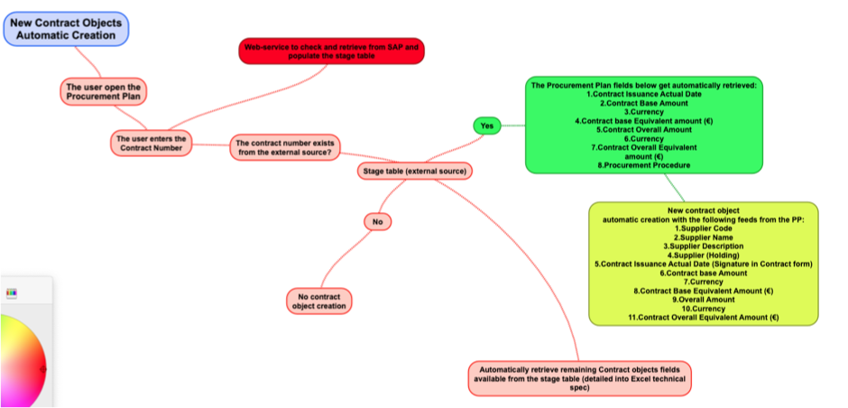

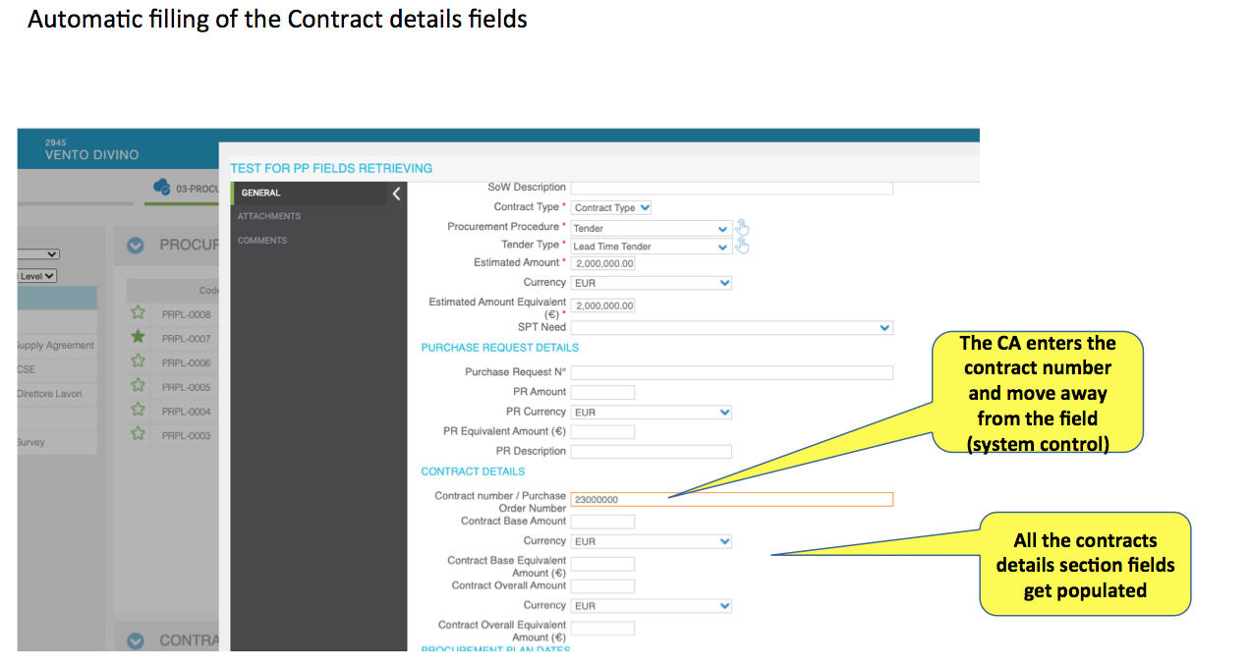

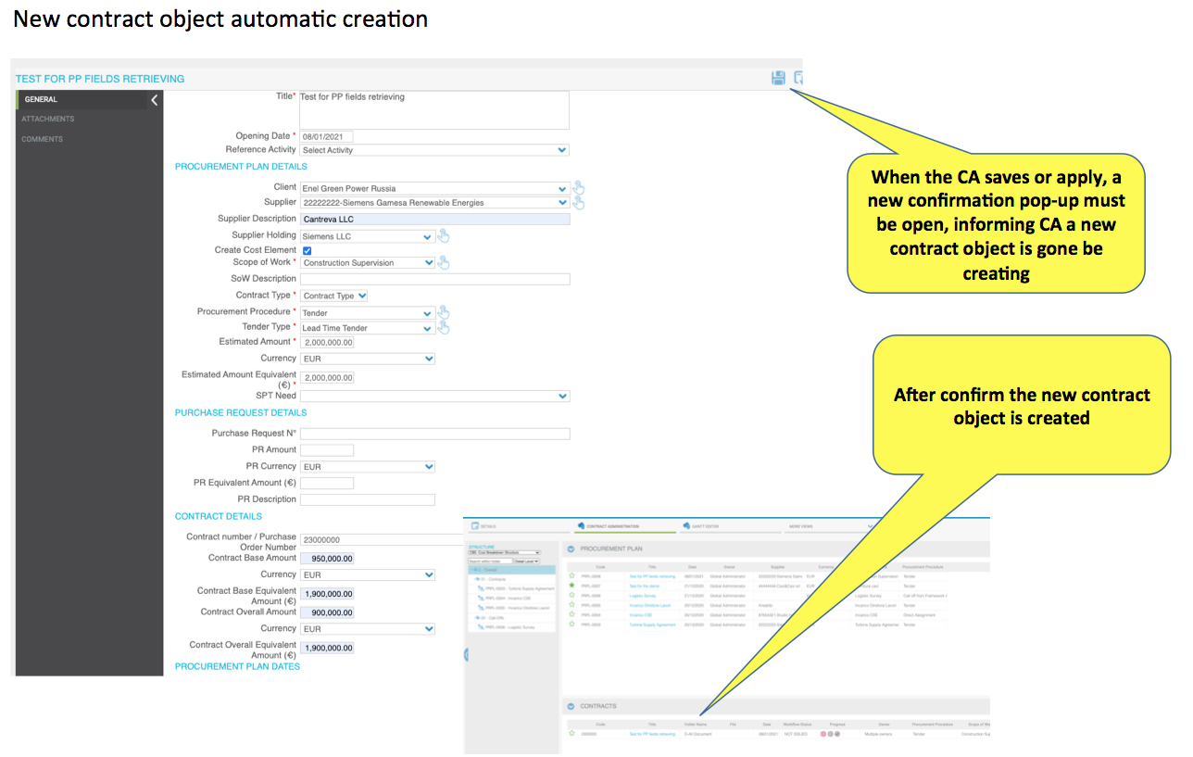

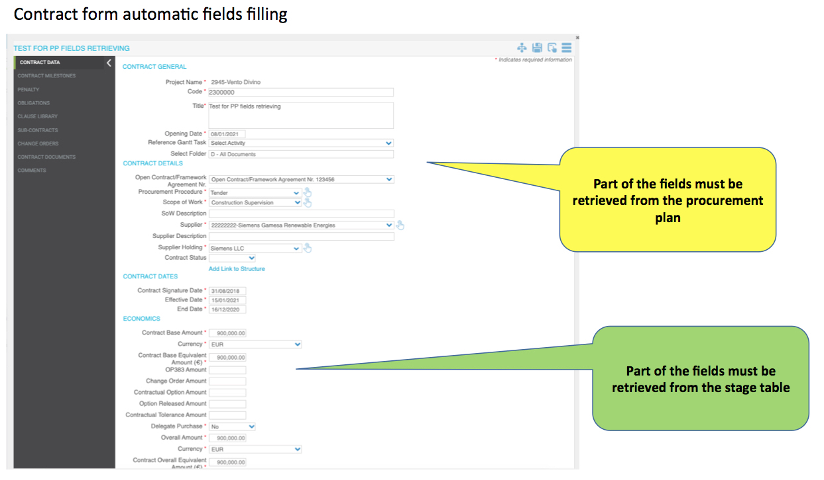

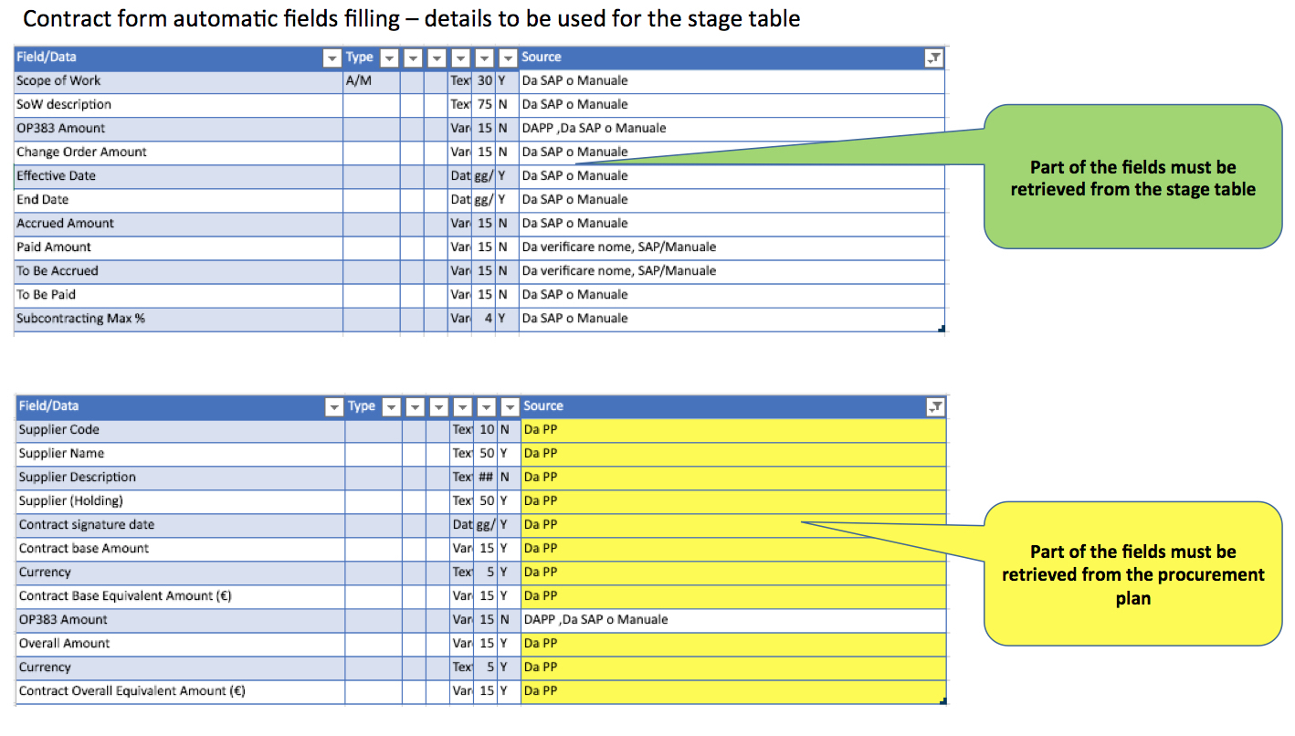

* **General implementation requisite**

When in the Procurement Plan Form a Contract Number is Inserted and if the contract exists in the new Table filled with external source data:

1. Automatic Filling of Contract details Field in Procurement Plan Form
2. Automatic Creation of the Contract from the Procurement Plan.

In the new Object “Contract” automatically created:

1. Automatic Filling with data from Procurement Plan,
2. Automatic Filling of other Fields with data from the new Table filled with external source data.

# Alert

As a general approach, the user should be able to access a table in configuration area where to set the new alerts and the e-mail notification. The new table must contain the following fields:

|  |  |  |
| --- | --- | --- |
| Clumn Name | Type |  |
| Form Object | Drop down list | Framework, Milestones, Obligations (should be retrieved from a user configuration table |
| Field | Drop down list | The list of numeric and date fields for the selected objects |
| Condition | Drop down list | The condition to be used within the query |
| E-mail notification | Drop down list | The email notification to execute if condition is verified |
| Recipient form field | Drop down list | The field where the name of the person is identified, if defined mail will go only to this person; IF blank then email will go to recipients defined into the notification |
| Icon | File selector | The icon to show in the register |

See the example below:

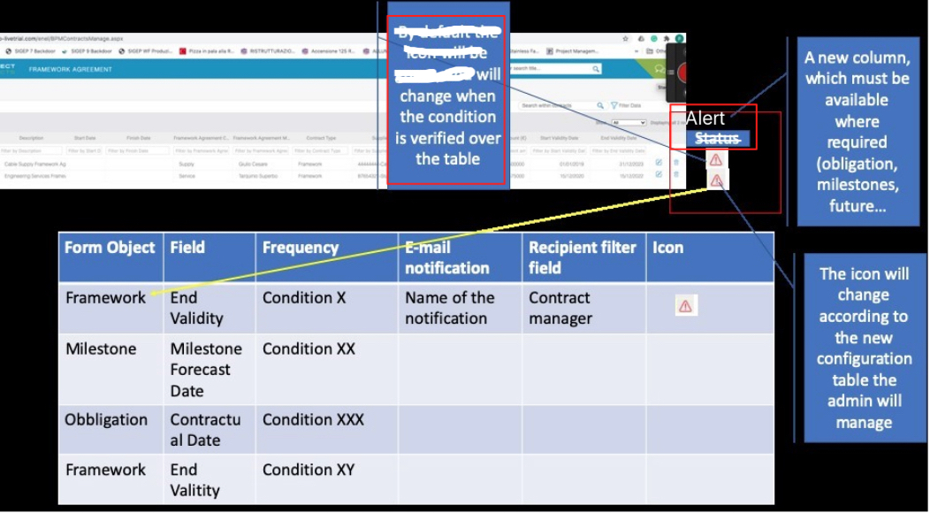

* **Business Requirement**

Implementation of Alerts with the purpose of monitoring expirations, validity and other dates for Framework Agreement, Milestones and Obligations.

* **Implementation logic**

Alerts needs to be shown in objects registers and email (only for framework agreement 6 months before end of validity date) as per requirement.

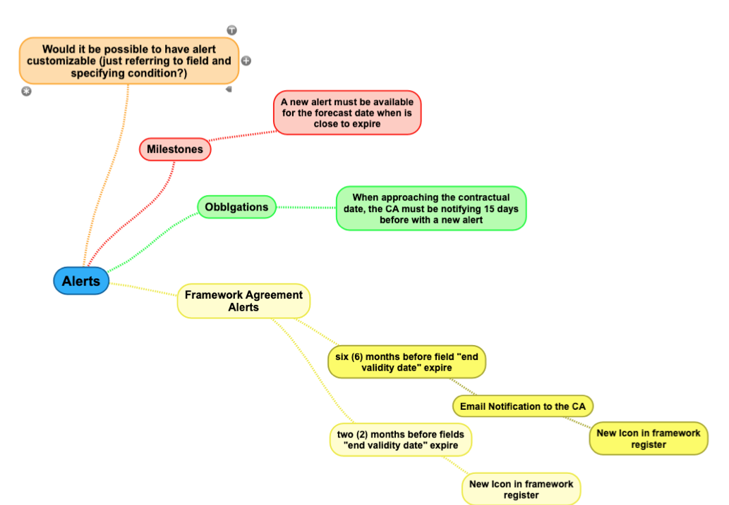

1. **Framework Agreements**

* E-mail notification:

Email Notification to the User selected in the object Frame Agreement in the field: “Framework Agreement Manager” and to a certain Users/Group to be defined in the email notif. Configuration section, and the notification/text etc should be Configurable and should be sent when the “End Validity Date” Field is = or < of 6 months (compared to the Today Date)

* Alerts NO E-mail (Icon only in the register):

Register Alert Icon should be available in the Framework Agreement Register (and in widgets related to Frame Agreement).

The logic is that the New Alert Icon should be:

* + 1. Yellow when the “End Validity Date” Field is = or < of 6 months (compared to the Today Date)
    2. Red when the “End Validity Date” Field is = or < of 2 months (compared to the Today Date)

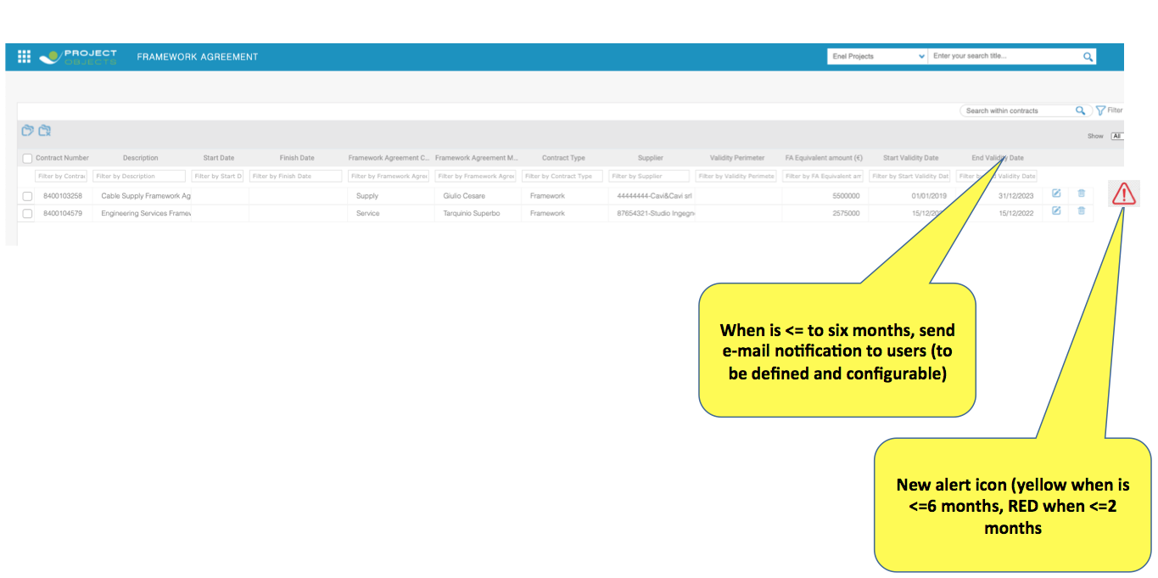

1. **Obligations**

* Alerts NO E-mail (Icon only in the user control register embedded in the contract form):

Register Alert Icon should be available in the Obligation Register (Part of the Contract Form) (and in widgets related to Obligations).

The logic is that the New Alert Icon should be:

* + - * Red when the “Contractual Date” Field is = or < of 15 days (compared to the Today Date)

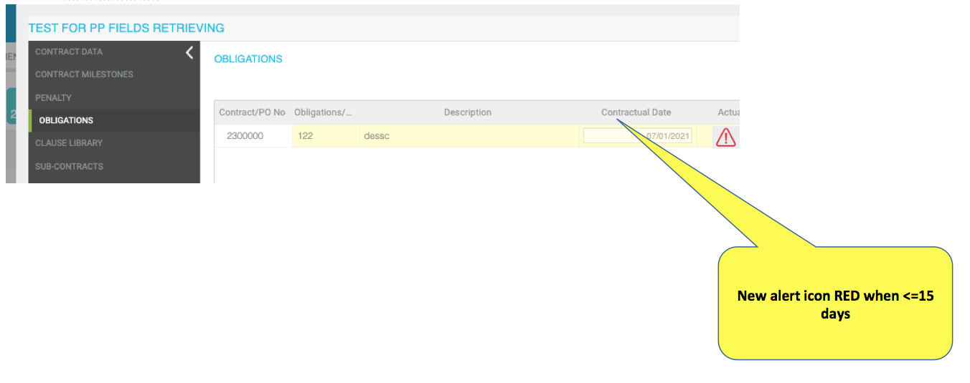

1. **Milestones**

* Alerts NO E-mail (Icon only in the user control register embedded in the contract form):

Register Alert Icon should be available in the Obligation Register (Part of the Contract Form) (and in widgets related to Milestones).

The logic is that the New Alert Icon should be:

* + - * Red when the “Milestone Forecast Date” Field is = or < of 15 days (compared to the Today Date)

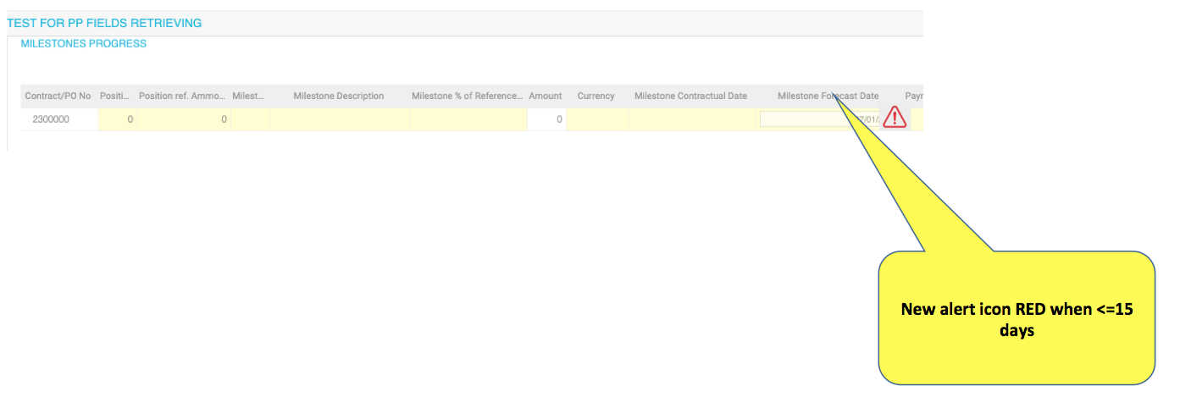

* **General implementation requisite**

1. Email Alert for Framework Agreement related to the Field “End Validity Date”, System Administrator/Power Users should be able to configure Email notification for Framework Agreement (recipient of the notification, Text and Criteria)
2. Register (and Widget if available) Alert Icon for Framework Agreement related to the Field “End Validity Date”
3. Register (and Widget if available) Alert Icon for Obligations related to the Field “Contractual Date”
4. Register (and Widget if available) Alert Icon for Milestones alert related to the Field “Milestones Forecast Date”

# Contract form Clauses Library “Type LIST”

* **Business Requirement**

The Clauses “Type List” Table must be editable and not be hardcoded.

* **Implementation logic**

The Clauses “Type List” Table must be in editable by the system admin, in the same place where all the other Tables we are using are.

In “Business Objects Configuration” --> “Data Tables”

* **Operational steps**

The System Admin have the possibility to go in “Business Objects Configuration” --> “Data Tables” and add/remove/edit the values of the Table in the same way we do for other tables there.

* **General implementation requisite**

The Clauses “Type List” Table must be editable and not be hardcoded.

# Procurement Plan Purchase Request (PR) Field Update

* **Business Requirement**

To have the possibility to choose if **Automatically** Fill the PR Fields details in the Procurement Plan Form once inserted the PR Number and **on demand** with a new button, or **Manually** fill the fields.

* **Implementation logic**

The User will be able inserting the PR Number in the “Purchase Request N°” Field, to automatically fill the fields with data from Stage Table and have the possibility to update the fields pressing a **new button** (in case the data in the stage table have been updated and user need to retrieve latest data), and if no data present in the stage table user should be able to manually fill the fields.

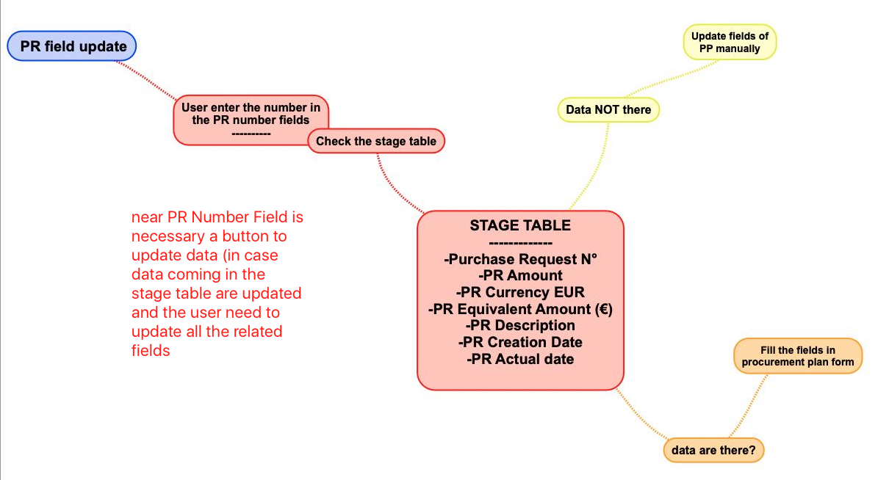

* **Operational steps**

1. The User enter the “Purchase Request N°”, if the number of PR is present in the Stage Table, then the system should automatically fill the information related to the fields indicated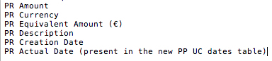
2. If the PR Number is not present in the Stage Table, the User must be able to fill the fields manually
3. Periodically, in case the data in the Stage Table have been updated and user need to retrieve latest data, a new button is required to update on demand the fields with data from Stage Table.

Procurement Plan PR Fields Details Mock-up

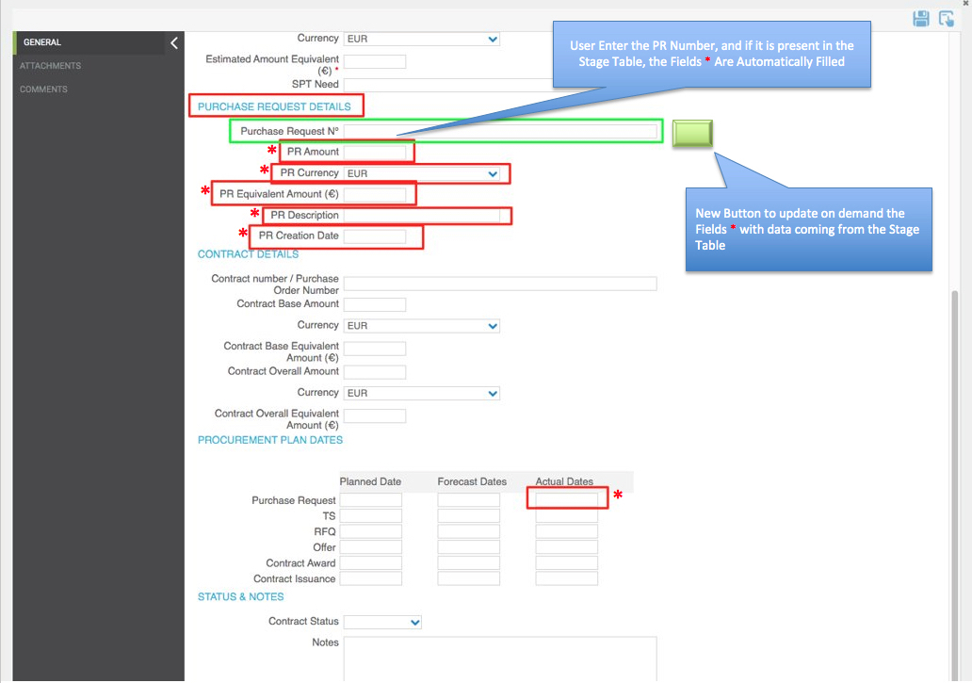

* **General implementation requisite**
  1. Adding to the Stage Table the following fields.

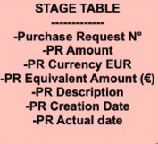

* 1. Possibility to **Automatically** fill the PR Fields (indicated with * in the above “Procurement Plan PR Fields Details Mock-up") with data from Stage Table by inserting the Purchase Request N°
  2. Possibility to **Manually** fill the PR Fields indicated in case data do not present in the Stage Table
  3. Possibility to Update “**On demand**” the PR Fields indicated with data from Stage Table, using of a new Button to be implemented next to the “Purchase Request N°” field

# Procurement Plan Creation from Widget

* **Business Requirement**

Users should be able to create Procurement Plan also from the ADD Button in the Procurement Plan Widget and the function should work with the same logic as per creation of Procurement Plan from the right click menu on the structure

* **Implementation logic**

When the User click on the Add Icon on the top right of the Procurement Plan Widget the system should use the same logic as when creation the object from the right click menu from the structure.

Those logics are the same as Point 1 of this Secs File.

# Procurement Plan Scope of Work Creation

• **Business Requirement**

To have the possibility to create a Scope of Work Text using a function to put text together.

• **Implementation logic / Operational Steps**

The Field “Scope of Work” should be blocked and not editable.

Clicking on the icon close to the Field “Scope of Work” a popup will appear, and based on the **Technology selected** for the **project**, the user will be able to see the list of text that can be used for that technology.

The Lists should be managed in table (same as other tables) and can be modified, adding/removing records, from the users.

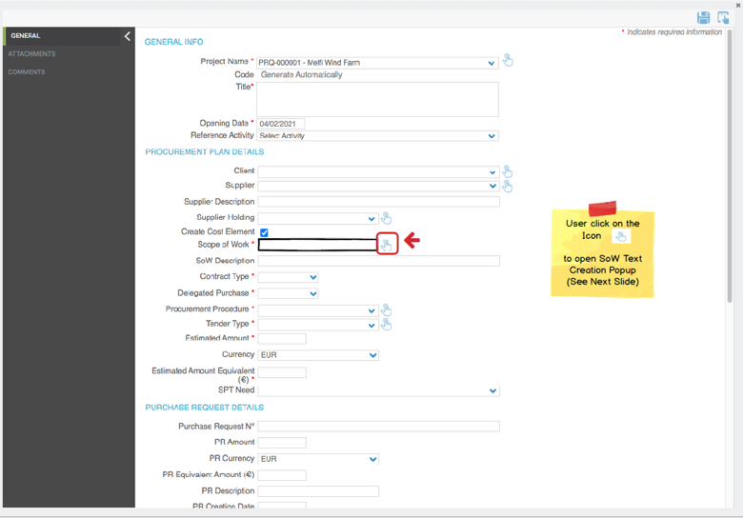

The Popup should contain 4 columns as per picture below (Technology, Plant Area, SoW, Bind).

The popup should contain real time Column filtering (as Team Space registers).

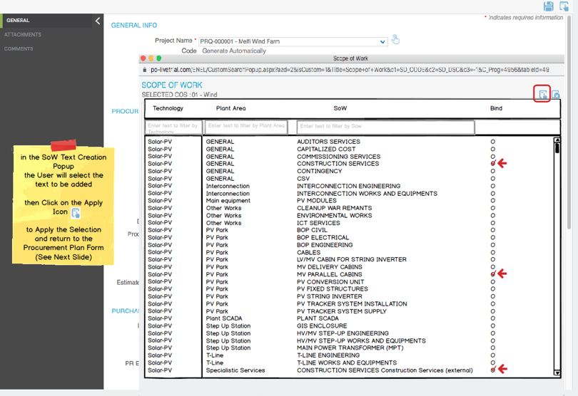

Once the User select all the text want to add in the “Scope of Work” field, then the system should create the text made of all the text (from column “SoW”) adding 1 “space”, 1 “+” and 1 “space” between text. As shown in the example below. And it should be in the order as per table (from top to bottom)

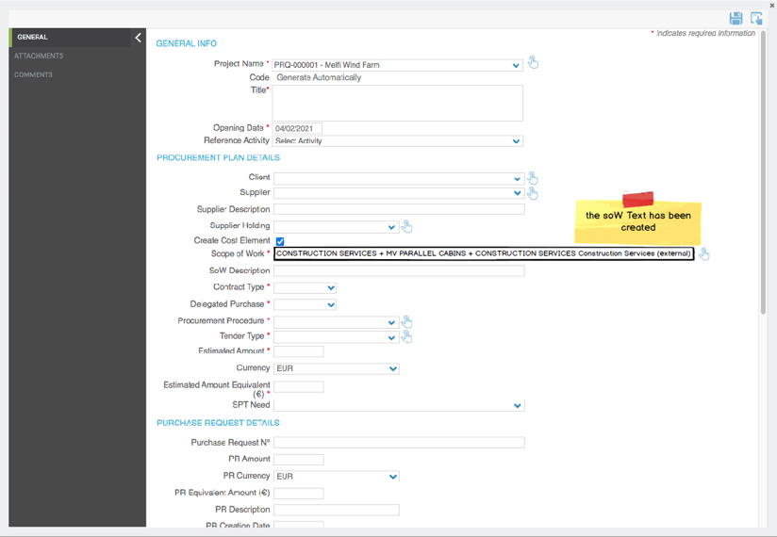

Once the SOW is created/saved, if the User click again on the Icon, the SoW Text Creation Popup will appear **showing the previous selection**, and giving also the possibility to the user to change selections in order to modify the SOW. See picture below.

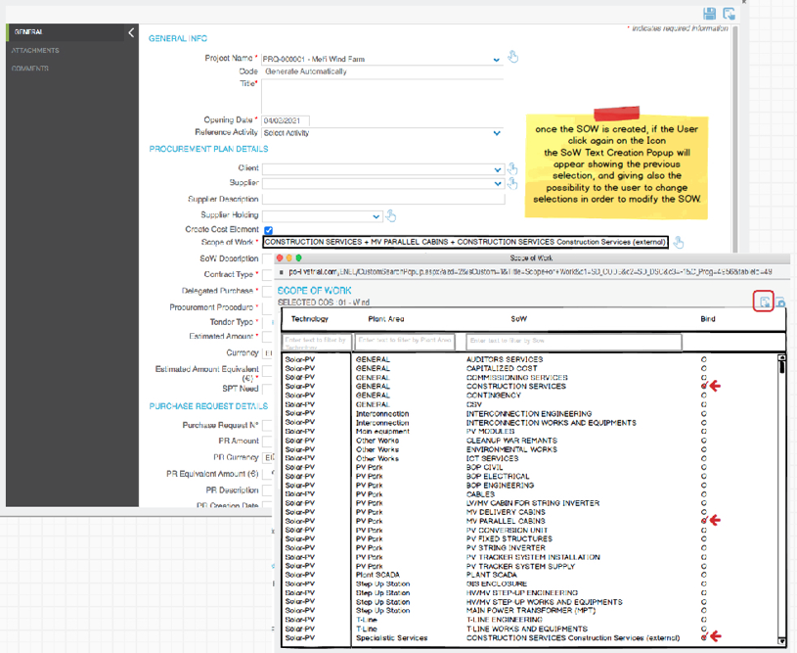

The Technology list is the one associated to the Project.

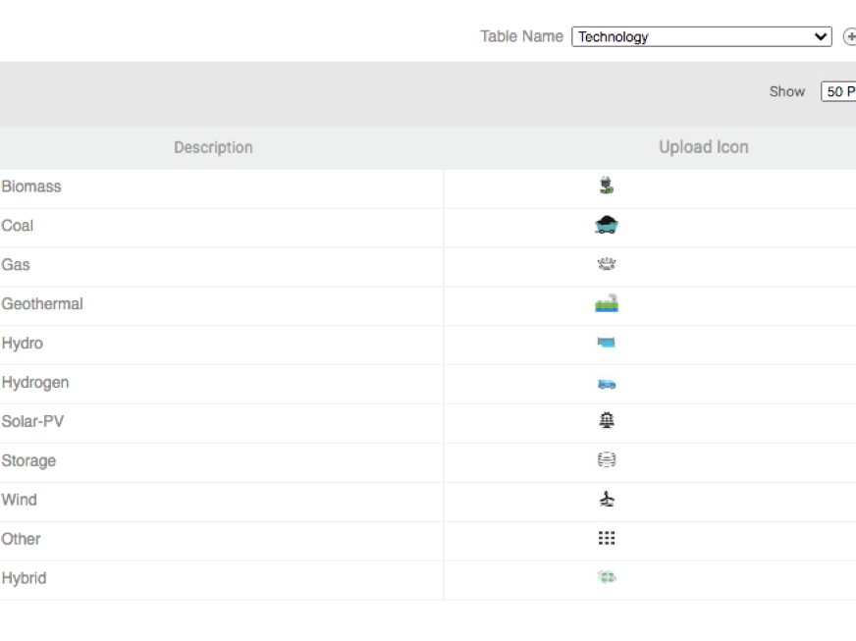

Every Technology will have his own Data that should appear available for selection in the popup, with 3 exceptions:

if in the project as Technology is selected one of those 3 option: “**Other**”, or “**Hybrid**”, or “**Hydrogen**”, then in the Popup should be visible all the lists available for all other technologies.

At the moment we have available from Enel the list of the info for 2 technologies (“**Solar-PV**” and “**Wind**”).

Those are the data for those 2 technologies, Enel will provide the remaining in the next days, but anyway a System Admin should be able to add text for other technology.

|  |  |  |
| --- | --- | --- |
| **Technology** | **Plant Area** | **SoW** |
| Solar - PV | GENERAL | AUDITORS SERVICES |
| Solar - PV | GENERAL | CAPITALIZED COST |
| Solar - PV | GENERAL | COMMISSIONING SERVICES |
| Solar - PV | GENERAL | CONSTRUCTION SERVICES |
| Solar - PV | GENERAL | CONTINGENCY |
| Solar - PV | GENERAL | CSV |
| Solar - PV | GENERAL | DECOMMISSIONING |
| Solar - PV | GENERAL | DEVELOPMENT COSTS |
| Solar - PV | GENERAL | DEVELOPMENT FEE |
| Solar - PV | GENERAL | EAR INSURANCE |
| Solar - PV | GENERAL | ENGINEERING SERVICES |
| Solar - PV | GENERAL | EXPEDITING SERVICES |
| Solar - PV | GENERAL | FINANCIAL COSTS |
| Solar - PV | GENERAL | GENERAL SERVICES |
| Solar - PV | GENERAL | HSE SERVICES |
| Solar - PV | GENERAL | LANDS |
| Solar - PV | GENERAL | LOGISTIC SERVICES |
| Solar - PV | GENERAL | MANAGEMENT FEE |
| Solar - PV | GENERAL | OTHER SERVICES |
| Solar - PV | Interconnection | INTERCONNECTION ENGINEERING |
| Solar - PV | Interconnection | INTERCONNECTION WORKS AND EQUIPMENTS |
| Solar - PV | Main equipment | PV MODULES |
| Solar - PV | O&M Building | O&M Building |
| Solar - PV | Other Works | CLEANUP WAR REMANTS |
| Solar - PV | Other Works | ENVIRONMENTAL WORKS |
| Solar - PV | Other Works | ICT SERVICES |
| Solar - PV | Plant SCADA | PLANT SCADA |
| Solar - PV | PV Park | BOP CIVIL |
| Solar - PV | PV Park | BOP ELECTRICAL |
| Solar - PV | PV Park | BOP ENGINEERING |
| Solar - PV | PV Park | CABLES |
| Solar - PV | PV Park | LV/MV CABIN FOR STRING INVERTER |
| Solar - PV | PV Park | MV DELIVERY CABINS |
| Solar - PV | PV Park | MV PARALLEL CABINS |
| Solar - PV | PV Park | PV CONVERSION UNIT |
| Solar - PV | PV Park | PV FIXED STRUCTURES |
| Solar - PV | PV Park | PV STRING INVERTER |
| Solar - PV | PV Park | PV TRACKER SYSTEM INSTALLATION |
| Solar - PV | PV Park | PV TRACKER SYSTEM SUPPLY |
| Solar - PV | Specialistic Services | AUDITORS SERVICES Second Party Audits Services (external) |
| Solar - PV | Specialistic Services | COMMISSIONING SERVICES Commissioning Services (external) |
| Solar - PV | Specialistic Services | CONSTRUCTION SERVICES Construction Services (external) |
| Solar - PV | Specialistic Services | ENGINEERING SERVICES GEOTECHNICAL INVESTIGATIONS/SURVEYS |
| Solar - PV | Specialistic Services | ENGINEERING SERVICES OTHER ENGINEERING SERVICES (Specialistic studies, etc..) |
| Solar - PV | Specialistic Services | EXPIDITING SERVICES Expediting services (external) |
| Solar - PV | Specialistic Services | GENERAL SERVICES Other |
| Solar - PV | Specialistic Services | GENERAL SERVICES Other External Services |
| Solar - PV | Specialistic Services | HSE SERVICES ENVIRONMENTAL MONITORING SERVICE |
| Solar - PV | Specialistic Services | HSE SERVICES Other |
| Solar - PV | Specialistic Services | LOGISTIC SERVICES Logistic services (external) |
| Solar - PV | Step Up Station | GIS ENCLOSURE |
| Solar - PV | Step Up Station | HV/MV STEP-UP ENGINEERING |
| Solar - PV | Step Up Station | HV/MV STEP-UP WORKS AND EQUIPMENTS |
| Solar - PV | Step Up Station | MAIN POWER TRANSFORMER (MPT) |
| Solar - PV | T-Line | T-LINE ENGINEERING |
| Solar - PV | T-Line | T-LINE WORKS AND EQUIPMENTS |

|  |  |  |
| --- | --- | --- |
| **Technology** | **Plant Area** | **SoW** |
| Wind | GENERAL | AUDITORS SERVICES |
| Wind | GENERAL | CAPITALIZED COST |
| Wind | GENERAL | COMMISSIONING SERVICES |
| Wind | GENERAL | CONSTRUCTION SERVICES |
| Wind | GENERAL | CONTINGENCY |
| Wind | GENERAL | DECOMMISSIONING |
| Wind | GENERAL | DEVELOPMENT COSTS |
| Wind | GENERAL | DEVELOPMENT FEE |
| Wind | GENERAL | EAR INSURANCE |
| Wind | GENERAL | ENGINEERING SERVICES |
| Wind | GENERAL | EXPEDITING SERVICES |
| Wind | GENERAL | FINANCIAL COSTS |
| Wind | GENERAL | GENERAL SERVICES |
| Wind | GENERAL | HSE SERVICES |
| Wind | GENERAL | LANDS |
| Wind | GENERAL | LOGISTIC SERVICES |
| Wind | GENERAL | MANAGEMENT FEE |
| Wind | GENERAL | OTHER SERVICES |
| Wind | Interconnection | INTERCONNECTION ENGINEERING |
| Wind | Interconnection | INTERCONNECTION WORKS AND EQUIPMENTS |
| Wind | Main equipment | WTG ERECTION |
| Wind | Main equipment | WTG SUPPLY |
| Wind | O&M Building | O&M Building |
| Wind | Other Works | CLEANUP WAR REMANTS |
| Wind | Other Works | ENVIRONMENTAL WORKS |
| Wind | Other Works | ICT SERVICES |
| Wind | Plant SCADA | PLANT SCADA |
| Wind | Specialistic Services | AUDITORS SERVICES Second Party Audits Services (external) |
| Wind | Specialistic Services | COMMISSIONING SERVICES Commissioning Services (external) |
| Wind | Specialistic Services | CONSTRUCTION SERVICES Construction Services (external) |
| Wind | Specialistic Services | ENGINEERING SERVICES GEOTECHNICAL INVESTIGATIONS/SURVEYS |
| Wind | Specialistic Services | ENGINEERING SERVICES OTHER ENGINEERING SERVICES (Specialistic studies, etc..) |
| Wind | Specialistic Services | EXPIDITING SERVICES Expediting services (external) |
| Wind | Specialistic Services | GENERAL SERVICES Other |
| Wind | Specialistic Services | GENERAL SERVICES Other External Services |
| Wind | Specialistic Services | HSE SERVICES ENVIRONMENTAL MONITORING SERVICE |
| Wind | Specialistic Services | HSE SERVICES Other |
| Wind | Specialistic Services | LOGISTIC SERVICES Logistic services (external) |
| Wind | Step Up Station | GIS ENCLOSURE |
| Wind | Step Up Station | HV/MV STEP-UP ENGINEERING |
| Wind | Step Up Station | HV/MV STEP-UP WORKS AND EQUIPMENTS |
| Wind | Step Up Station | MAIN POWER TRANSFORMER (MPT) |
| Wind | T-Line | T-LINE ENGINEERING |
| Wind | T-Line | T-LINE WORKS AND EQUIPMENTS |
| Wind | WIND Park | BOP CIVIL |
| Wind | WIND Park | BOP ELECTRICAL |
| Wind | WIND Park | BOP ENGINEERING |
| Wind | WIND Park | CABLES |
| Wind | WIND Park | MET MAST |
| Wind | WIND Park | WTG PADMOUNT TRANSFORMER |

• **General implementation requisite**

* 1. Based on the Technology selected for the project, the user will be able to see the list of text that can be used for that technology.
  2. Every Technology will have his own Data that should appear available for selection in the popup, with 3 exceptions: if in the project as Technology is selected one of those 3 option: “**Other**”, or “**Hybrid**”, or “**Hydrogen**”, then in the Popup should be visible all the lists available for all other technology.
  3. The Lists should be managed in table (same as other tables) and can be modified, adding/removing records, from the users.
  4. The popup should contain column filter (as per team space registers)
  5. Once the SOW is created/saved, if the User click again on the Icon, the SoW Text Creation Popup will appear **showing the previous selection**, and giving also the possibility to the user to change selections in order to modify the SOW.
* Key Features of this development done by PO India:

1. BPM Data Table for “**Plant Area**”: We will create new table under the *Business Object Configuration* to make it customizable for the end user.
2. We will Create new page under standard codes for “**Scope of work**”. This form will contain three columns:
   1. **Technology**: Dropdown filled with technology created under business object configuration Technology data table.
   2. **Plant Area:** Dropdown with reference of point #1.
   3. **SoW:** Open textfor manual entry
3. **SoW User control:** We willcreate user control to implement the overall business as explained in the specification document and key points are as given below:
   1. Textbox with new icon
   2. On click of icon new popup will be opened to select SoW
   3. Use order by **Technology**, **Plant area** and **SoW** ascending order with filter criteria
   4. Filter as explained in the document
   5. All the selected items should displayed in the textbox
   6. We have set Max. Length **200** for showing selected **SoW** in the text box. We have keep design aligned with other controls over the form. We have showed selected SoW on Tooltip of textbox. Tooltip will show all the selected SoW.
4. **Changes in Cost Element creation:** Now with new approach length of cost element description will be 80 characters and we need to truncate text exceeding length of 80 characters in Cost element description. If user change/update the selection in Scope of Work in procurement plan form, then cost element description will also change/update.
5. Once the SOW is created/saved, if the User click again on the Icon, the SoW Text Creation Popup will appear **showing the previous selection**, and giving also the possibility to the user to change selections in order to modify the SOW.
6. As of now we have removed the filtering logic for technologies Hybrid, Hydrogen and Others. If user selects any of these technology in project details then only SoW related to these technologies will be visible respectively in the pop-up.

# UC Sow from Procurement Plan in Contract Form

* **Business Requirement**

The SoW UC Developed for the Procurement Plan (Spec N.12) must be available ALSO in the Contract Form.

* **Implementation logic**

At the moment in Contract form there is a field Scope of work, but it is just a dropdown menu and can be deleted. This must be replaced with SoW UC developed for Procurement Plan and it should work exactly the same as Procurement Plan form (Spec12) with the add that this field can be imported during contract creation from Procurement Plan.

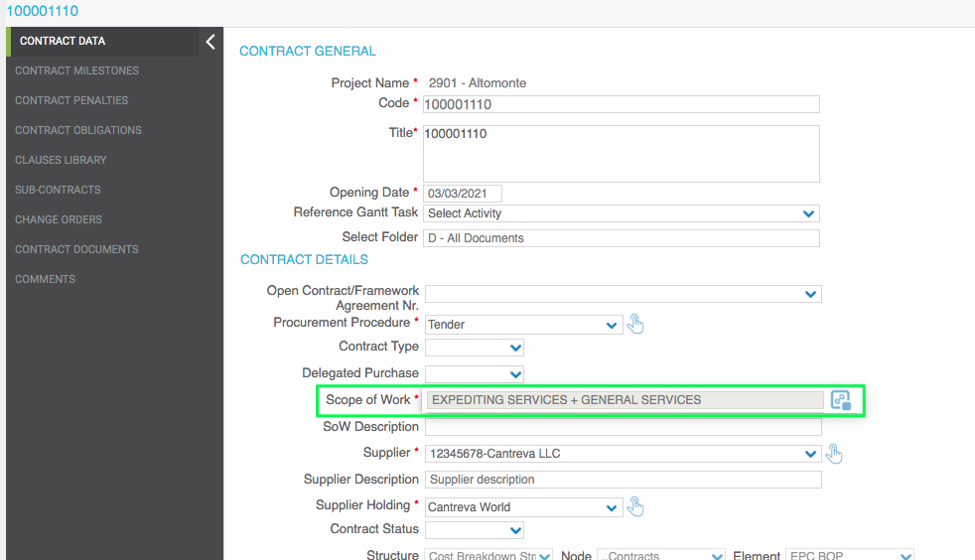

Key Features of this development done by PO India:

**Point #13**: We are considering the same UC which is created for Point #12 SoW development with common points of consideration.

1. BPM Data Table for “**Plant Area**”: Create new table under the *Business Object Configuration* to make it customizable for the end user
2. Create new page under standard codes for “**Scope of work**”. This form will contain three columns:
   1. **Technology**: Dropdown filled with technology created under business object configuration reference provided in the specification
   2. **Plant Area:** Dropdown with reference of point #1 (aforementioned)
   3. **SoW:** Open textfor manual entry
3. **SoW User control:** Create user control to implement the overall business as explained in the specification document and key points are as given below:
   1. Textbox with new icon
   2. On click of icon new popup will be opened to select SoW
   3. Use order by **Technology**, **Plant area** and **SoW** ascending order with filter criteria
   4. Filter as explained in the document
   5. All the selected items should displayed in the textbox
4. Prepare script to modify the existing form to pace new UC of SoW in place of dropdown on Contract Form
5. Copy SoW from PP to Contract when it is created from PP. This changes works only when contract created from PP. It will not change the SoW in PP if we retrieve data from the contract.

# Contract form Guarantees UC

* **Business Requirement**

To Manage Contract Guarantees in a dedicated section in the Contract Form

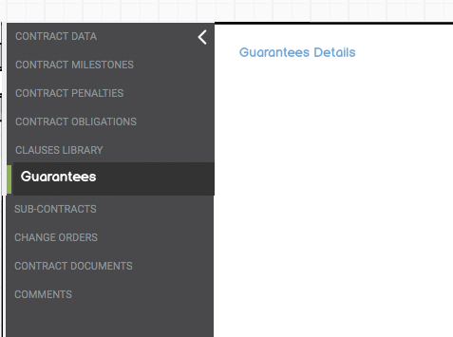

* **Implementation logic**

The new user control must be implemented as per the Fields Required as shown in the Table Below:

The fields should be by default in the order indicated by the client

**Field Required:**

***Contract Nr.***

***SoW***

***Vendor Name***

***Project Name***

***Enel Legal Entity***

***Country***

***Guarantee Code***

***GuaPo ID***

***Guarantee Type***

***Obligation Type (CM)***

***Guarantee Status***

***Guarantor Name***

***Guarantor Type***

***Guarantor Evaluation***

***Guarantee Amount***

***Currency***

***Guarantee Equivalent Amount (€)***

***AFC Responsible Department***

***Contract Manager***

***Guarantee Return Foreseen***

***Guarantee Validity Expected Start Date***

***Guarantee Validity Expected End Date***

***Max Expiring Date***

***Modification Date***

***Return Date***

***Activation Date***

***Closing Date***

***Joint/Social Responsibility***

***Joint/Social Responsibility (Months)***

***Note for GuaPo Update***

***Imported from GuaPo***

The new user control has fields that can be: Automatically calculated, retrieved from external source Called GuaPo (PO stage table) or Manual entered (some from Dropdown that need to be created in PO with his related data table editable from sys admin), according to a predefined logic.

The Record can be created during Import or Manually Created from the User and filling all the field manually as per Field Logic Table below.

In the table below you can find the Logic and the details for all the Fields.

**Field Logic Table**

|  |  |  |  |  |
| --- | --- | --- | --- | --- |
| **Field/Data** | **Type** | **Data Logic** | **Format** | **DropDown List Content** |
| Contract Nr. | Not Editable | Retrieved from Contract (present in GuaPo) |  |  |
| SoW | Not Editable | Scope of Work retrieved from Contract which is retrieved from Procurement Plan |  |  |
| Vendor Name | Not Editable | Supplier retrieved from Contract - Not Editable |  |  |
| Project Name | Not Editable | Project Name retrieved from Contract - Not Editable |  |  |
| Enel Legal Entity | See Data Logic --> | -if the Record (the line) is Retrieved from GuaPo this Field is NOT Editable   -if the Record (the line) is Manually added, The value is manually entered by the user | Text |  |
| Country | See Data Logic --> | -if the Record (the line) is Retrieved from GuaPo this Field is NOT Editable   -if the Record (the line) is Manually added, The value is manually entered by the user | Text |  |
| Guarantee Code | See Data Logic --> | This is the PO Guarantee ID, and must be an **automatically** created Code as follow: ContractNumber-G-progressive number EXAMPLE:  **3010003884-G-001** | Text |  |
| GuaPo ID | See Data Logic --> | -if the Record (the line) is Retrieved from GuaPo this Field is NOT Editable   -if the Record (the line) is Manually added, The value is manually entered by the user | Text |  |
| Guarantee Type | See Data Logic --> | -if the Record (the line) is Retrieved from GuaPo this Field is NOT Editable   -if the Record (the line) is Manually added, The value is manually entered by the user | Dropdown List: | Bank Surety Bond Insurance Surety Bond Other Parent Company Guarantee |
| Obligation Type (CM) | Dropdown List: | The value is ALWAYS manually entered by the user and When Update from GuaPo the info on the record, this field must be ignored and keep the info manually entered | Dropdown List: | Advance payment obligations Bidding obligations Maintenance obligations Other Performance obligations Warranty obligations |
| Guarantee Status | See Data Logic --> | -if the Record (the line) is Retrieved from GuaPo this Field is NOT Editable   -if the Record (the line) is Manually added, The value is manually entered by the user | Dropdown List: | Active Active for RS Approved by Risk Control Cancelled Closed Draft Foreclosed Received Rejected Replaced Urged |
| Guarantor Name | See Data Logic --> | -if the Record (the line) is Retrieved from GuaPo this Field is NOT Editable   -if the Record (the line) is Manually added, The value is manually entered by the user | Text |  |
| Guarantor Type | See Data Logic --> | -if the Record (the line) is Retrieved from GuaPo this Field is NOT Editable   -if the Record (the line) is Manually added, The value is manually entered by the user | Dropdown List: | Bank Holding/Other Insurance |
| Guarantor Evaluation | See Data Logic --> | -if the Record (the line) is Retrieved from GuaPo this Field is NOT Editable   -if the Record (the line) is Manually added, The value is manually entered by the user | Text |  |
| Guarantee Amount | See Data Logic --> | -if the Record (the line) is Retrieved from GuaPo this Field is NOT Editable   -if the Record (the line) is Manually added, The value is manually entered by the user | Amount |  |
| Currency | See Data Logic --> | -if the Record (the line) is Retrieved from GuaPo this Field is NOT Editable   -if the Record (the line) is Manually added, The value is manually entered by the user | Currency Dropdown List |  |
| Guarantee Equivalent Amount (€) | See Data Logic --> | -if the Record (the line) is Retrieved from GuaPo this Field is NOT Editable   -if the Record (the line) is Manually added, The value is manually entered by the user | Amount |  |
| AFC Responsible Department | See Data Logic --> | -if the Record (the line) is Retrieved from GuaPo this Field is NOT Editable   -if the Record (the line) is Manually added, The value is manually entered by the user | Text |  |
| Contract Manager | See Data Logic --> | -if the Record (the line) is Retrieved from GuaPo this Field is NOT Editable   -if the Record (the line) is Manually added, The value is manually entered by the user |  |  |
| Guarantee Return Foreseen | See Data Logic --> | -if the Record (the line) is Retrieved from GuaPo this Field is NOT Editable   -if the Record (the line) is Manually added, The value is manually entered by the user | Dropdown List: | Yes No |
| Guarantee Validity Expected Start Date | See Data Logic --> | -if the Record (the line) is Retrieved from GuaPo this Field is NOT Editable   -if the Record (the line) is Manually added, The value is manually entered by the user | gg/mm/aaaa |  |
| Guarantee Validity Expected End Date | See Data Logic --> | -if the Record (the line) is Retrieved from GuaPo this Field is NOT Editable   -if the Record (the line) is Manually added, The value is manually entered by the user | gg/mm/aaaa |  |
| Max Expiring Date | See Data Logic --> | -if the Record (the line) is Retrieved from GuaPo this Field is NOT Editable   -if the Record (the line) is Manually added, The value is manually entered by the user | gg/mm/aaaa |  |
| Modification Date | See Data Logic --> | -if the Record (the line) is Retrieved from GuaPo this Field is NOT Editable   -if the Record (the line) is Manually added, The value is manually entered by the user | gg/mm/aaaa |  |
| Return Date | See Data Logic --> | -if the Record (the line) is Retrieved from GuaPo this Field is NOT Editable   -if the Record (the line) is Manually added, The value is manually entered by the user | gg/mm/aaaa |  |
| Activation Date | See Data Logic --> | -if the Record (the line) is Retrieved from GuaPo this Field is NOT Editable   -if the Record (the line) is Manually added, The value is manually entered by the user | gg/mm/aaaa |  |
| Closing Date | See Data Logic --> | -if the Record (the line) is Retrieved from GuaPo this Field is NOT Editable   -if the Record (the line) is Manually added, The value is manually entered by the user | gg/mm/aaaa |  |
| Joint/Social Responsibility | See Data Logic --> | -if the Record (the line) is Retrieved from GuaPo this Field is NOT Editable   -if the Record (the line) is Manually added, The value is manually entered by the user | Dropdown List: | Yes No |
| Joint/Social Responsibility (Months) | See Data Logic --> | -if the Record (the line) is Retrieved from GuaPo this Field is NOT Editable   -if the Record (the line) is Manually added, The value is manually entered by the user | Number |  |
| Note for GuaPo Update | Simple Text Note Field | The value is ALWAYS manually entered by the user and When Update from GuaPo the info on the record, this field must be ignored and keep the info manually entered | Text Note Field |  |
| **Imported from GuaPo** | **NEVER Editable** | **This Field should show if the Record has been Imported from GuaPo** |  | If the record is coming from GuaPo this should show “YES”  Otherwise field should stay Empty |

New Button is Required in order to Update the info coming from GuaPo (PO Stage Table).

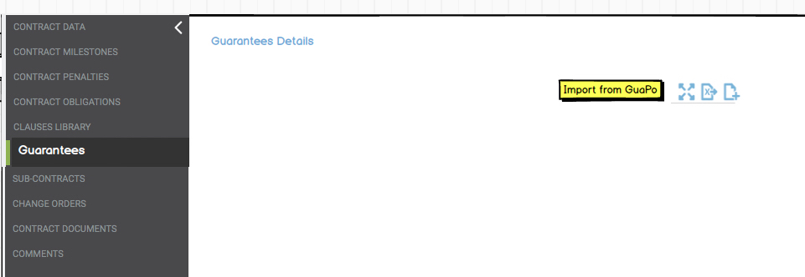

* **General implementation requisite**

1. if the Record (the line) is Retrieved from GuaPo the Fields retrieved are NOT Editable (Only the Fields: “**Obligation Type (CM)**” and “**Note for GuaPo Update**” are Always editable and they must be ignored during import from GuaPo
2. if the Record (the line) is Manually added, The value is manually entered by the user or selected form a Dropdown (as specified in the Field Logic Table)
3. The UC should have same EXCEL Export functionality and Full Screen Functionality as per other UC present in Contract form 

Key Features of this development done by PO India:

**Point #14**: Contract Form Guarantee User control.

* + 1. Create New user control for Contract Form Guarantee with all expected columns
    2. Create Contract Stage Table which is to be referred by ENEL to fill data and get reference from and to PO application.
    3. Import Guarantee data from stage table. Multiple record can be imported from stage table as per validation rules to be enforced based on Contract number.
    4. If the Record (the line) is Retrieved from GuaPo the Fields retrieved are NOT Editable (Only the Fields: “**Obligation Type (CM)**” and “**Note for GuaPo Update**” are Always editable and they must be ignored during import from GuaPo
    5. if the Record (the line) is Manually added, The value is manually entered by the user or selected form a Dropdown (as specified in the Field Logic Table)
    6. Add EXCEL Export functionality for the control
    7. Add Full Screen Functionality as per other UC present in Contract form
    8. We have added a new icon in **Imported** column of Grid if record is imported from GuaPO. If record is manually added then this column will remain blank.
    9. In downloaded excel sheet **Imported** columnwill show **YES** if record is imported from GuaPO and if record is manually added then **Imported** column will show **NO**.

# CLAIM FORM, AUTOMATIC FILLING OF CONTRACT DETAILS FIELDS

• **Business Requirement**

Automatically Fill the contract information details in the Claim Form once inserted the Contract Nr. (as in the Procurement Plan Form). Possibility to update the contract data on demand with a new button.

• **Implementation logic**

As described below, the user should be able to insert the contract number in the procurement plan and if the contract exists in PO Contract Register, then in the Claim Form, the Contract details are automatically filled.

"Contract Nr." field must be set as mandatory.

The User will be able to update the fields pressing a new button (in case the data in the PO Contract Register have been updated and user need to retrieve latest data).

• **Operational steps**

Insert “Contract Nr.” and move away from the field to retrieve contract information (as in the PP Form).

In case the data in PO Contract Register have been updated and user need to retrieve latest data, a new button is required to update on demand the fields with data from PO Contract Register.

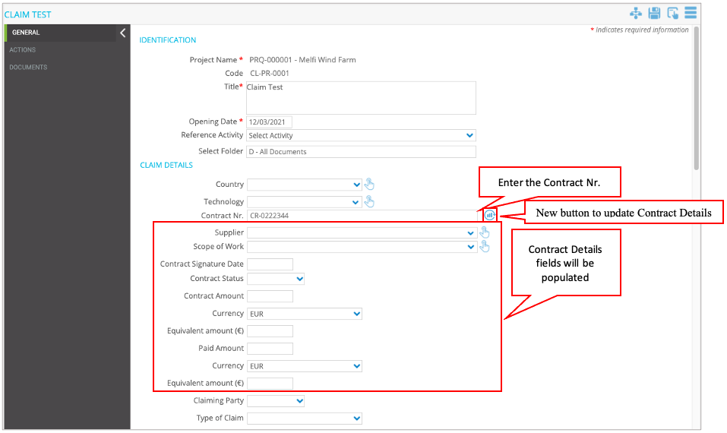

The value of fields in the left column should be moved to the field in the right column

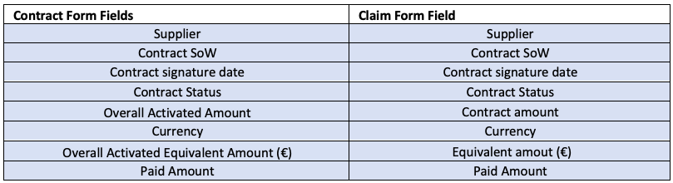

• **General implementation requisite**

"Contract Nr." field must be set as mandatory.

Fields in the table must not be editable manually.

# CLAIM FORM, AUTOMATIC FILLING OF PROJECT DETAILS FIELDS

• **Business Requirement**

Automatically Fill the project information details in the Claim Form.

• **Implementation logic**

The fields described below must receive values from the related project.

• **Operational steps**

The project data are automatically filled in when you create a new claim objects.

Fields that should be retrieved from Project:

* Country
* Technology
* Execution Area
* Area

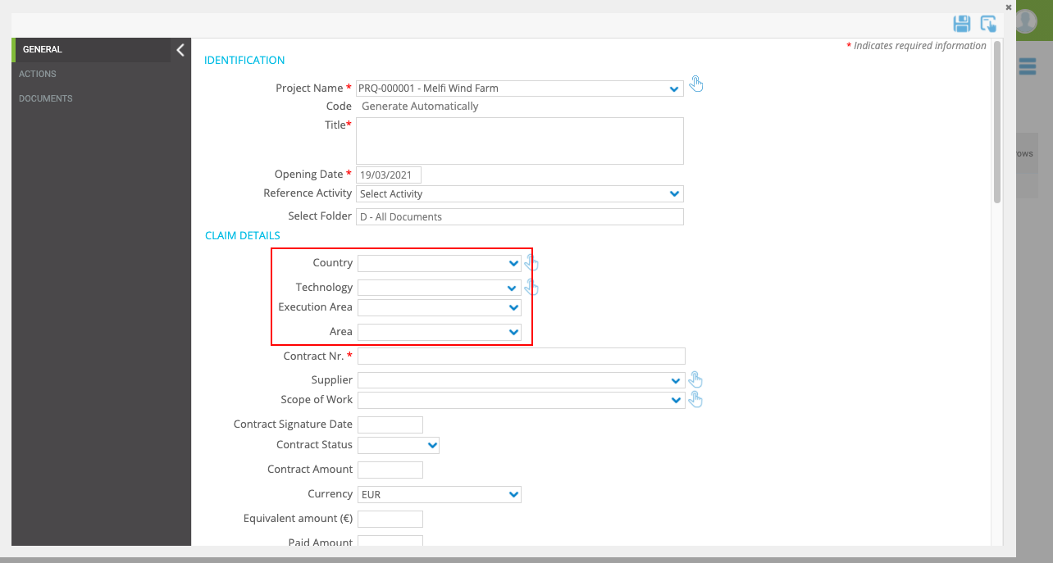

• **General implementation requisite**

These fields must not be editable manually.

# CLAIM FORM, Fields Logic Specs

**1. Claim ID field**

* The “Code” field must be renamed to Claim ID.
* The numbering of the Claim ID should be as follows:

Claim ID = [contract number] – CL – [progressive number]



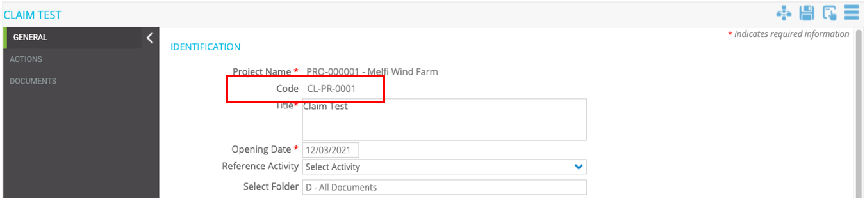

**2.** **Arbitration Avoided field**

“Arbitration Avoided” Field should be editable only if the Claim Status = Closed

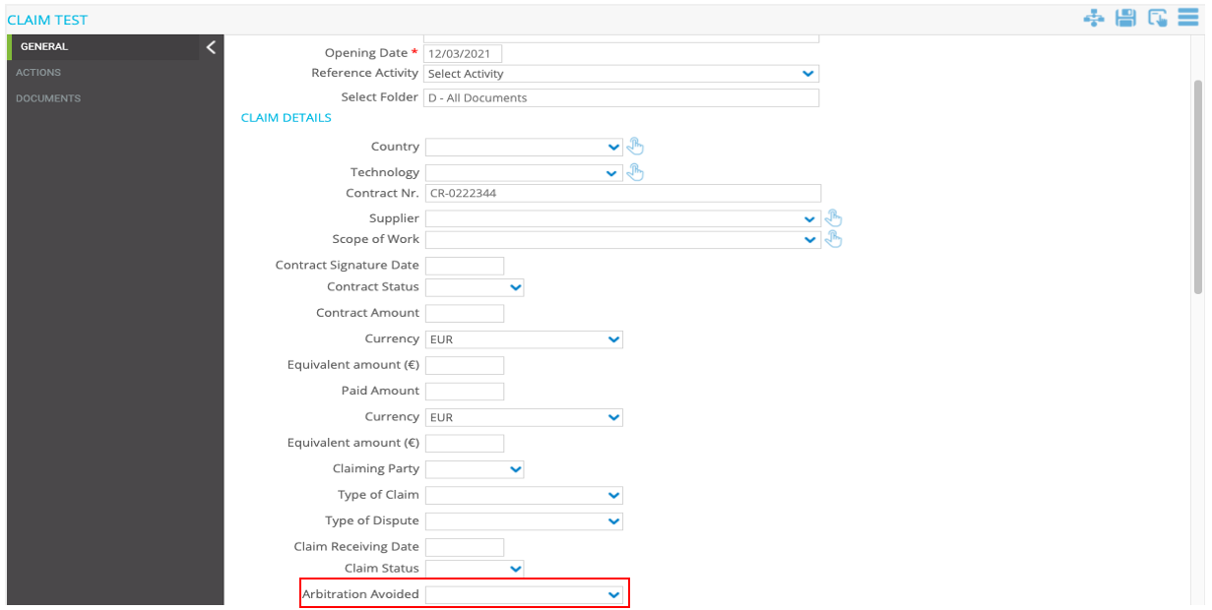

**3.** **Last Update Date field**

The “Last Update Date” field should show the date of the last time that the form was saved.

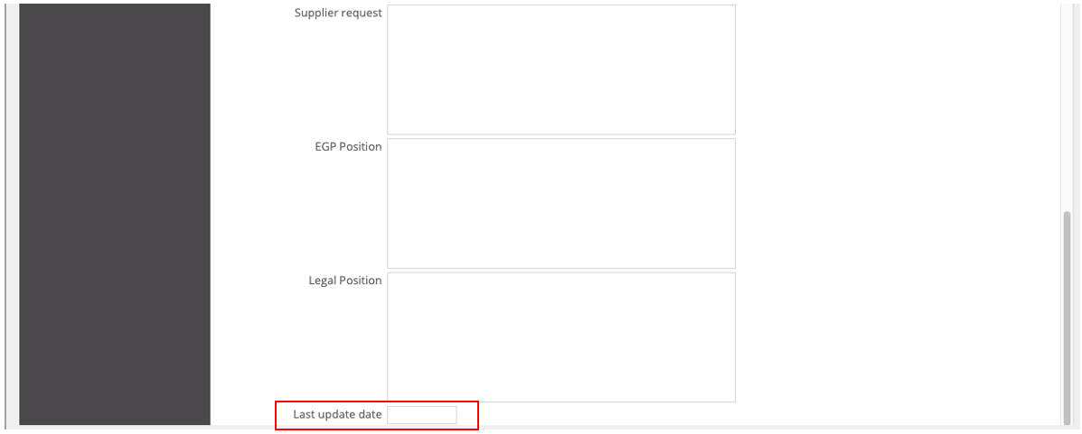

# ACTIONS UC, CLAIM FORM

• **Business Requirement**

Manage Claim Actions in a dedicated section in the Claim Form.

• **Implementation logic**

The new user control must be implemented as per the Fields Required as shown in the Table Below. The fields should be by default in the order indicated by the client.



The new user control has field Automatically calculated or Manual entered, according to a predefined logic.

In the table below you can find the Logic (Column Data logic) and the details for all the Fields.

Field details (Format, length and Mandatory Y/N) should be set as per requirement.

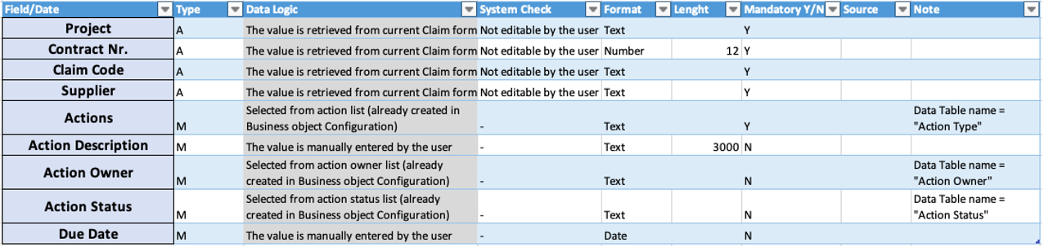

**Data table Values (already created):**

* Action Type:

1. Claim under analysis

2. Change Order under negotiation

3. Legal counterclaim / action

4. Final agreement to be closed

5. Negotiation with Supplier

6. External advisor involved

7. Other - see details

* Action Owner:

1. PMGT

2. PROC

3. LEGAL

4. CMGT

5. Contractor

6. External advisor

* Action Status:

1. On going

2. Pending

3. Done

Action UC Mockup

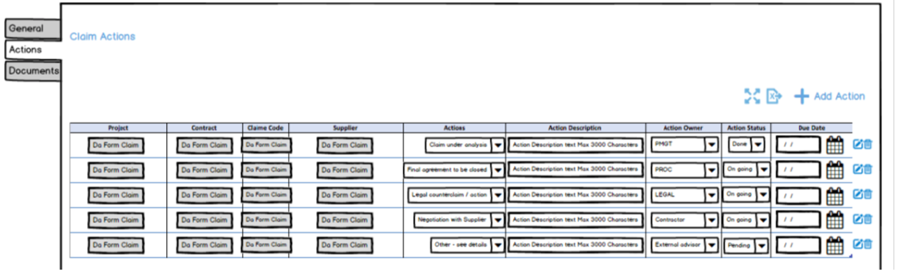

If no action has been added, when user press Save or Apply, an alert message should appear with the following sentence: “ERROR - Action form is empty! Please include at least one action in order to save the Claim form.” the user should press OK to the Popup with the text indicated.

• **Operational steps**

The User will be able to Add Action Claim from the dedicated tab in the Claim Form.

To create an Action, the user should be able to:

1) For the specific project, access the project workspaces

1. Select the Claim
2. Select the tab “Actions”
3. Click the add icon and enter all mandatory fields
4. Save the new Claim Action line

2) Once saved the claim will be available for editing/delete

3) The User will have the possibility to expand the view full screen and to export to Excel the Claim table/register.

* **General implementation requisite**

1. EXCEL Export functionality
2. Full Screen Functionality

# PR – No SAP Countries Form, Automatic Filling of Project Details fields

* **Business Requirement**

Automatically Fill the project information details in the “PR – No SAP Countries” form.

* **Implementation logic**

The fields described below must receive values from the related project.

* **Operational steps**

The project data are automatically filled in when you create a new “PR – No SAP Countries” objects.

Fields that should be retrived from Project:

* Technology
* Country
* Execution Area
* Area

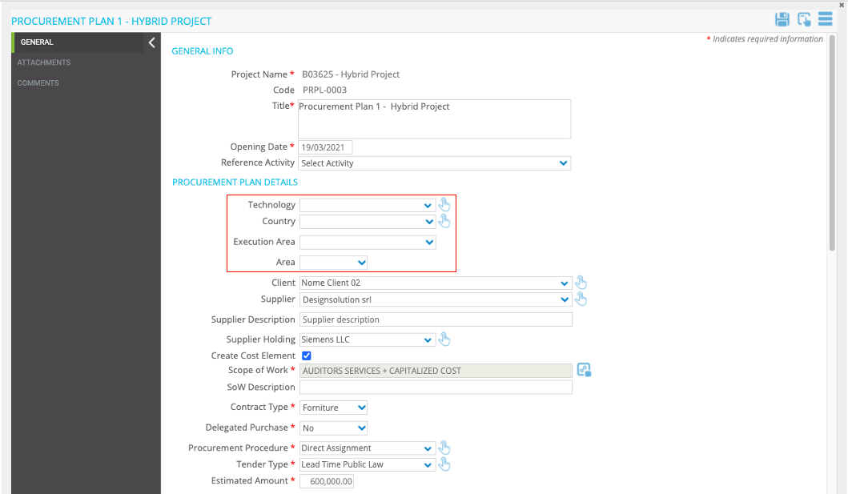

* **General implementation requisite**

These fields must not be editable manually.

# Requesting USer, field logic

* **Implementation logic**

The “Requesting User” field should show the name of the user who created the PR – No SAP Countries object.

* **General implementation requisite**

This field should not be manually editable.

# PR Number, field logic

* **Implementation logic**

The “Code” field must be renamed to PR Number.

The numbering of the PR Number should be as follows:

PR Number = PR-[“Requesting Company” Code]–[Project Code]–[progressive number]

Example 

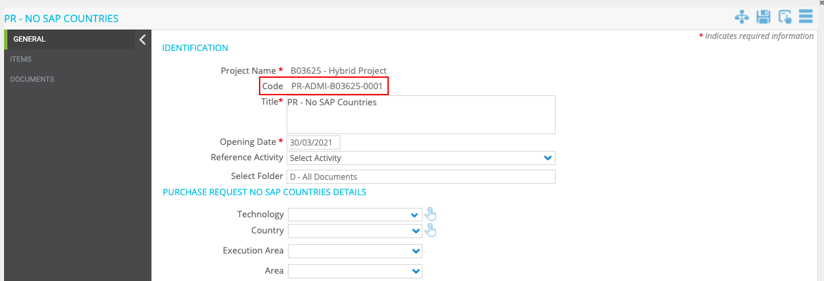

# Estimated Amount, field logic

* **Implementation logic**

The "Estimated Amount" field must show the value of the field highlighted in the mockup below (sum of the amounts of all items).

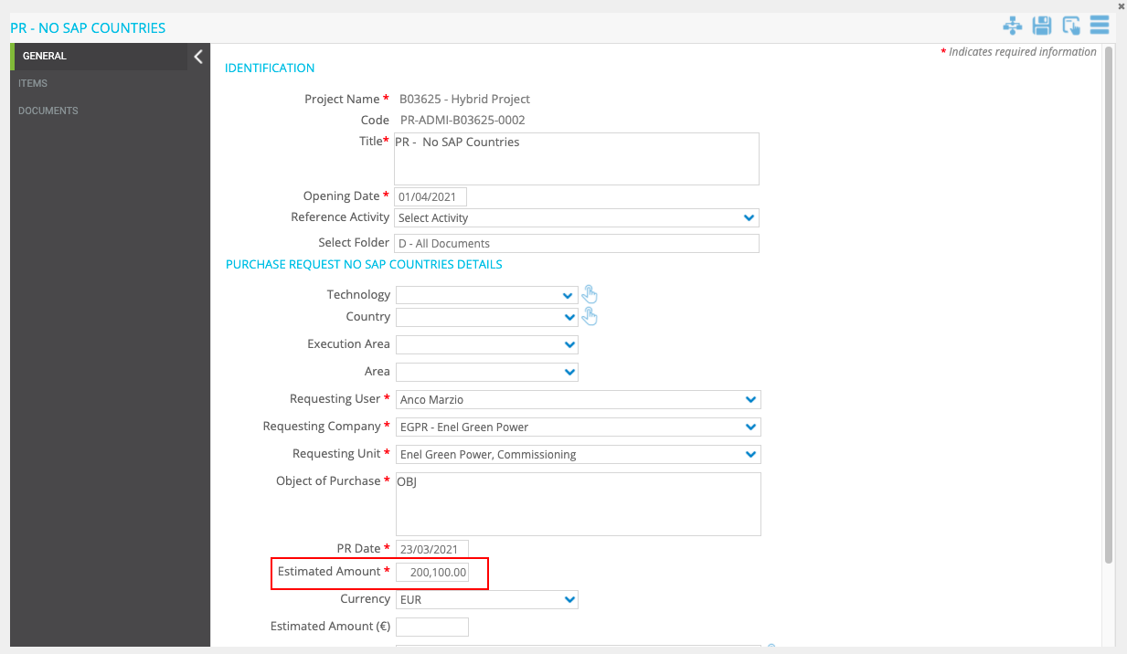

ITEMS UC Mockup

* **General implementation requisite**

Not editable

# PM Approval date field, field logic

* **Implementation logic**

The field “PM Approval Date” should automatically show the date of finalisation of the PR - No SAP Countries object. (Release from step2)

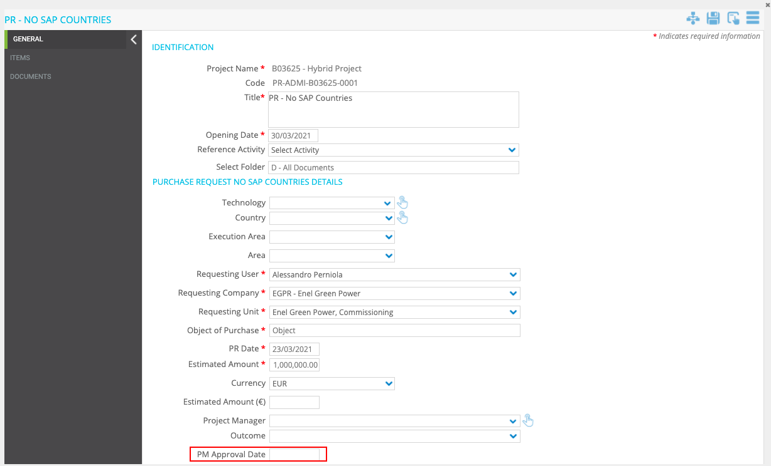

# Workflow status, register column logic

1. Rename Column

* **Business Requirement**

The Column “Workflow Status” of the register should be renamed to “PR Status” (Only for “PR – No Sap Countries” register)

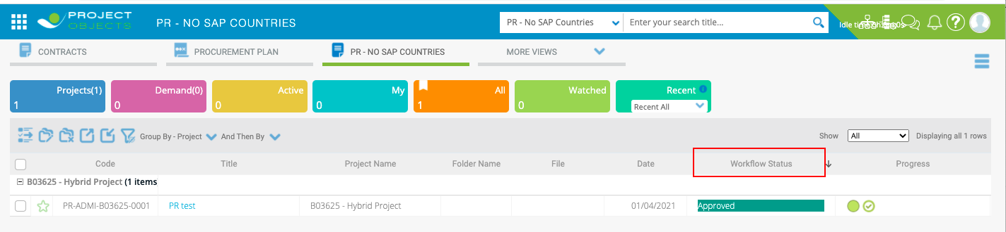

1. PR Status logic implementation

* **Business Requirement**

When the PR - No SAP Countries is finalized the text inside the "PR Status" (Column in the register), must be filled with the value present in the "Outcome" dropdown.

* **Implementation logic**

When the user finalise the PR - No SAP Countries, by the release of the object from step 2, if "Approved" is selected in the "Outcome" dropdown, the "PR Status" must show "Approved". If "Not Approved" is selected in the "Outcome" dropdown, the "PR Status" must show the text "Not approved".

* **Operational steps**

Project Manager selects “Approved” or “Not Approved” in the “Outcome” dropdown.

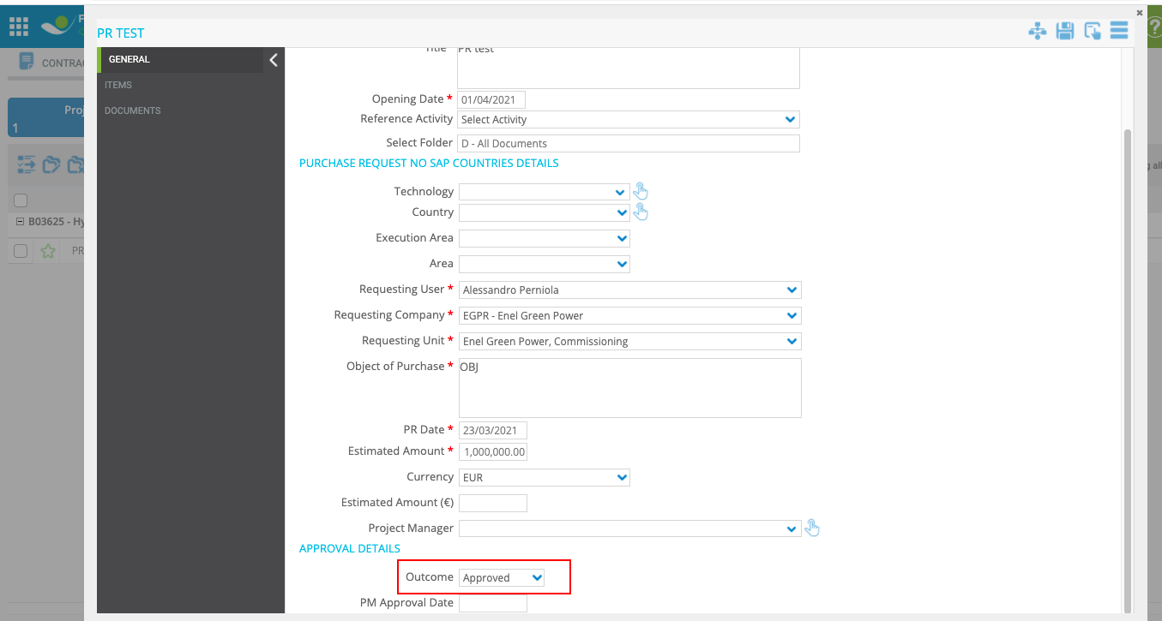

User (ProjectManager owner step2) finalises the PR - No SAP Countries, by the release of the object from step 2.

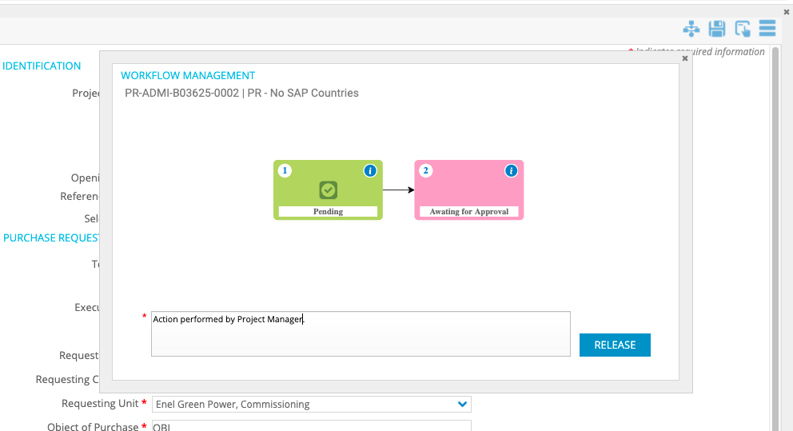

The “PR Status” should show the value selected in the ”Outcome” field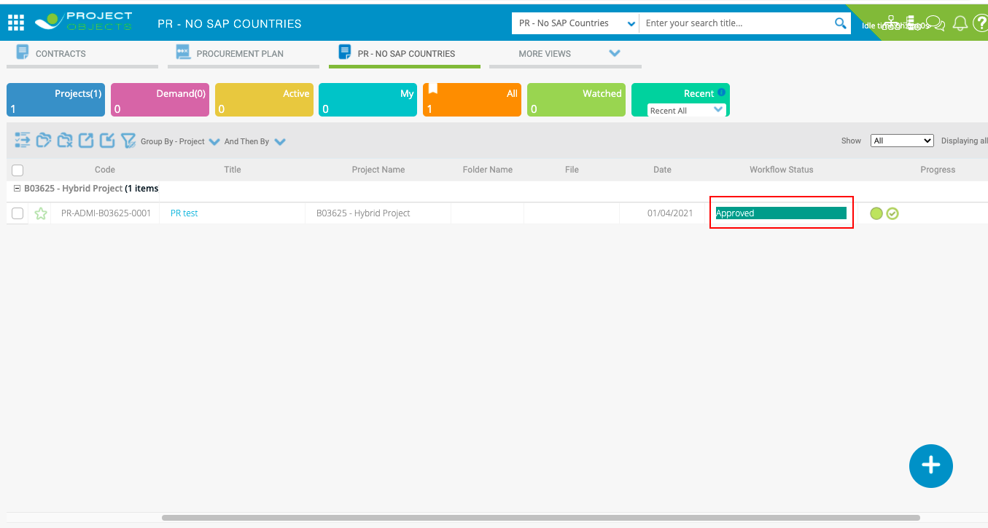

# Item uC for PR – NO sap Countries

* **Business Requirement**

To Manage Items in a dedicated Tab in the “PR- No SAP Countries” Form.

More than 100 items can be inserted.

* **Implementation logic**

The UC should contain real time Column filtering (as Team Space registers).

|  |  |  |  |  |  |
| --- | --- | --- | --- | --- | --- |
| **Field/Data** | **Type** | **Data Logic** | **Format** | **DropDown List Content** | **Note** |
| Position ID | See Data Logic --> | Progressive numbering (not editable) |  |  | 001, 002, 003... |
| Description | See Data Logic --> | Manually entered | Text |  | 1000 characters |
| Unit Price | See Data Logic --> | Manually entered | Amount |  |  |
| Units of Measure | See Data Logic --> | Manually entered | Drop Down |  |  |
| Quantity | See Data Logic --> | Manually entered | Number |  |  |
| Amount | See Data Logic --> | Calculated (Unit Price * Quantity) | Amount |  |  |
| Currency | See Data Logic --> | Retrieved from the “Currency” field of the form |  |  |  |
| Equivalent Amount € | See Data Logic --> | Manually entered | Amount |  |  |

* **Operational steps**

The User will be able to Add ITEMS from the dedicated tab in the PR - No SAP Countries Form.

To create an ITEMS, the user should be able to:

1) For the specific project, access the project workspaces

1. Select the PR - No SAP Countries
2. Select the tab “ITEMS”
3. Click the add icon and enter the fields
4. Save the new ITEM line

2) Once saved the Items will be available for editing/delete

3) The User will have the possibility to expand the view full screen and to export to Excel the Items table/register.

ITEMS UC Mockup

The UC should contain real time Column filtering (as Team Space registers).

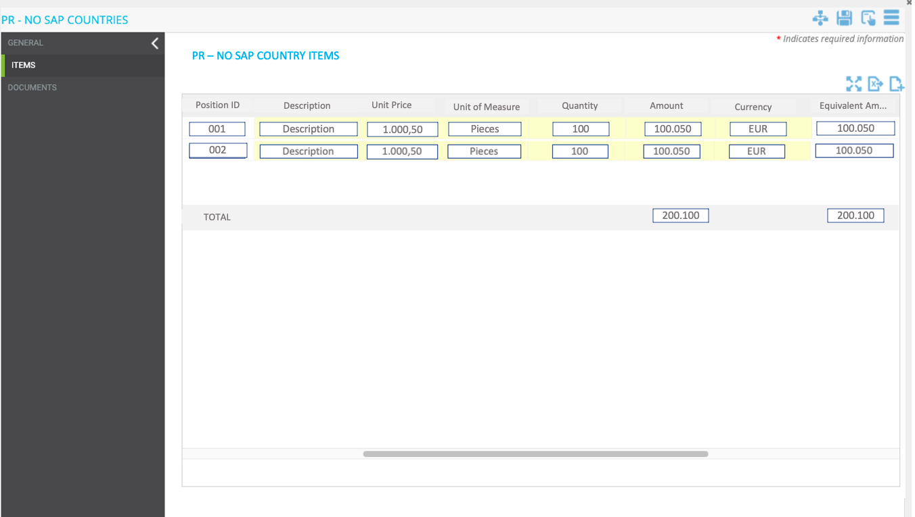

* **General implementation requisite**
* EXCEL Export functionality
* Full Screen Functionality
* Real time Column filtering

# Procurement plan form, automatic filling of project details fields

* **Business Requirement**

Automatically Fill the project information details in the Procurement Plan Form

* **Implementation logic**

The fields described below must receive values from the related project.

* **Operational steps**

The project data are automatically filled in when you create a new Procurement Plan objects.

Fields that should be retrived from Project:

* Technology
* Country
* Execution Area
* Area



* **General implementation requisite**

These fields must not be editable manually.

# Milestones UC, new fields and logic

* **Business Requirement**

Add 3 new fields in the milestones UC.

New fields should be placed between the “Delay (Days)” and “Note” columns.

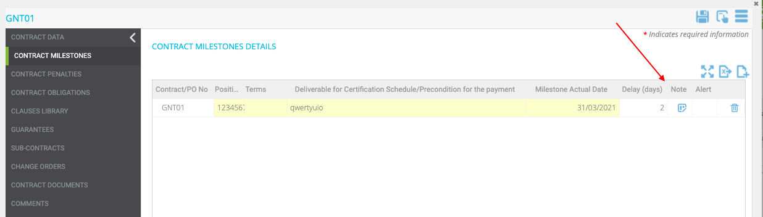

* **Implementation logic**

**Field Required:**

Advanced Payment Requested

Advanced Payment Amount

Advanced Payment Equivalent Amount (€)

|  |  |  |  |  |
| --- | --- | --- | --- | --- |
| **Field/Data** | **Type** | **Data Logic** | **Format** | **DropDown List Content** |
| Advanced Payment Requested | See Data Logic --> | Manually entered  (DROPDOWN ALREADY CREATED) | Dropdown List: | Yes/No |
| Advanced Payment Amount | See Data Logic --> | Manually entered | Amount |  |
| Advanced Payment Equivalent Amount (€) | See Data Logic --> | Manually entered | Amount |  |

* **General implementation requisite**

All new fields should be manually entered by the user.

# Guarantees UC, new fields and logic

* **Business Requirement**

Add 5 new fields in the guarantees UC.

New fields should be placed between the “Note for GuaPo Update” and “Imported” columns.

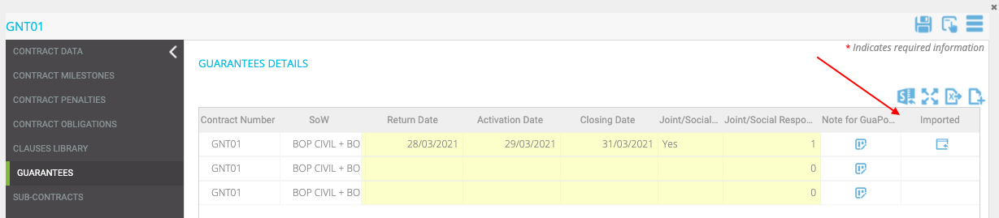

* **Implementation logic**

**Field Required:**

Executed

Requested Amount

Requested Equivalent Amount (€)

Executed Amount

Executed Equivalent Amount (€)

|  |  |  |  |  |
| --- | --- | --- | --- | --- |
| Executed | See Data Logic --> | The value is ALWAYS manually entered by the user and When Update from GuaPo the info on the record, this field must be ignored and keep the info manually entered | Dropdown List: | Yes/No |
| Requested Amount | See Data Logic --> | The value is ALWAYS manually entered by the user and When Update from GuaPo the info on the record, this field must be ignored and keep the info manually entered | Amount |  |
| Requested Equivalent Amount (€) | See Data Logic --> | The value is ALWAYS manually entered by the user and When Update from GuaPo the info on the record, this field must be ignored and keep the info manually entered | Amount |  |
| Executed Amount | See Data Logic --> | The value is ALWAYS manually entered by the user and When Update from GuaPo the info on the record, this field must be ignored and keep the info manually entered | Amount |  |
| Executed Equivalent Amount (€) | See Data Logic --> | The value is ALWAYS manually entered by the user and When Update from GuaPo the info on the record, this field must be ignored and keep the info manually entered | Amount |  |

* **General implementation requisite**

All new fields should be always manually entered by the user and when Update from GuaPo the info on the record, these fields must be ignored and keep the info manually entered.

# Guarantees numbering

* **Business Requirement**

Change the numbering logic of the guarantees: “Guarantee Code” field

* **Implementation logic**

If a guarantee has been deleted, its code must no longer be used for guarantees that will be created later.

Numbering should always continue even if there are gaps in the list.

* **Operational steps**

e.g. If I delete guarantee GNT01-G-002, the next item that I create will take the code GNT01-G-004 (see the screenshot below)

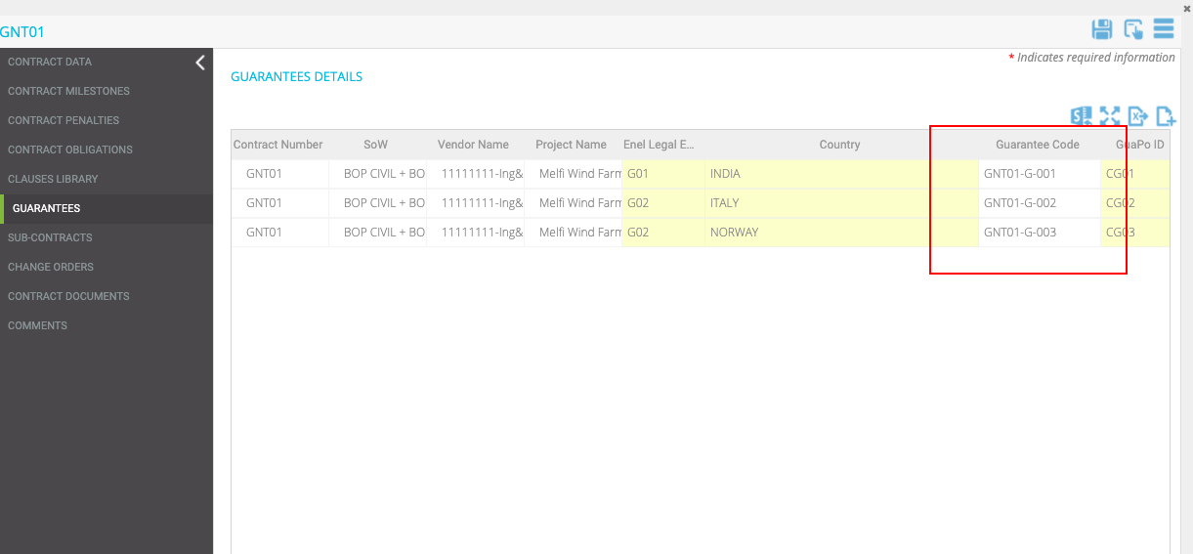

# Guarantees UC, rename tooltip for import

* **Business Requirement**

Rename tool tip for import.

* **Implementation logic**

The tooltip for guarantees import should be renamed from “Import from GuaPo” to “Import”

# Guarantees Validity Expected END Date, notification

* **Business Requirement**

Receive notification 30 days before the "Guarantee Validity Expected End Date".

* **Implementation logic**

The notification must be sent 30 days before the date entered in the "Guarantee Validity Expected End Date" field.

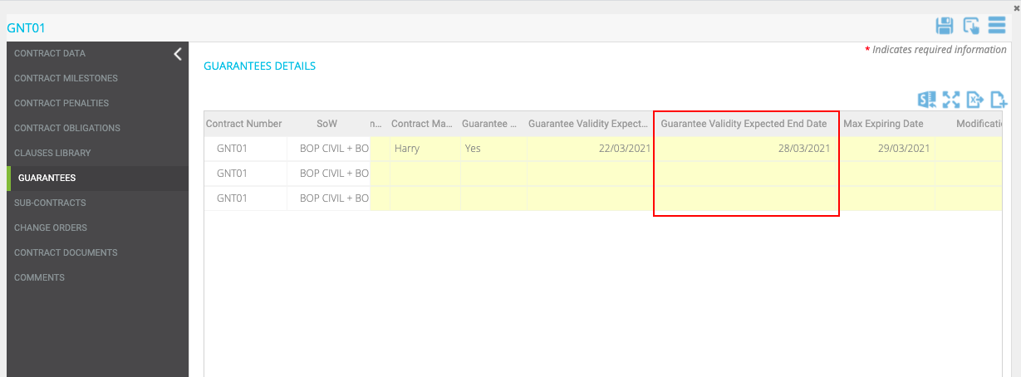

The notification must appear only to the "Contract Manager" inserted in the contract form

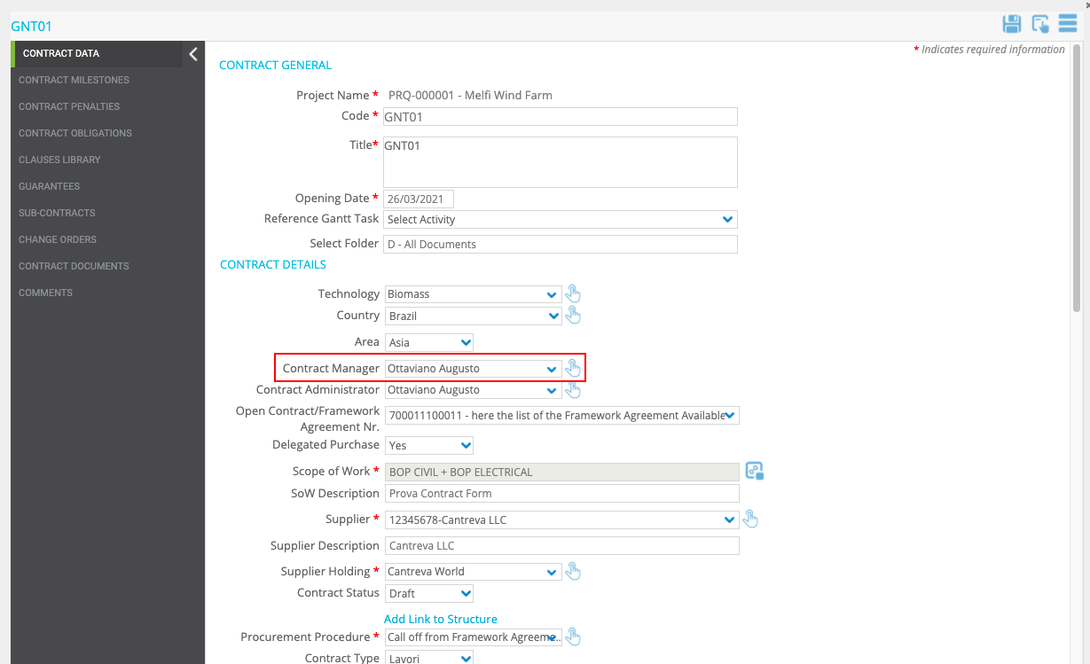

The notification should appear in the PO Notifications area

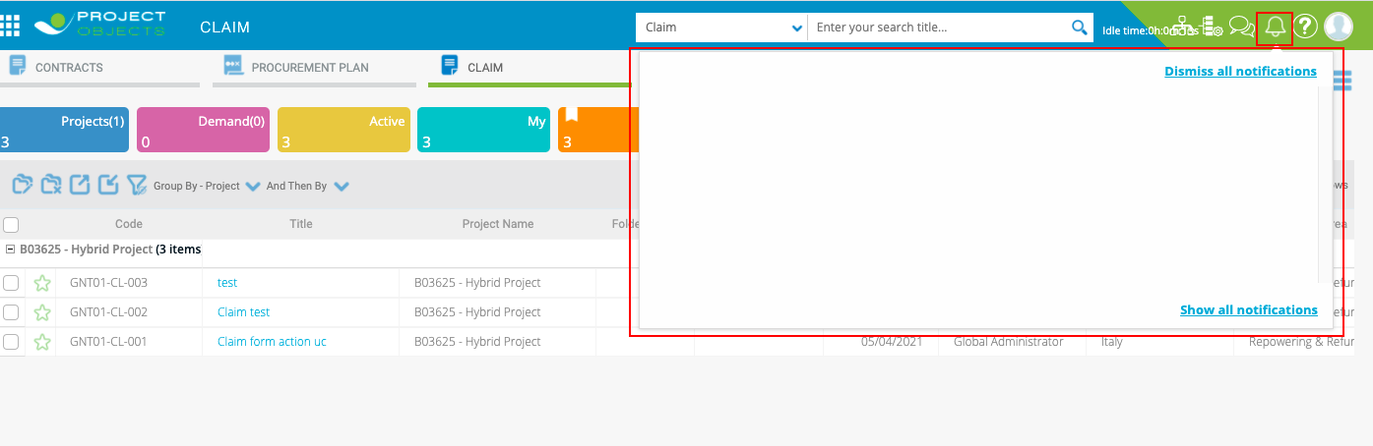

The text of the notification should be:

“30 Days to the Guarantee [Guarantee Code] Validity Expected End Date”

Example: 30 Days to the Guarantee GNT01-G-004 Validity Expected End Date

# PR – NO sap countries form, “PROJECT MANAGER” FIELD LOGIC

• **Implementation logic**

The user selected within the Drop Down Project Manager must be the approver of step 2.

The drop down must show only the users that belong to the group "PR Project Manager", Owner of step 2.

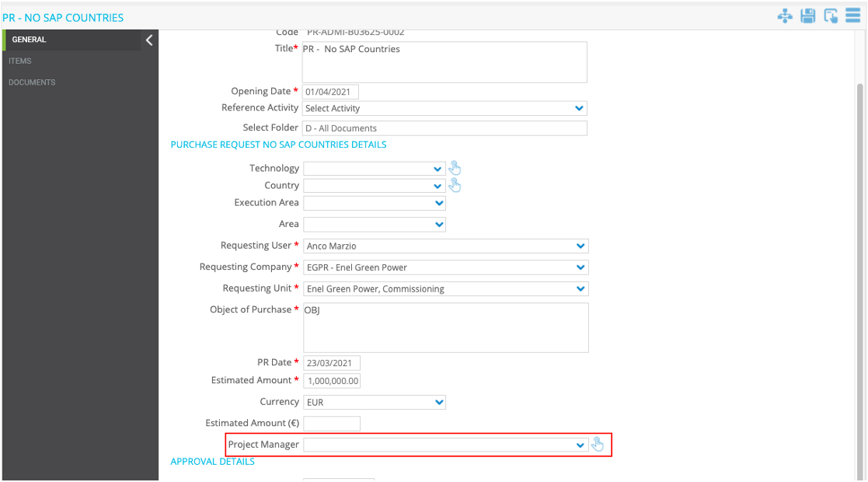

• **General implementation requisite**

Editable only in step1

# Fa, agreement n° field

* **Implementation logic**

The “Code” field must be renamed to “Agreement N° ”

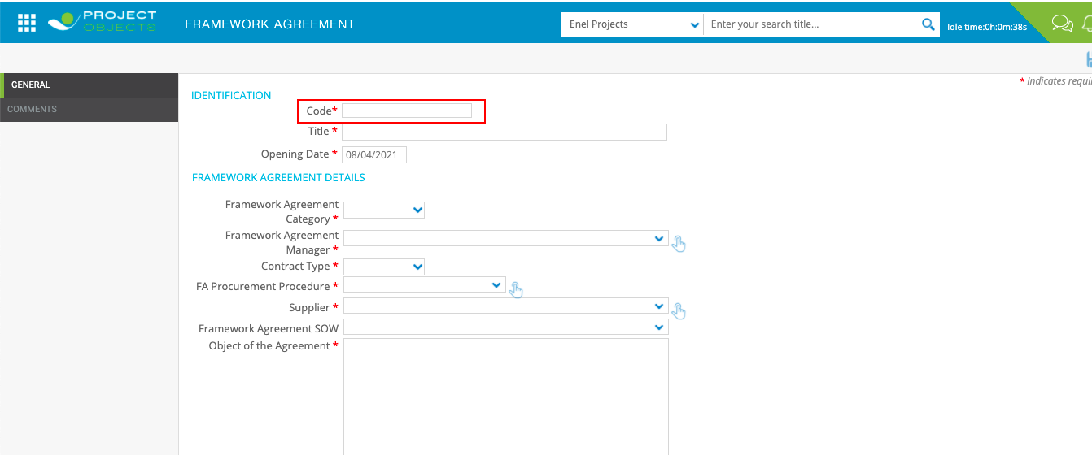

# “agreement n°”, Automatic Filling of Framework agreement Details from stage table

* **Business Requirement**

Have the framework agreement data filled in automatically when the "Agreement N°" is entered

* **Implementation logic**

The User will be able inserting the framework agreement number in the “Agreement N°” Field, to automatically fill the fields with data from Stage Table and if no data present in the stage table user should be able to manually fill the fields.

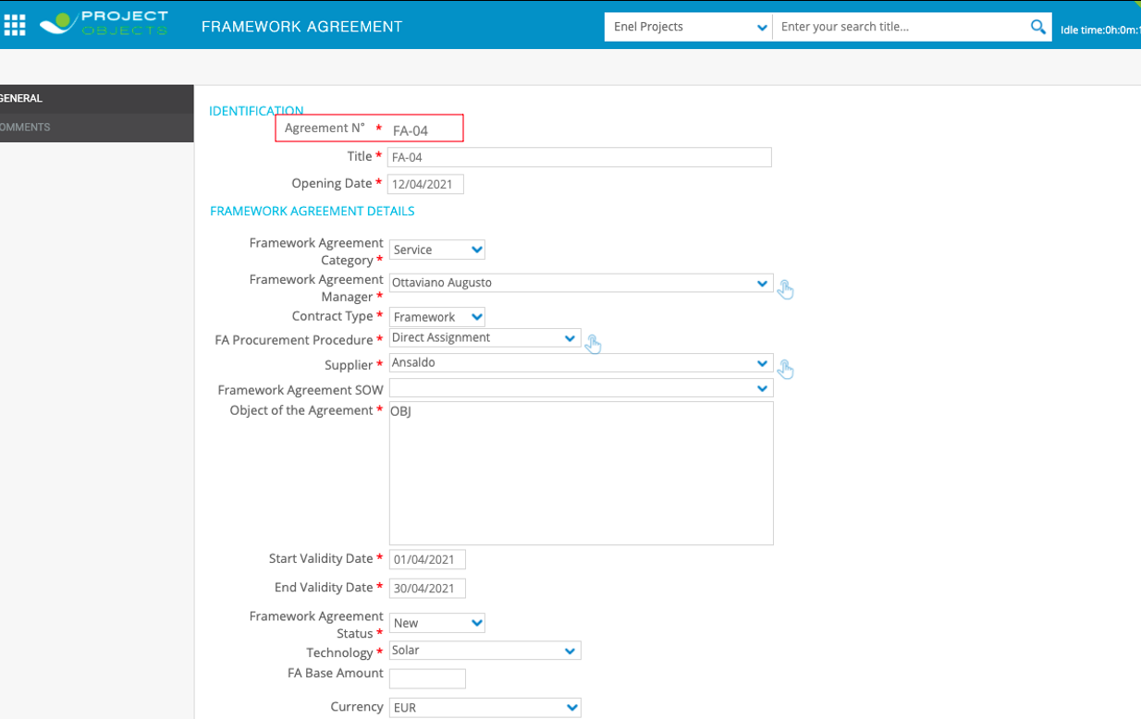

* **Operational steps**

1. The user enter the framework agreement number in “Agreement N°” field
2. Framework Agreement data will be automatically filled in

* **General implementation requisite**

Fields should be editable even if the data arrived from the Stage Table

# Fa, new button to update fields from omnia(Stage table)

* **Business Requirement**

Create a new button to request on demand the update of the form data from OMNIA(Stage Table)

**Note: Framework Agreement Stage Table should be the same of Contract Stage Table**

**In OMNIA (Enel Source) Contract and Framework Agreement are the same object (in the code they have different numbering). Therefore in the same stage table we will have some field related to Contract and others to Framework Agreement)**

* **Implementation logic**

Every time the icon is clicked, the values of some fields of the form are updated.

(for the import use as reference the field “Agreement N°”

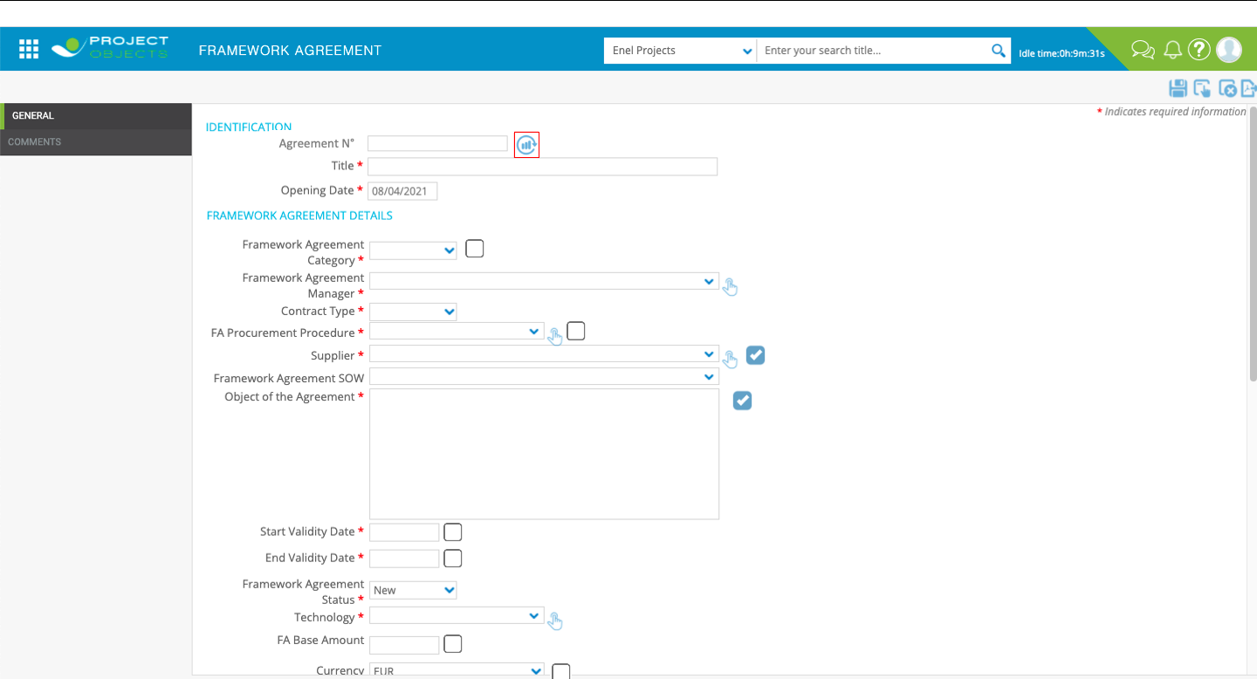Mockup

LIST OF FIELDS

* Framework Agreement Category
* Procurement Procedure
* Supplier
* Object of the Agreement
* Start Validity Date
* End Validity Date
* FA Base Amount
* Currency
* FA Base Equivalent Amount (€)
* Change Orders Amount
* Change Orders Equivalent Amount (€)
* Call Off Overall Amount in SAP
* Residual Amount (da SAP)
* **General implementation requisite**

Tooltip = “ Import ”

The fields in the above list should be manually editable

# FA, flags to ignore omnia (stage table) data import

* **Business Requirement**

Have the possibility to update only some fields during data import from OMNIA (Stage Table).

* **Implementation logic**

Is required to have a checkbox next to the fields imported from OMNIA(Stage Table). Fields with the flag will be ignored during the import (Manual or Scheduled).

The fields that need the checkbox are those listed in point 35 (all fields coming from OMNIA/Stage Table).

* **Operational steps**

1. The user fills in some or all the fields in the form.
2. Flag some fields.
3. Click on the new button to update the data taken from OMNIA(Stage Table).
4. The Fields without Flags are updated with the data from OMNIA(Stage Table).
5. Fields with Flags are not updated with OMNIA(Stage Table) data.

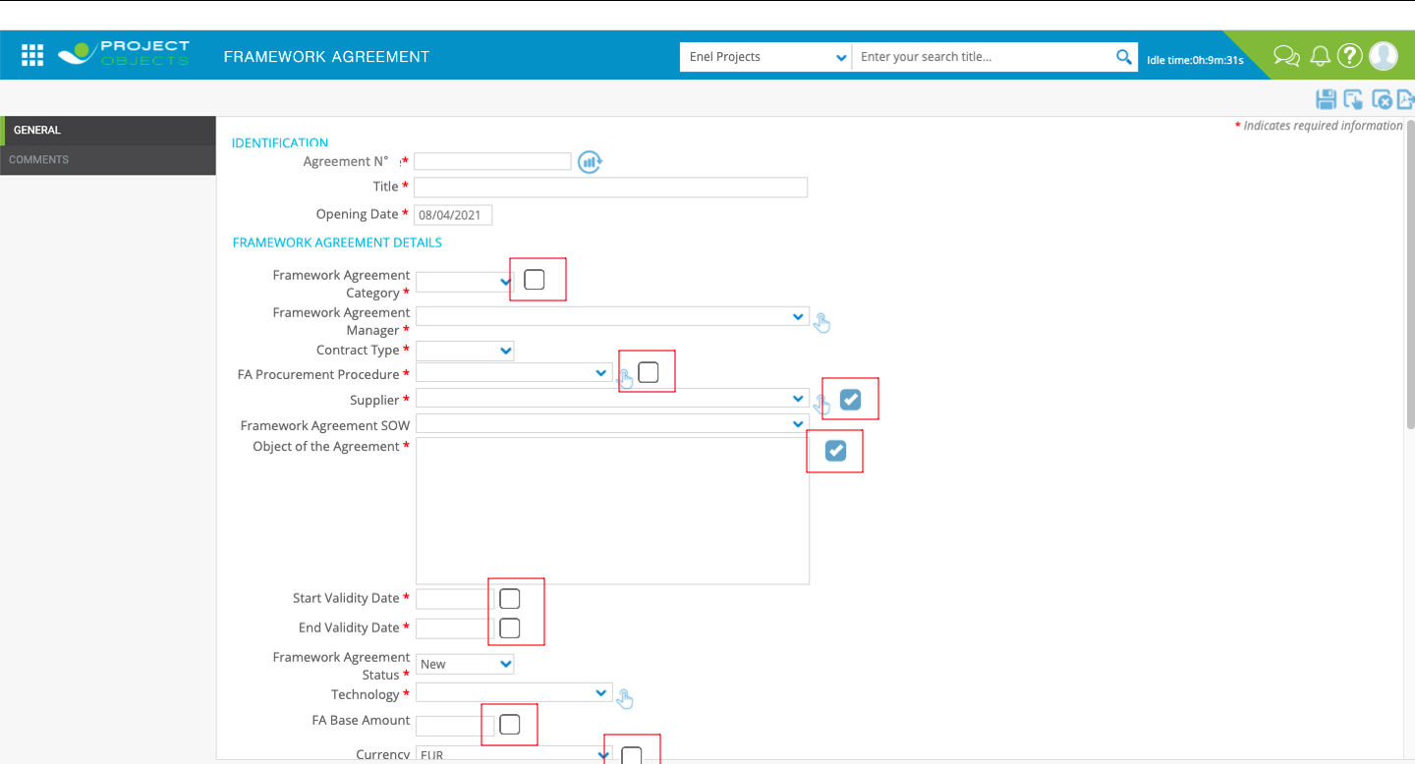Mockup

* **General implementation requisite**

Tooltip= “Ignore from Update”

# Automatic data import from omnia every 24h

* **Implementation logic**

Every 24 hours the fields without the flag selected should be automatically imported from Omnia(Stage Table) without any action by the user (Ignoring the ones flagged).

# Framework agreement manager, field logic

* **Implementation logic**

The “Framework Agreement Manager” field should show the name of the user who created the Framework Agreement.

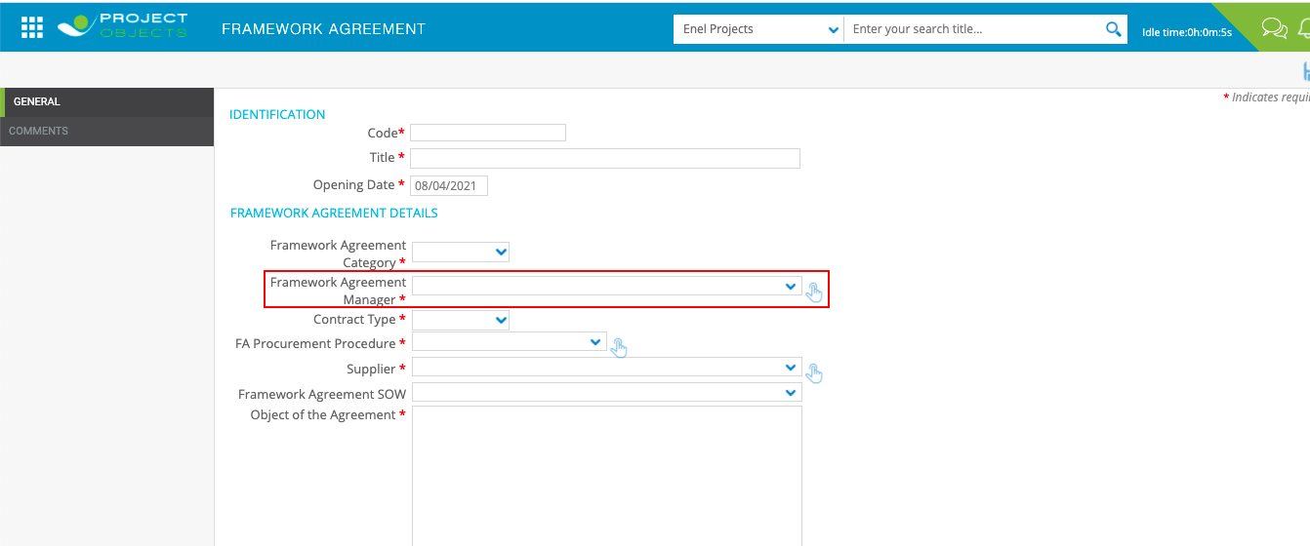

* **General implementation requisite**

This field should not be manually editable.

# Fa overall amount, field logic

* **Implementation logic**

The value of “FA Overall Amount” field should be calculated as the sum of the following 4 fields:

“FA Base Amount” + “Change Order Amount” + “Contractual Option Amount (included in Contract Original Amount) Released” + “Tolerance Released amount”

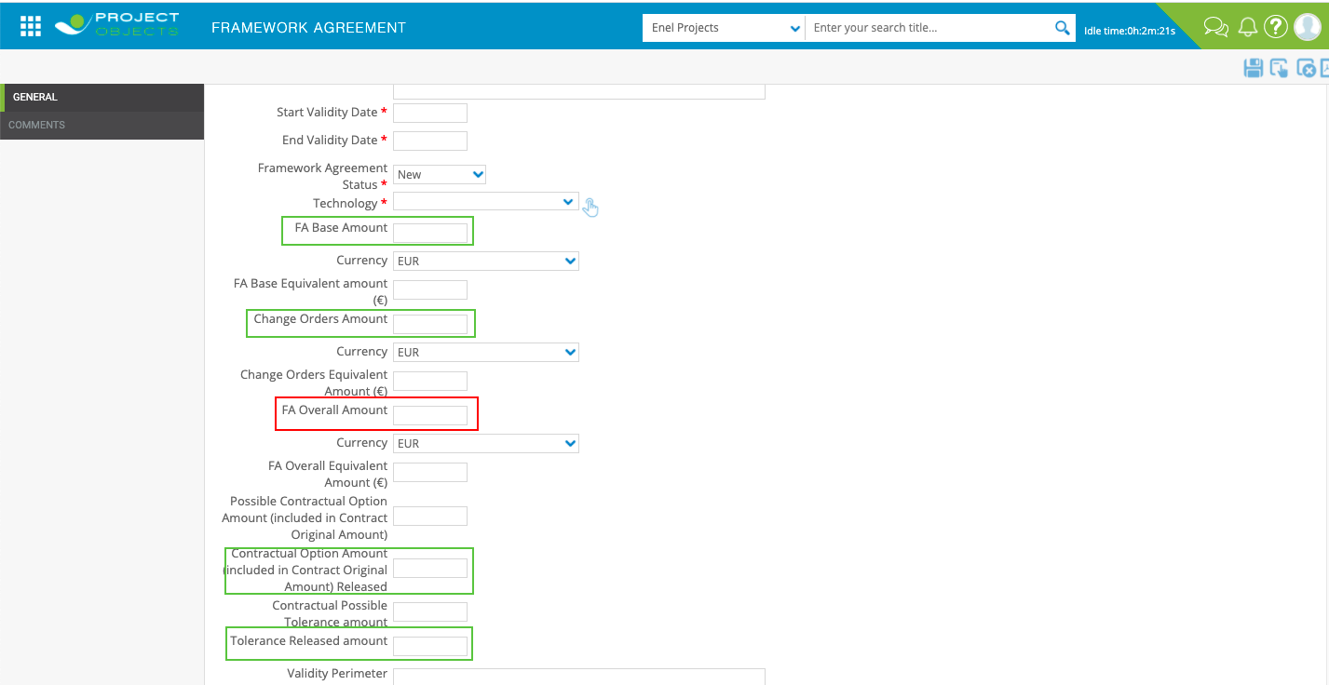

* **Operational steps**

Each time a value of the 4 fields changes, the "FA Overall Amount" field must be recalculated

# Framework agreement form, “Call off overall amount call-off list” field logic

* **Implementation logic**

The “Call Off Overall Amount Call-Off List” should calculate the sum of all the field "PO Amount" from Call-Off "Finalized" related to this Framework Agreement.

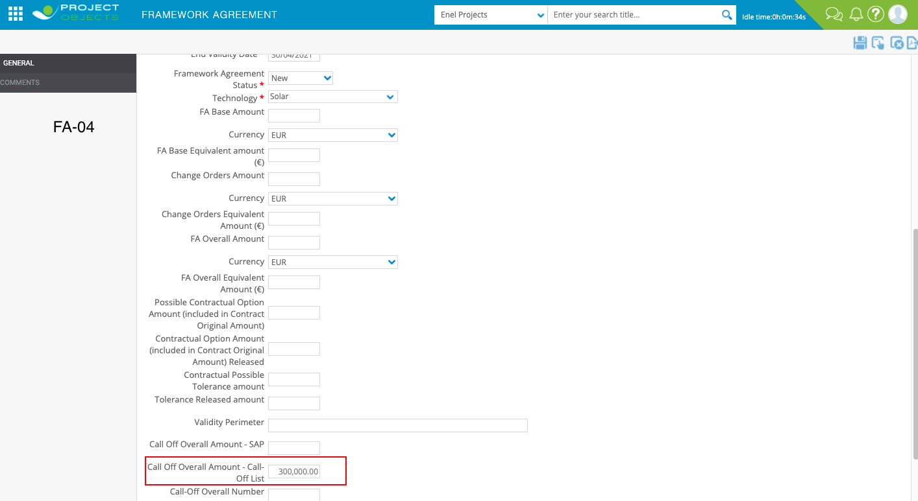Framework Agreement

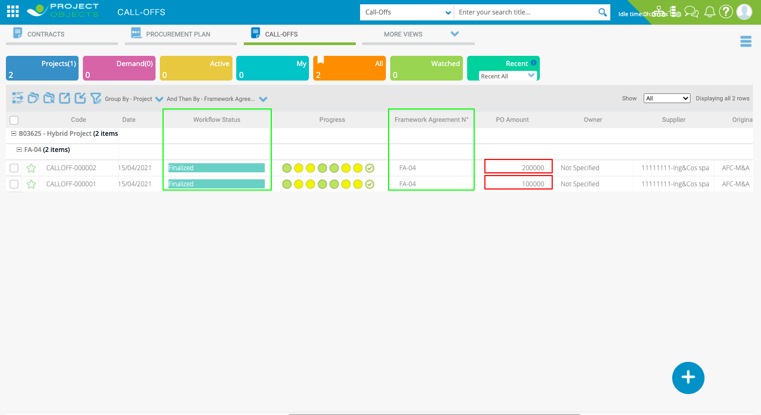Call Off

* **General implementation requisite**

The field should not be manually editable

# Framework agreement form, “Call off overall number” field logic

* **Implementation logic**

The field Call Off Overall Number should show the total Number of all the Call-Off "Finalized" related to the same Framework Agreement.

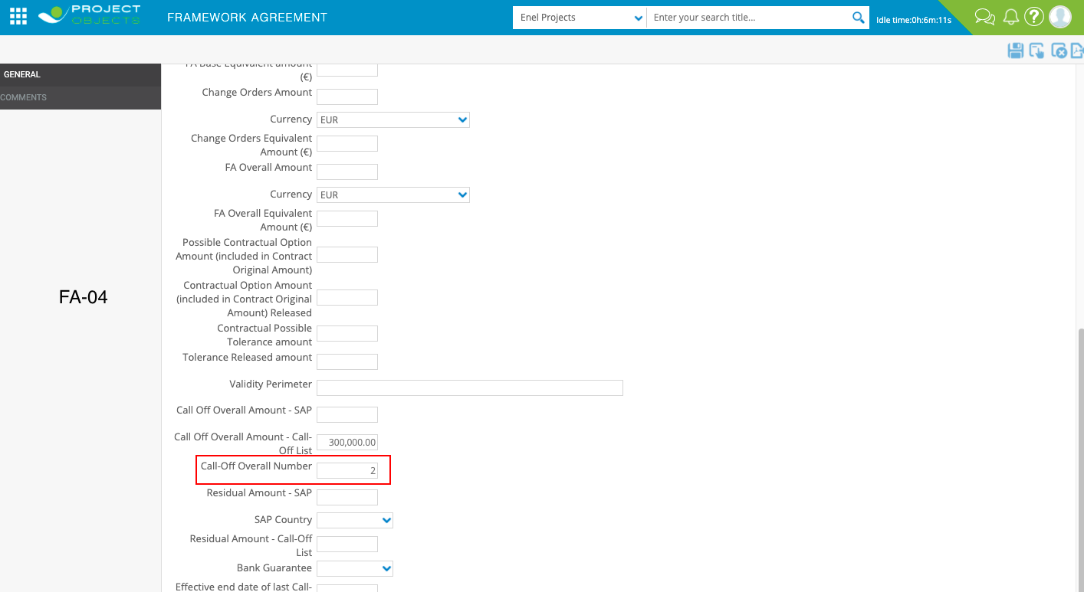Framework Agreement

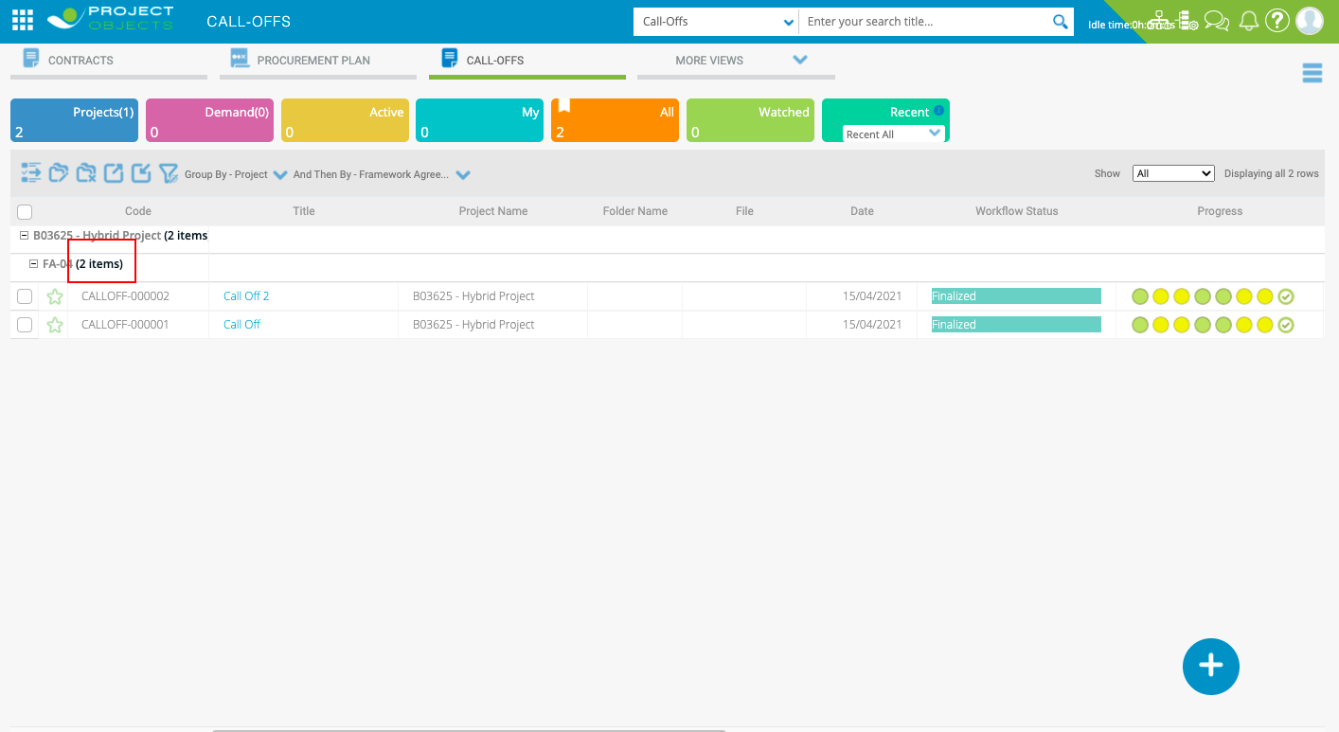Call Off

* **General implementation requisite**

The field should not be manually editable

# Framework agreement form, “Residual amount call-off list” field logic

* **Implementation logic**

The “Residual Amount Call-Off List” field should be calculated as follow:

FA Overall Amount - (Sum of all the field "PO Amount" from Call-Off "Finalized" With the Field "Sal Finale" equal to "NO" + Sum of all the field "Accrued Amount" from Call-Off "Finalized" related to the same Framework Agreement With the Field "Sal Finale" equal to "YES")

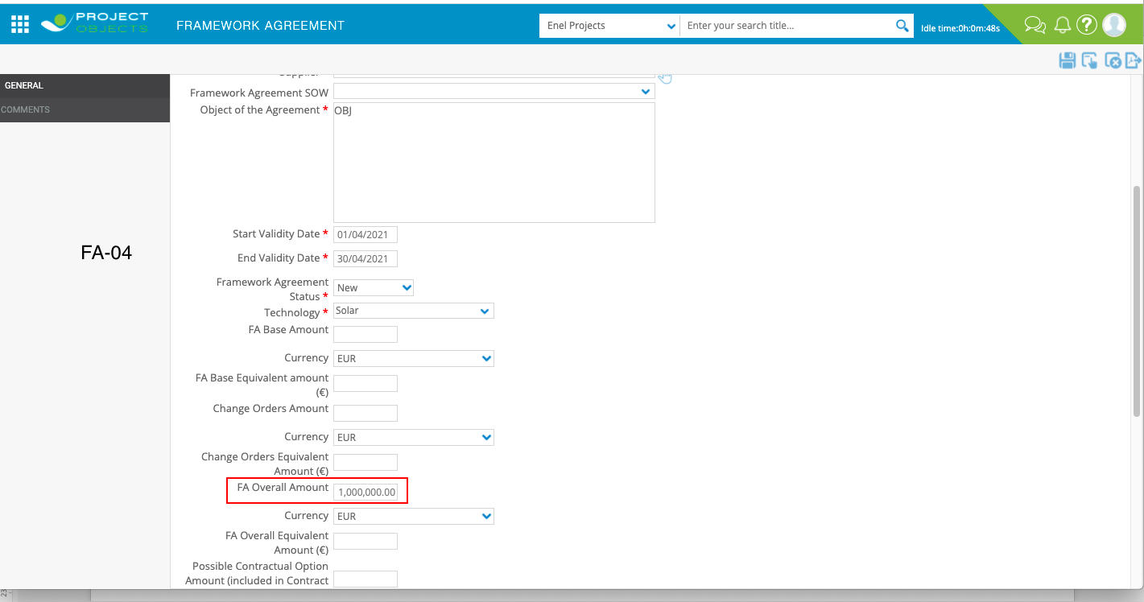Value from Framework Agreement Form

Values From Call Off

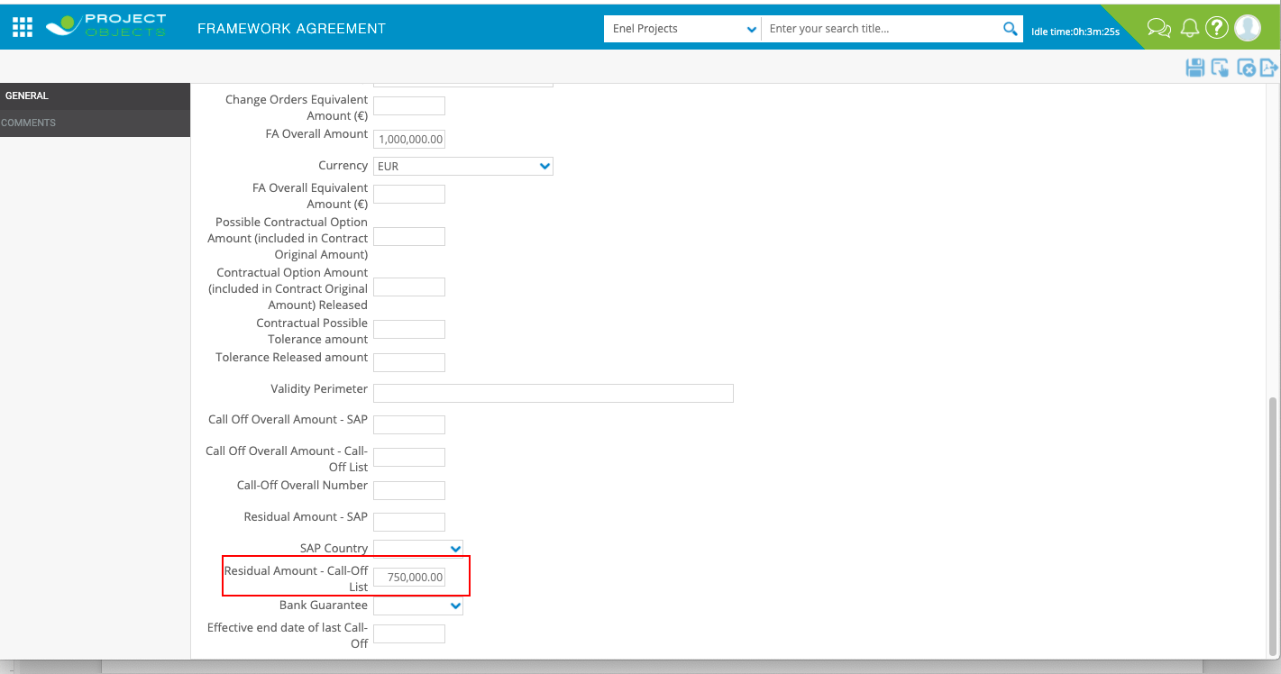Example with data in screenshots 1.000.000,00-(200.000,00+50.000,00)= 750.000,00

* **General implementation requisite**

The field should not be manually editable

# Framework agreement, “Residual Amount - Call-Off List”, Email notification

* **Business Requirement**

Have an Email Notification that informs when the value of the "Residual Amount - Call-Off List" field is equal to or less than 20% of the "FA Overall Amount" field

* **Implementation logic**

If “Residual Amount - Call-Off List” <= (“FA Overall Amount”/100)*20 an Email should be sent by the system.

* **General implementation requisite**

Email text and recipients must be user-configurable

# Framework Agreement, “Effective end date of last call off” email notification

* **Implementation logic**

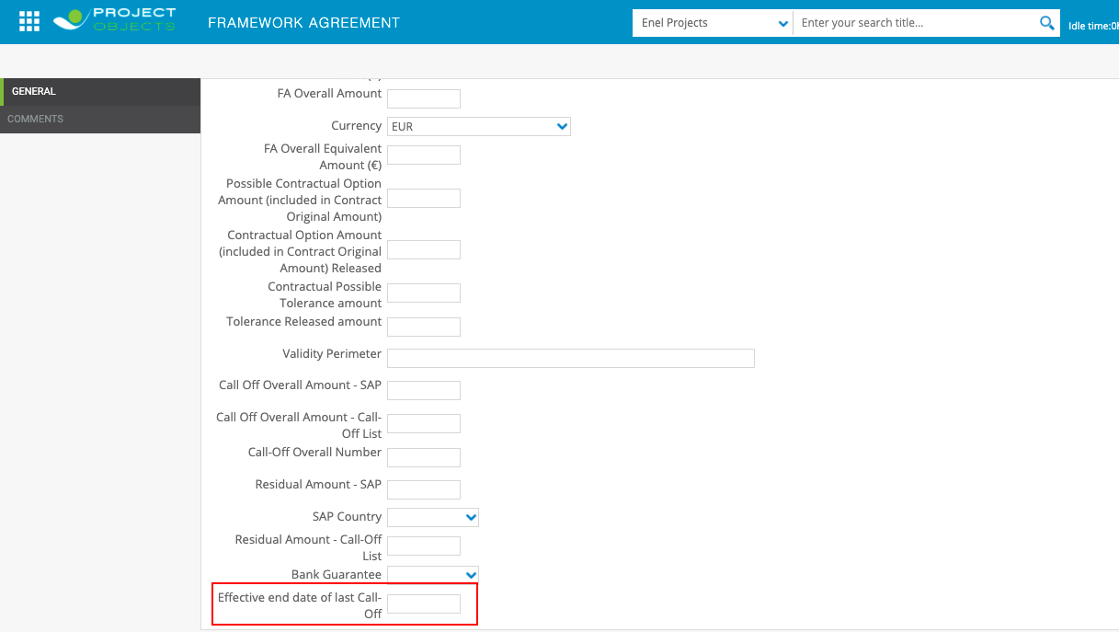12 Month after the date entered in in this field an Email should be sent by the system.

* **General implementation requisite**

Email text and recipients must be user-configurable

# Contract, automatic filling of Procurement plan Fields (update of specs n°7)

* **Business Requirement**

Automatically Fill the Procurement Plan details in the “Contract” form.

* **Implementation logic**

The fields listed below must receive the value from the related fields within the procurement plan form that originated the contract.

* **Operational steps**

When a new contract is created from the procurement plan, the following fields must be filled in automatically

Fields that should be retrived from Procurement Plan:

* Scope of Work (done)
* Supplier (done)
* Supplier Description (done)
* Supplier Holding (done)
* Contract Status (New)
* Contract Type (New)
* Contract Signature Date (done)
* Contract Base Amount (done)
* Currency (done)
* Contract Base Equivalent Amount (€) (done)
* Procurement Procedure (done)
* Delegated Purchase (New)
* Overall Amount (done)
* Currency (done)
* Contract Overall Equivalent Amount (€) (done)

# Contract, “Open contract/Framework agreement nr.” field logic

* **Implementation logic**

The “Open Contract/Framework Agreement Nr.” field should show the list of Framework Agreement” in PO.

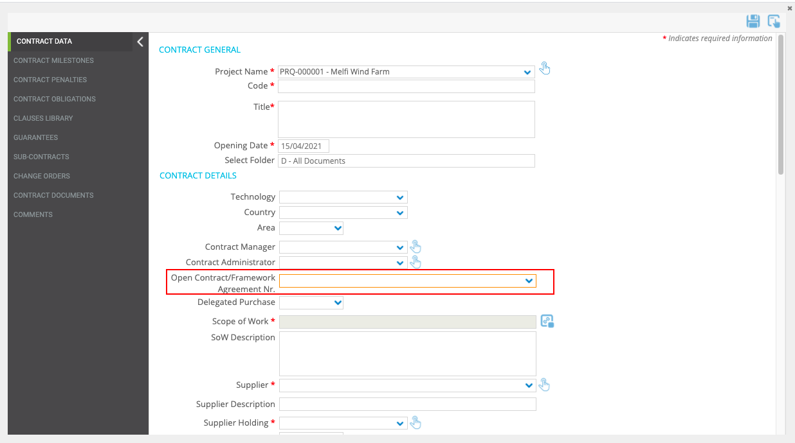

* 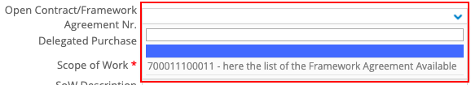**General implementation requisite**

(dropdown with search function)

# Contract Form, Automatic Filling of Project Details fields

* **Business Requirement**

Automatically Fill the project information details in the Contract Form.

* **Implementation logic**

The fields described below must receive values from the related project.

* **Operational steps**

The project data are automatically filled in when you create a new Contract objects.

Fields that should be retrieved from Project:

* Technology
* Country
* Execution Area
* Area
* Contract Manager
* Contract Administrator

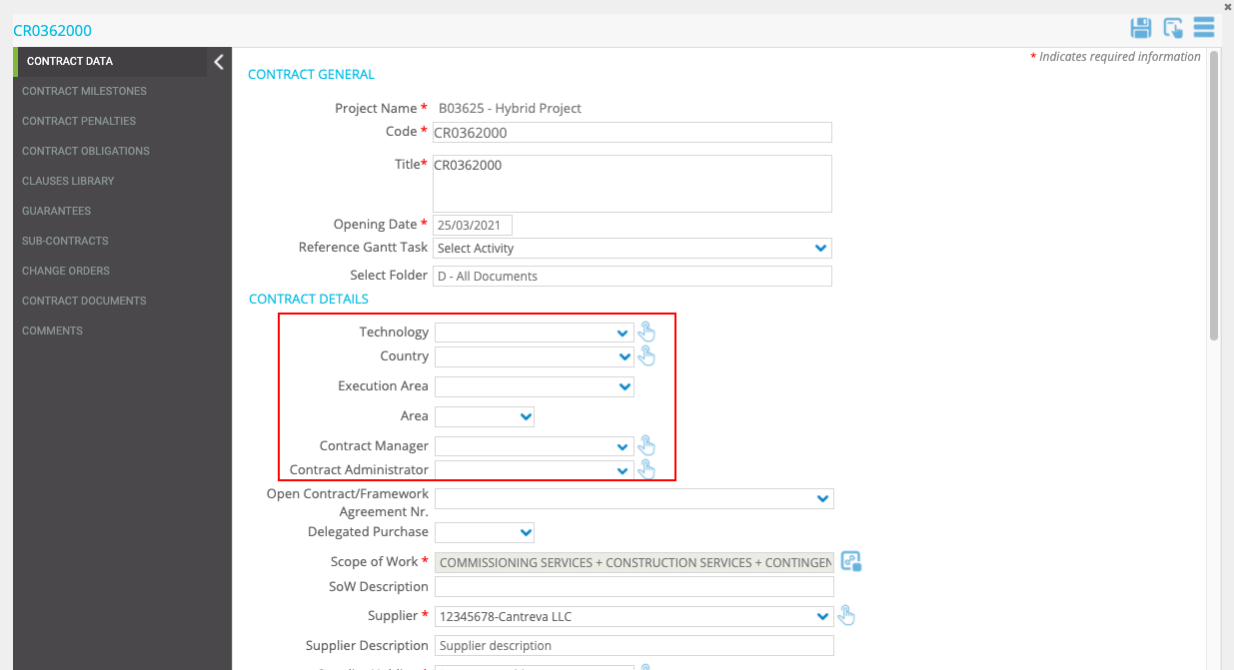

* **General implementation requisite**

These fields must not be editable manually.

# Contract, new button to update fields from omnia(stage Table)

* **Business Requirement**

Create a new button to request on demand the update of the form data from OMNIA(Stage Table)

**Note: Framework Agreement Stage Table should be the same of Contract Stage Table. In OMNIA (Enel Source) Contract and Framework Agreement are the same object (in the code they have different numbering). Therefore, in the same stage table we will have some field related to Contract and others to Framework Agreement)**

* **Implementation logic**

Every time the icon is clicked, the values of some fields of the form are updated.

(for the import use as reference the field “Code”)

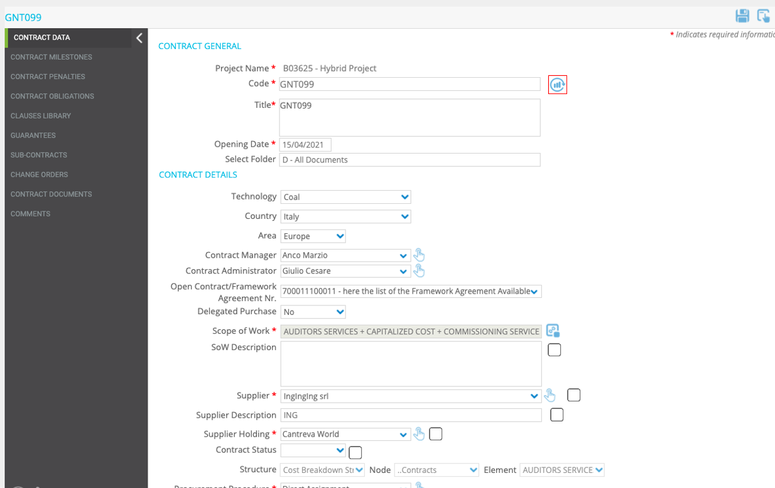Mockup

Below is the list of fields that need to be updated:

* SoW description
* Supplier
* Supplier Description
* Supplier (Holding)
* Contract Status
* Contract signature date
* Total C. O. Amount
* Issued C.O. Amount
* Contract Base Amount
* Currency
* Contract Base Equivalent Amount (€)
* Overall Amount
* Currency
* Contract Overall Equivalent Amount (€)
* Effective Date
* End Date
* Accrued Amount
* SAL Finale
* To Be Accrued
* Invoiced
* Invoiced Difference
* Paid Amount
* To Be Paid
* **General implementation requisite**

Tooltip = “Import”

The fields in the above list should be manually editable

# Contract, flags to ignore omnia (Stage Table) data import

* **Business Requirement**

Have the possibility to update only some fields during data import from OMNIA (Stage Table).

* **Implementation logic**

Is required to have a flag checkbox to the fields imported from OMNIA(Stage Table). Fields with the flag will be ignored during the import (Manual or Scheduled).

The fields that need the checkbox are those listed in point 48 (all fields coming from OMNIA/Stage Table).

* **Operational steps**

1. The user fills in some or all the fields in the form.
2. Flag some fields.
3. Click on the new button to update the data taken from OMNIA(Stage Table).
4. The Fields without Flags are updated with the data from OMNIA(Stage Table).
5. Fields with Flags are not updated with OMNIA(Stage Table) data.

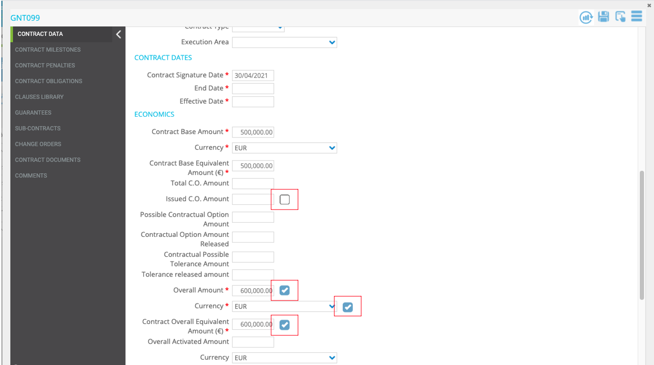Mockup

* **General implementation requisite**

Tooltip= “Ignore from Update”

# Automatic data import from omnia every 24h

* **Implementation logic**

Every 24 hours the fields without the flag selected should be automatically imported from Omnia(Stage Table) without any action by the user (Ignoring the ones flagged).

# Contract form, “Subcontracting Cumulative %” field logic

* **Implementation logic**

The “Subcontracting Cumulative %” field should be calculated as the percentage of the sum of all the “Subcontract Equivalent Amount” (for Subcontract related to this Contract) /“Overall Activated Equivalent Amount”. Subcontract finalized and not finalized.

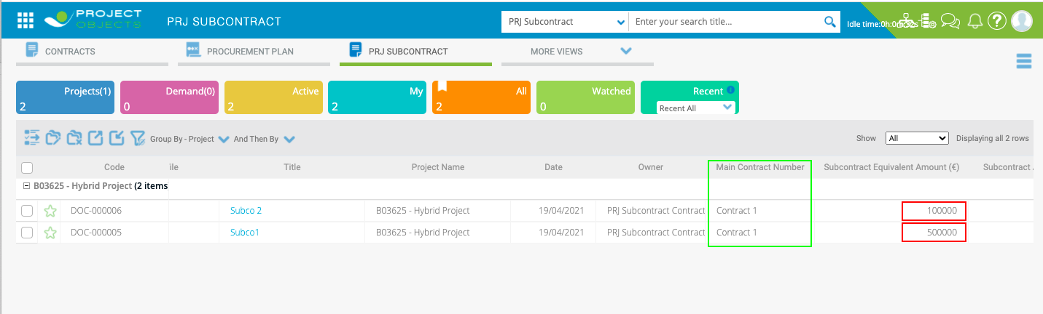“Subcontract Equivalent Amount” values related to the same contract

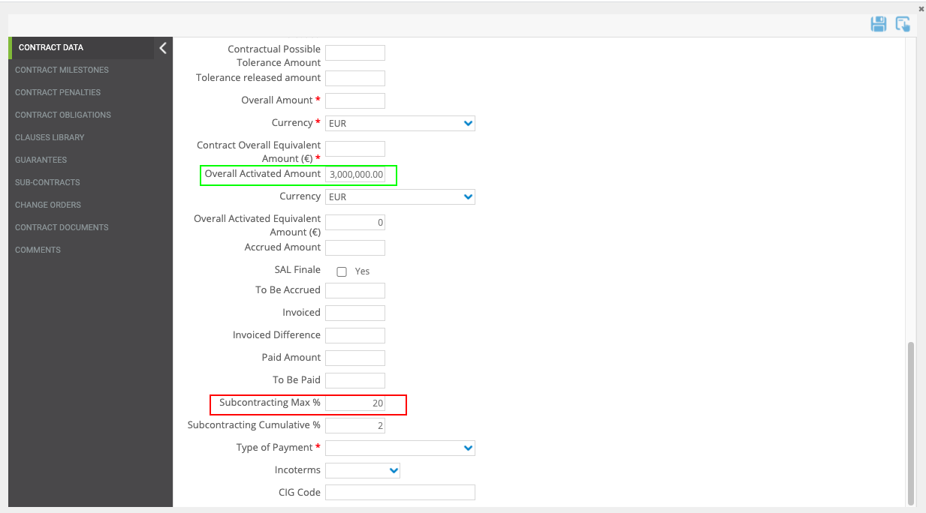

**Example:**

500.000,00= Subcontract Equivalent Amount of Subco 1 related to Contract1

100.000,00= Subcontract Equivalent Amount of Subco 2 related to Contract1

3.000.000,00= Overall Activated Amount of Contract1

[(500.000,00+100.000,00)/3.000.000,00]*100 = 20% Subcontracting Max %

* **General implementation requisite**

The field should not be manually editable

# Call off form, Fields Automatically imported after workflow finalization

* **Business Requirement**

Some fields must be imported from an external source after the workflow has been finalized**.**

* **Implementation logic**

The “Accrued” field and the “SAL Finale / Delivery Completed” field must never be manually editable. After the workflow has been finalized, every 24 hours the system will check in the Stage Table if there is a value associated with these fields(using the field PO Number as Reference), if it is present the system will automatically fill in the fields.

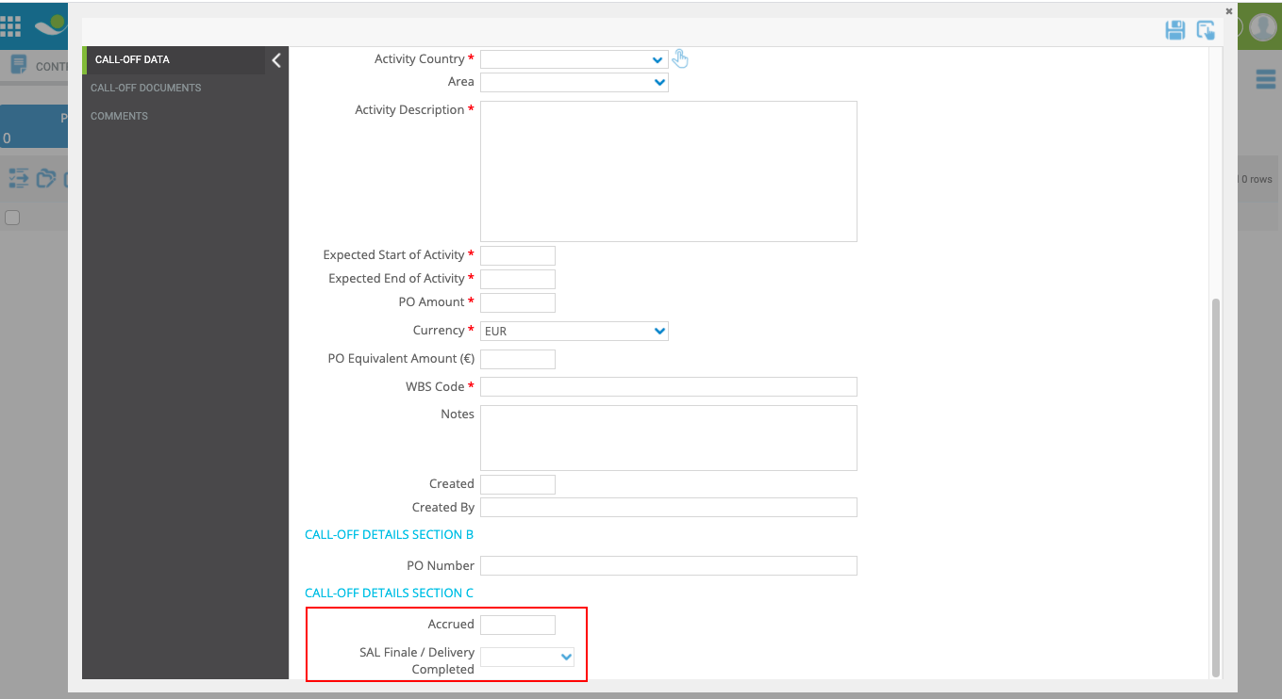

* **General implementation requisite**

Fields must not be manually editable

# Call off form, “Framework agreement n°” field logic

* **Implementation logic**

The Dropdown “Framework Agreement N°” must show the list of Framework Agreements when "**Service**" is selected in the field "Framework Agreement Category".

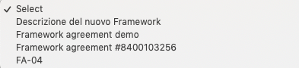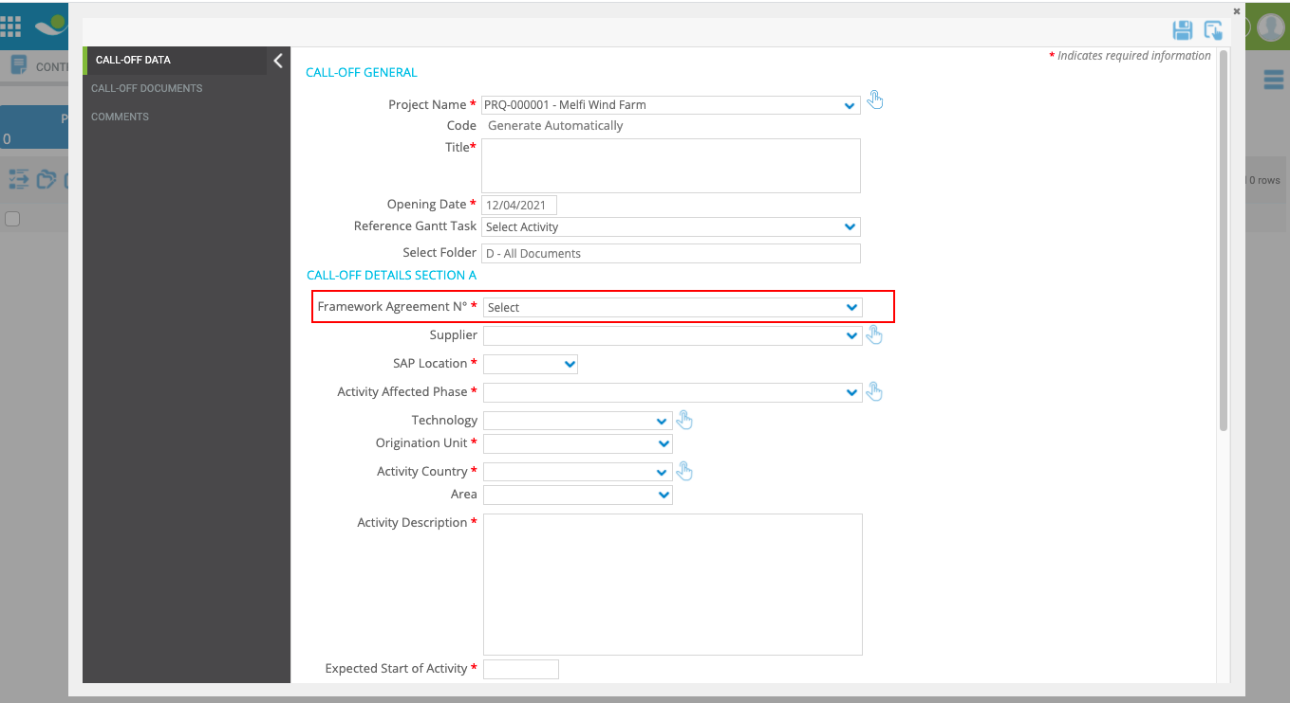

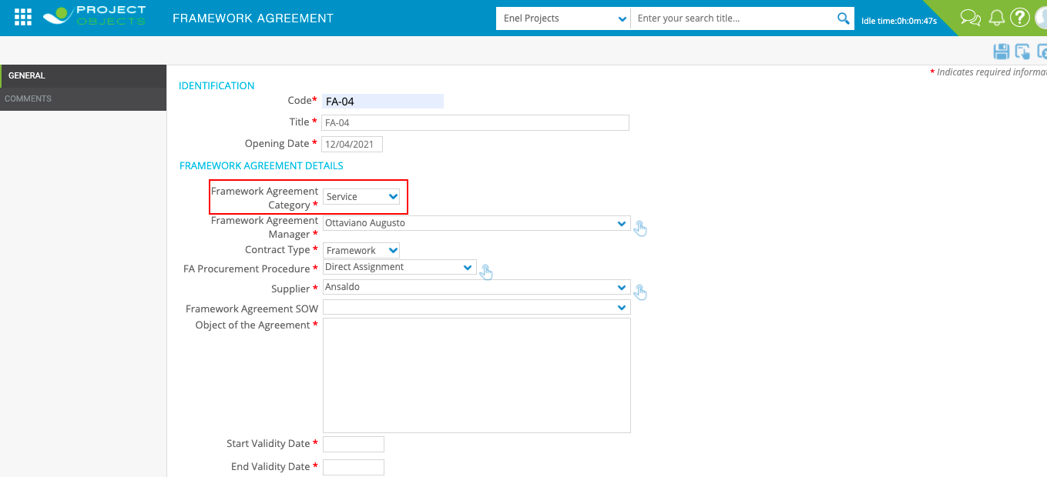

# Call off form, Filling some Fields with FA Details

* **Business Requirement**

Import some fields from the "Framework Agreement" form to the “Call Off” form

* **Implementation logic**

Some fields must be retrieved from the Framework Agreement Form selected in the field "Framework Agreement N°".

The fields that need to be imported are:

* Supplier
* 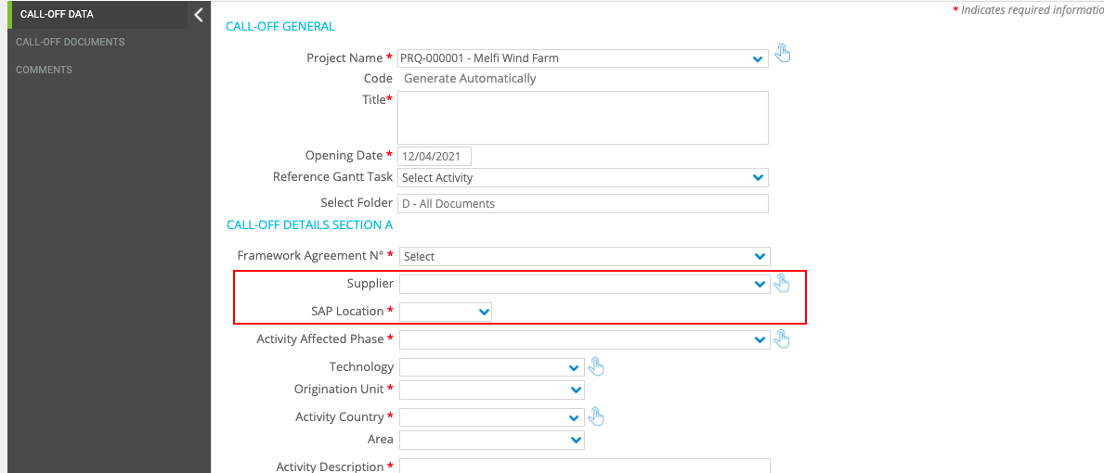SAP Location
* **General implementation requisite**

Fields must not be manually editable

# Call off form, “po amount” field pop up and email notification

* **Business Requirement**

Have a pop-up alert and an Email notification if the “PO Amount” is greater than the “Residual Amount – Call-Off List” for the related Framework Agreement (using the field “Framework Agreement N°” as Reference)

* **Implementation logic**

The release will be possible at Step 1 if the Field "Residual Amount - Call-Off List" in the related FA is = or > than the Field "PO Amount" in the Call-Off form , otherwise send email notification to the next **Step Owners** (Remember the WF is Conditional so Next Steps Owners may be different). **The form cannot be released until the check is "OK**".

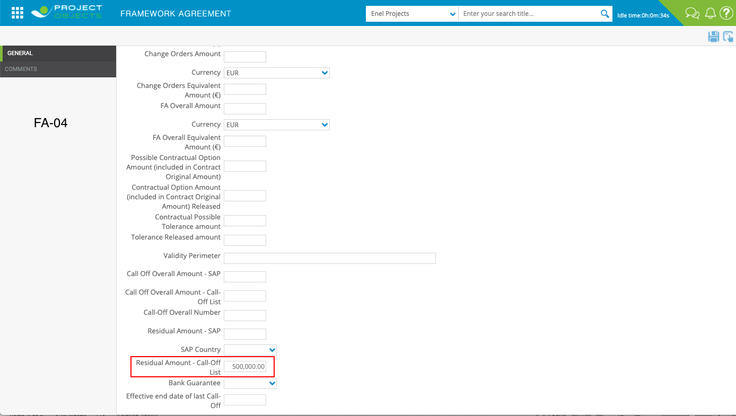Framework Agreement form value

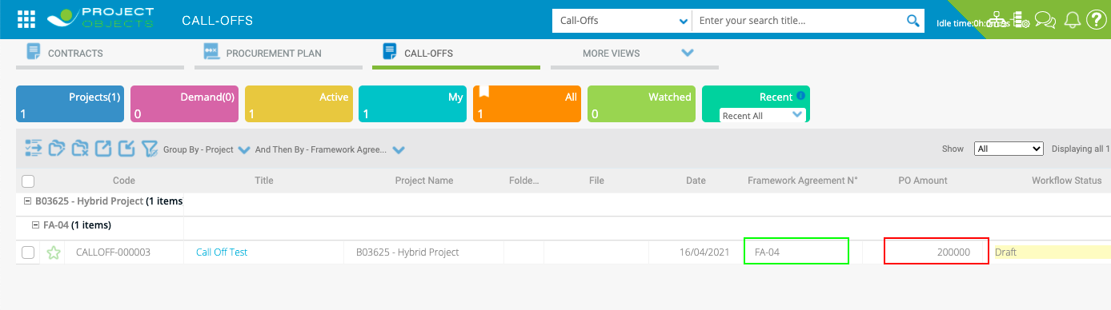



The text of the alert message should be:

The Call Off cannot be released because the “PO Amount” is greater than the “Residual Amount – Call-Off List” for this Framework Agreement.

* **General implementation requisite**

Email text and recipients must be user-configurable

# Call off form, ”Created” field logic

* **Implementation logic**

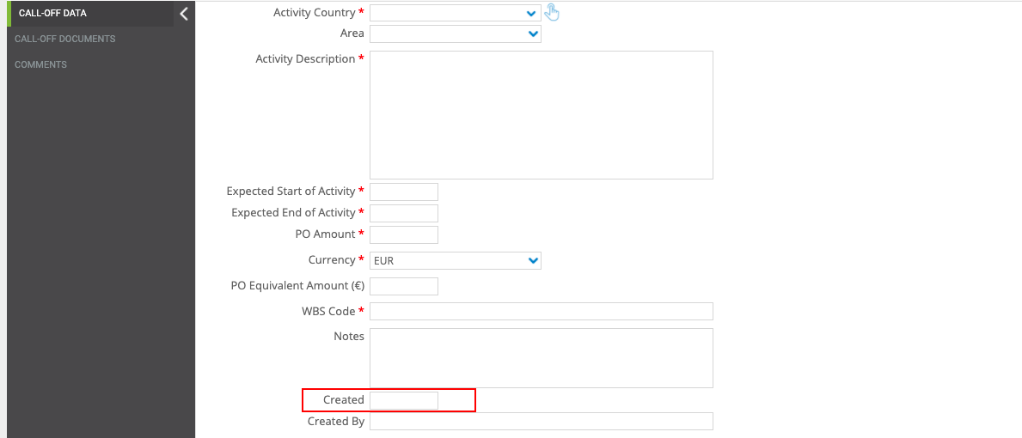The "Created" field must show the creation date of the "Call Off" form.

* **General implementation requisite**

The Field must not be manually editable

# Call off form, “Created by” logic field

* **Implementation logic**

The “Created by” field should show the name of the user who created the “Call Off” form.

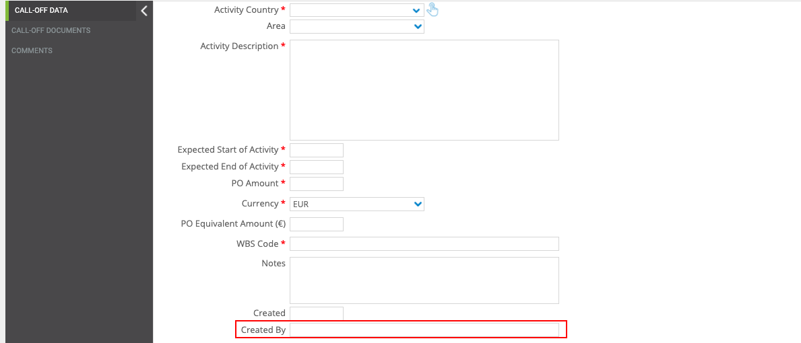

* **General implementation requisite**

The Field must not be manually editable

# PRJ Direct Assignment Form, “Procurement Plan Item” field logic

* **Implementation logic**

“Procurement Plan Item” dropdown should show only Procurement Plans that have the "Procurement Procedure" field equal to "Direct Assignment" related to this project.

**PRJ Direct Assignment Form**

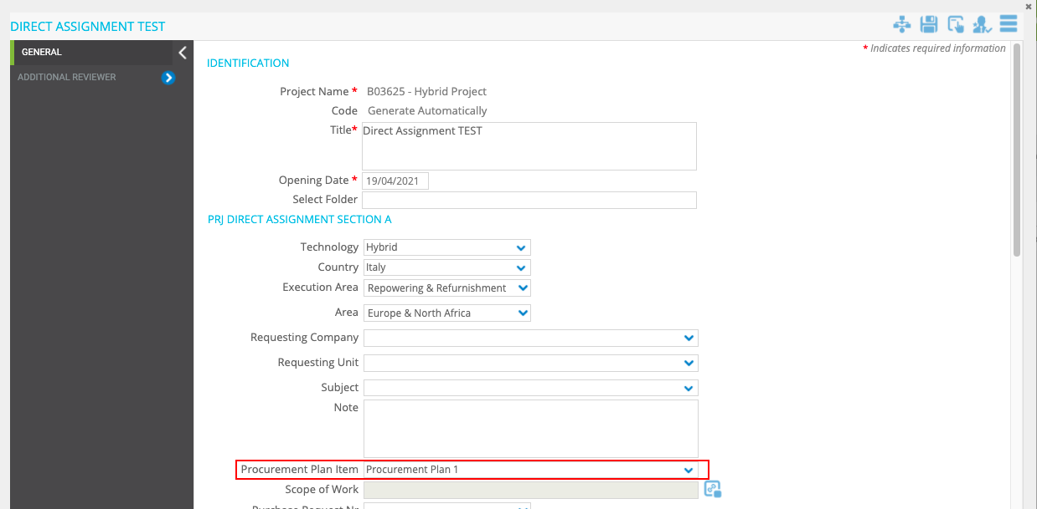

**Procurement Plan form**

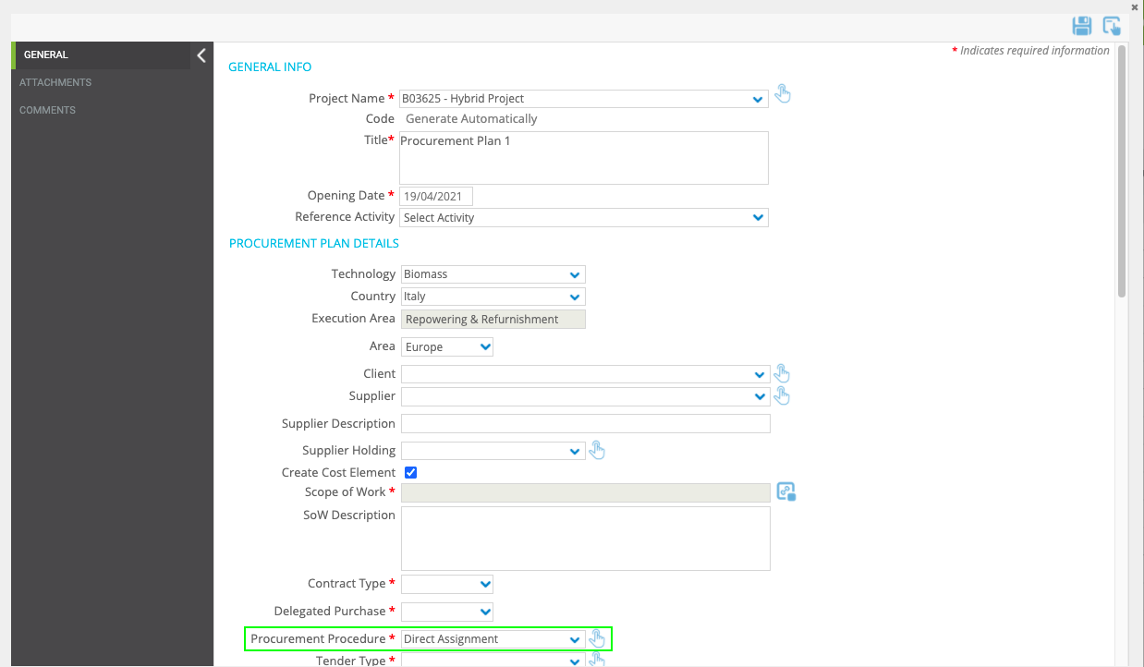

* **General implementation requisite**

This dropdown must have the autosearch feature

**Comments:** OK

# PRJ Direct Assignment form, automatic filling of Procurement plan details fields

* **Business Requirement**

Automatically Fill the project information details in the PRJ Direct Assignment form from Procurement Plan Form.

* **Implementation logic**

The fields described below must receive values from the related Procurement Plan.

* **Operational steps**

Data are automatically filled in when you select the Procurement Plan in the “Procurement Plan Item” dropdown.

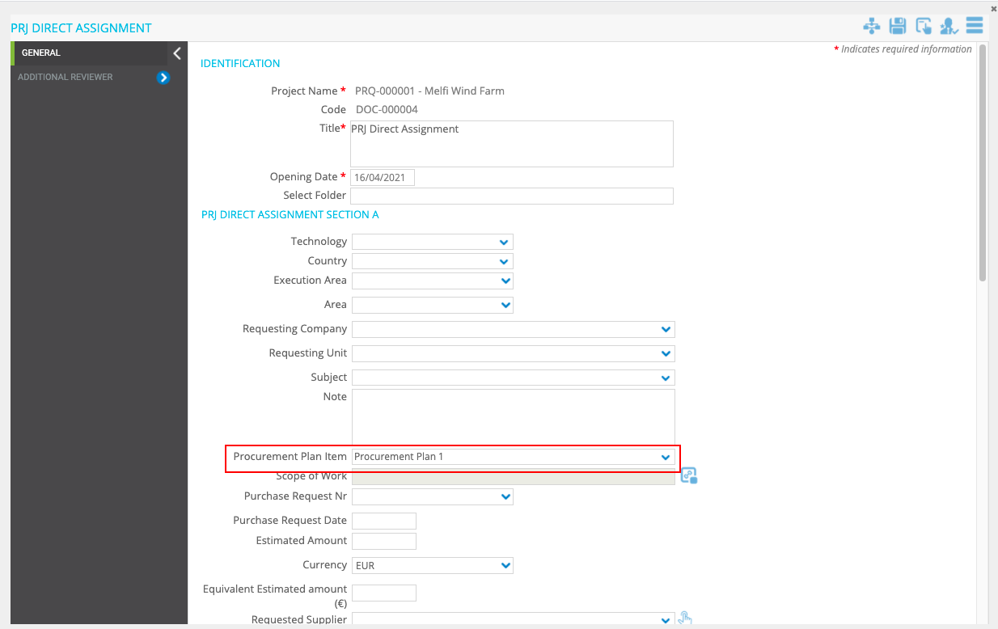

Fields that should be retrieved from Procurement Plan:

* SoW
* Purchase Request Nr
* Purchase Request Date
* Estimated Amount
* Currency
* Equivalent Estimated Amount (€)
* Requested Supplier
* **General implementation requisite**

These fields must not be editable manually.

**Comments:** OK

# Prj direct assignment Form, Automatic Filling of Project Details fields

* **Business Requirement**

Automatically Fill the project information details in the PRJ Direct Assignment Form.

* **Implementation logic**

The fields described below must receive values from the related project.

* **Operational steps**

The project data are automatically filled in when you create a new PRJ Direct Assignment objects.

Fields that should be retrieved from Project:

* Technology
* Country
* Execution Area
* Area

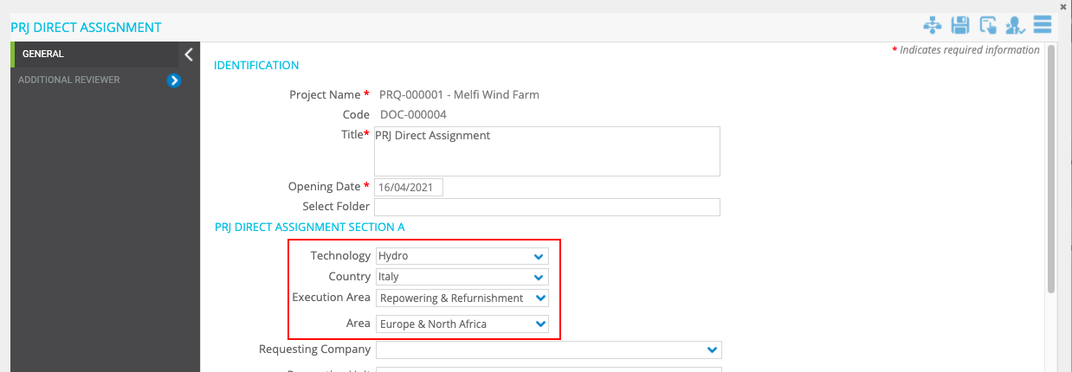

* **General implementation requisite**

The fields should not be manually editable

**Comments:** OK

# Prj direct assignment Form, “Approver” field logic

* **Implementation logic**

The user selected within the Drop Down “Approver” must be the approver of step 2.

The drop down must show only the users that belong to the group "PRJ DA Approver", Owner of step 2.

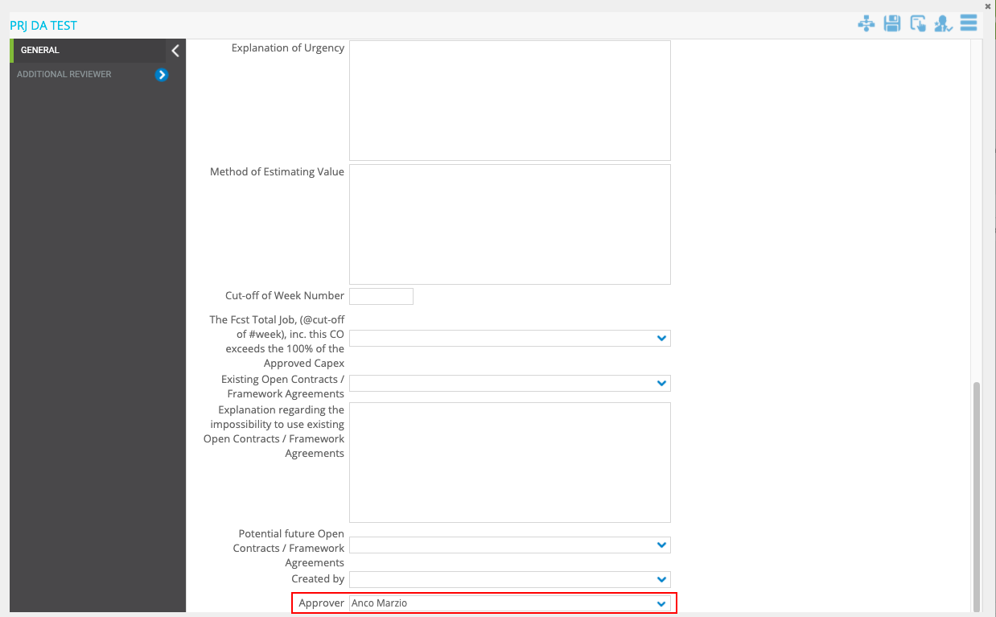

* **General implementation requisite**

Editable only in step1

(As already done for PR- No SAP Countries Point N°32)

**Comments:** OK

# PRJ Direct Assignment Form, “Created by” field logic

* **Implementation logic**

The “Created by” field should show the name of the user who created the “PRJ Direct Assignment” form.

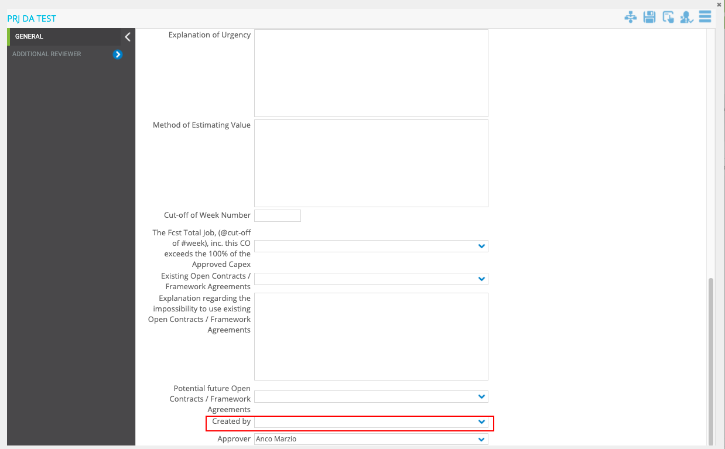

* **General implementation requisite**

The Field must not be manually editable

**Comments:** OK

# PRJ Direct Assignment, “Outcome” field logic

* **Business Requirement**

When the PRJ Direct Assignment is finalized the text inside the "Workflow Status" (Column in the register), must be filled with the value present in the "Outcome" dropdown.

* **Implementation logic**

When the user finalizes the PRJ Direct Assignment, by the release of the object from step 3, if "Approved" is selected in the "Outcome" dropdown, the "Workflow Status" must show "Approved". If "Rejected" is selected in the "Outcome" dropdown, the "Workflow Status" must show the text "Rejected".

* **Operational steps**

The owner of step2 selects “Approved” or “Rejected” in the “Outcome” dropdown.

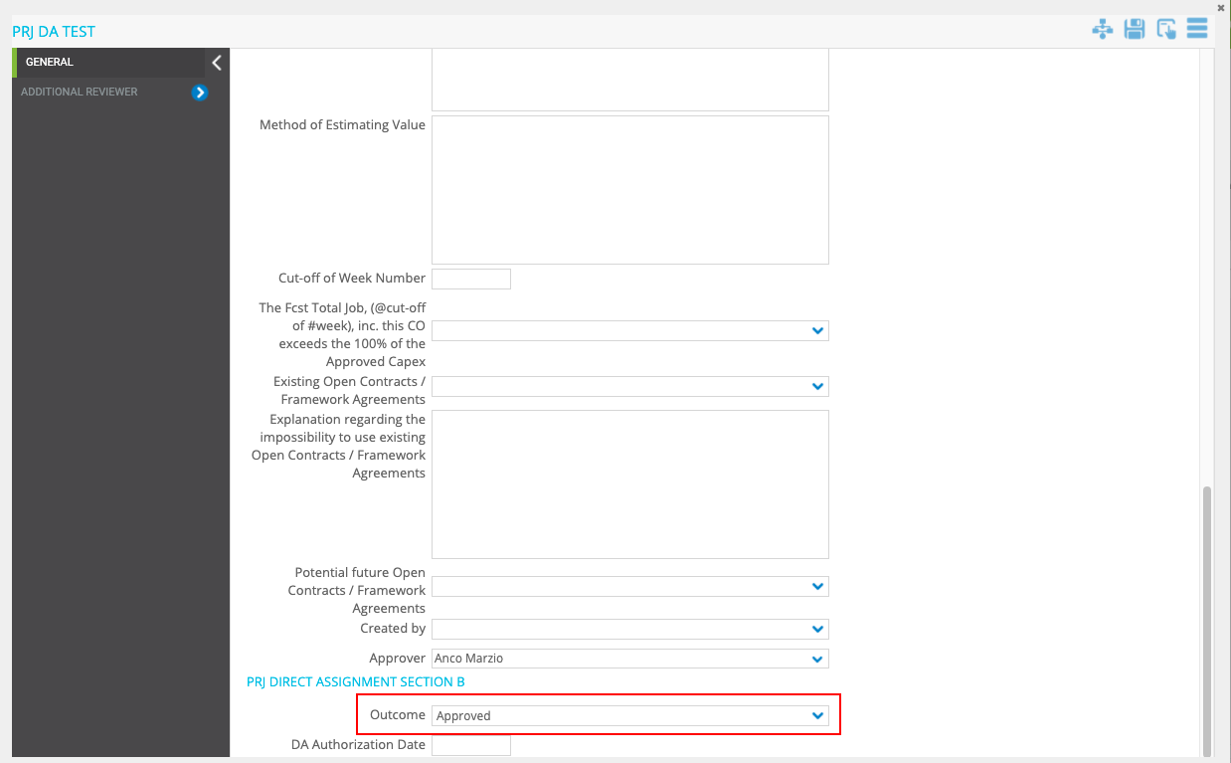

User finalises the PRJ Direct Assignment, by the release of the object from step 3.

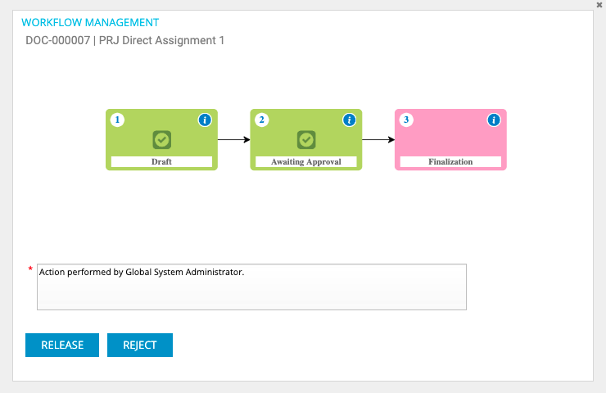

The “Workflow Status” should show the value selected in the ”Outcome” field

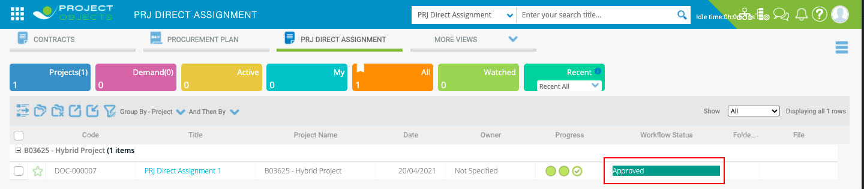

**Comments:** OK

# PRJ Direct Assignment, “DA Authorization Date” field logic

* **Implementation logic**

The field “DA Authorization Date” should automatically show the date of the Release from step2.

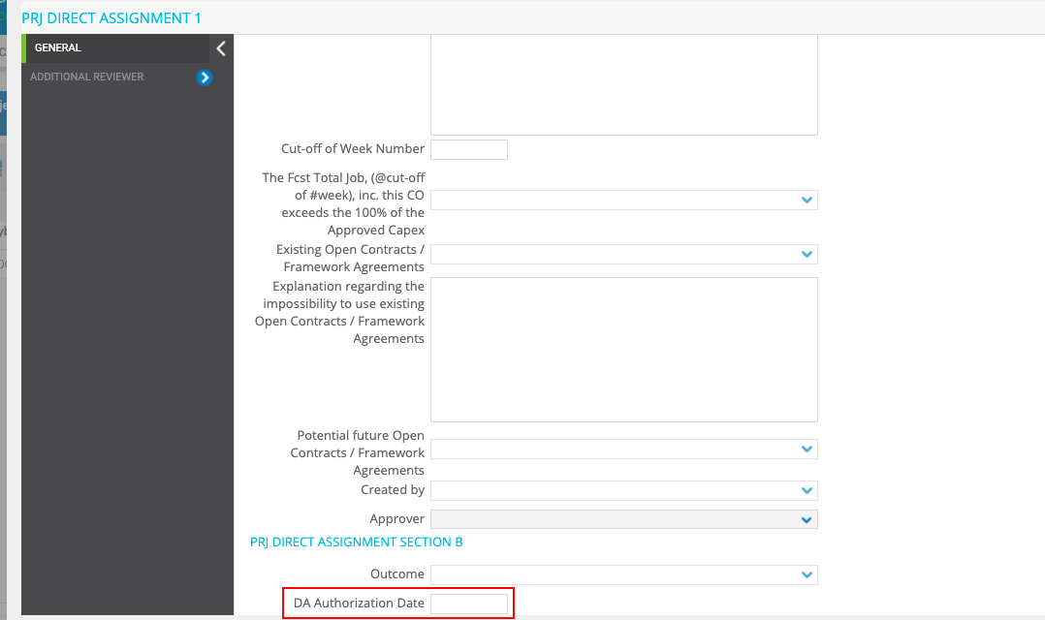

**Comments:** OK

# PRJ Direct Assignment, “Review” UC

* **Business Requirement**

The reviewer must be able to write the review in a pop-up window.

The user should have the possibility to write the review while looking at the form at the same time.

**Comments:** OK (Need to define approach for review and comments)

# FWA Direct Assignment form, automatic fields filling from Omnia (Stage Table)

* **Business Requirement**

Automatically Fill some fields in the FA Direct Assignment form from Omnia (Stage Table).

* **Implementation logic**

Data are automatically filled in when you insert the purchase request number in the “Purchase Request N°” text box. (The same User Control developed for the Procurement Plan and the same Stage Table)

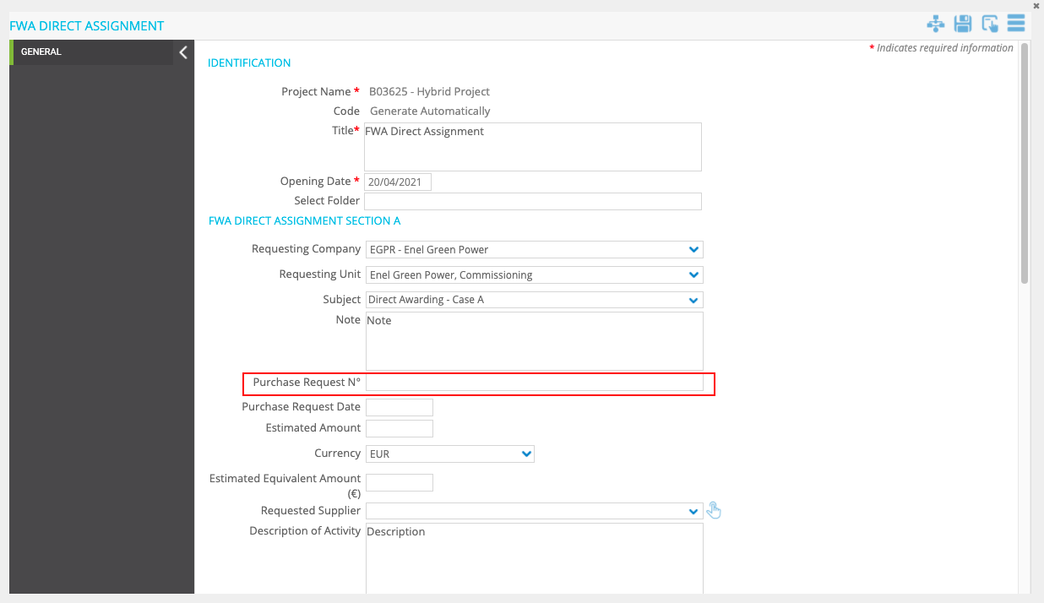

Fields that should be retrieved from Omnia (Stage Table):

* Purchase Request Date
* Estimated Amount
* Currency
* Equivalent Estimated Amount (€)
* Requested Supplier
* **General implementation requisite**

These fields must be manually editable.

**Comments:** OK

# FWA direct assignment Form, “Approver” field logic

* **Implementation logic**

The user selected within the Drop Down “Approver” must be the approver of step3.

The drop down must show only the users that belong to the group "FWA DA Approver", Owner of step 3.

(As already done for PR- No SAP Countries Point N°32)

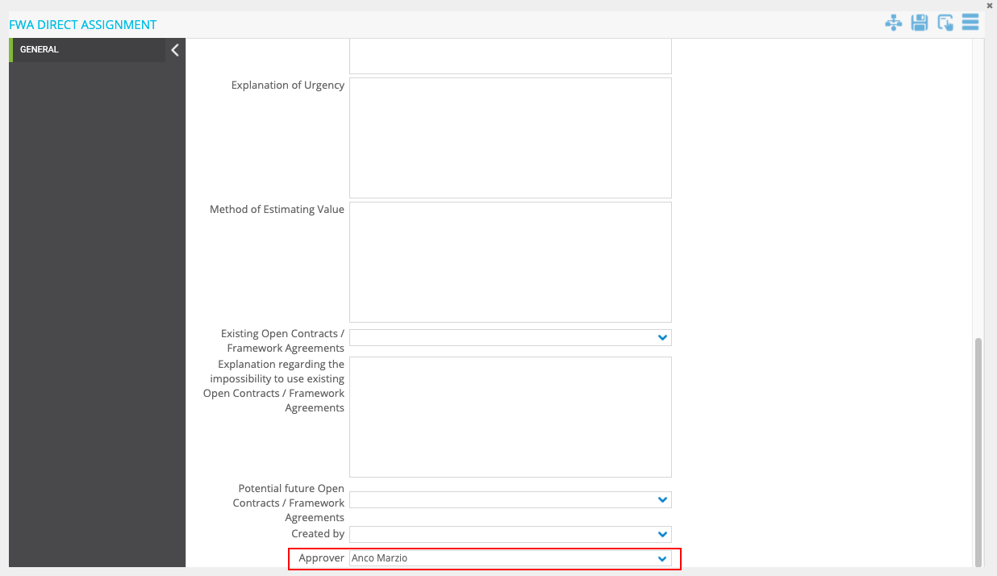

* **General implementation requisite**

Editable only in step1

Dropdown with Autosearch function

# FWA Direct Assignment Form, “Created by” field logic

* **Implementation logic**

The “Created by” field should show the name of the user who created the “FWA Direct Assignment” form.

* **General implementation requisite**

The Field must not be manually editable

# FWA Direct Assignment, “Outcome” field logic

* **Business Requirement**

When the FWA Direct Assignment is finalized the text inside the "Workflow Status" (Column in the register), must be filled with the value present in the "Outcome" dropdown.

* **Implementation logic**

When the user finalizes the FWA Direct Assignment, by the release of the object from step 4, if "Approved" is selected in the "Outcome" dropdown, the "Workflow Status" must show "Approved". If "Rejected" is selected in the "Outcome" dropdown, the "Workflow Status" must show the text "Rejected".

* **Operational steps**

The owner of step3 selects “Approved” or “Rejected” in the “Outcome” dropdown.

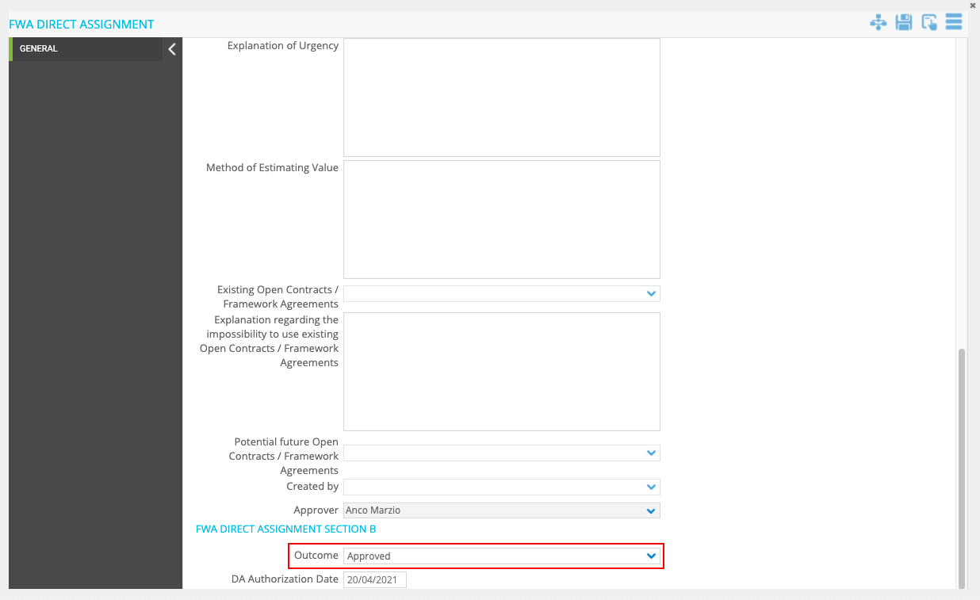

User finalises the FWA Direct Assignment, by the release of the object from step 4.

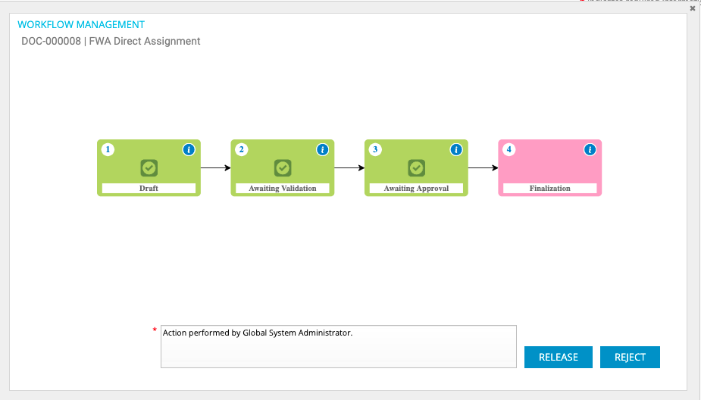

The “Workflow Status” should show the value selected in the ”Outcome” field

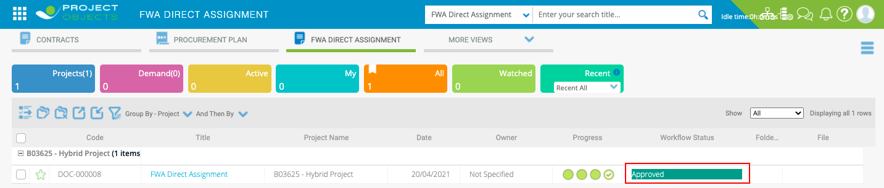

# FWA Direct Assignment, “DA Authorization Date” field logic

* **Implementation logic**

The field “DA Authorization Date” should automatically show the date of the Release from step3.

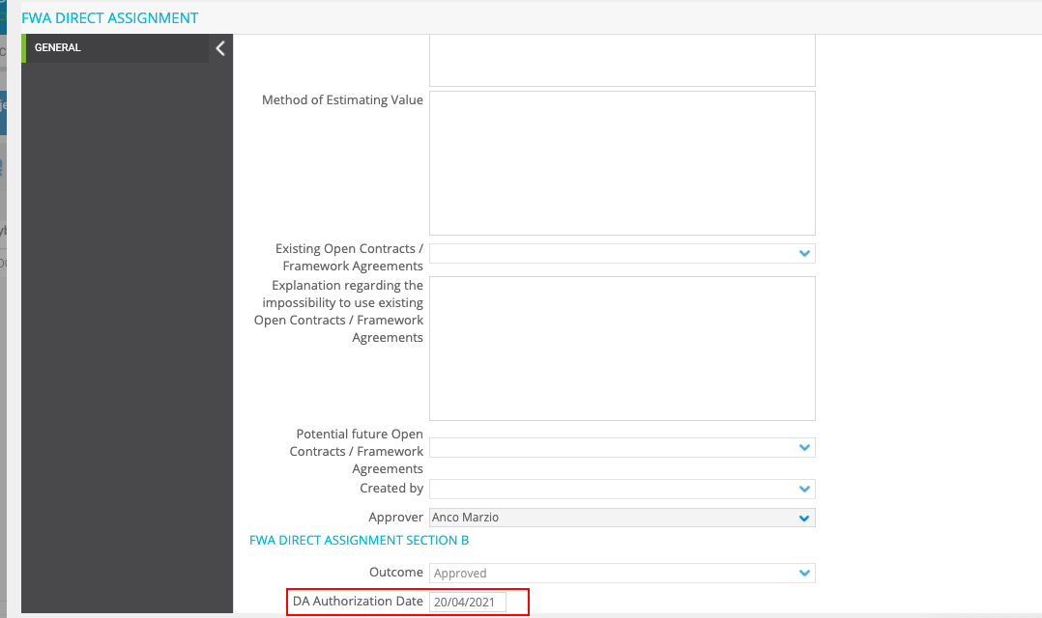

# PRJ Subcontract, Automatic Filling of Project Details fields

* **Business Requirement**

Automatically Fill the project information details in the PRJ Subcontract form.

* **Implementation logic**

The fields described below must receive values from the related project.

* **Operational steps**

The project data are automatically filled in when you create a new PRJ Subcontract objects.

Fields that should be retrieved from Project:

* Technology
* Country
* Execution Area
* Area
* Contract Manager

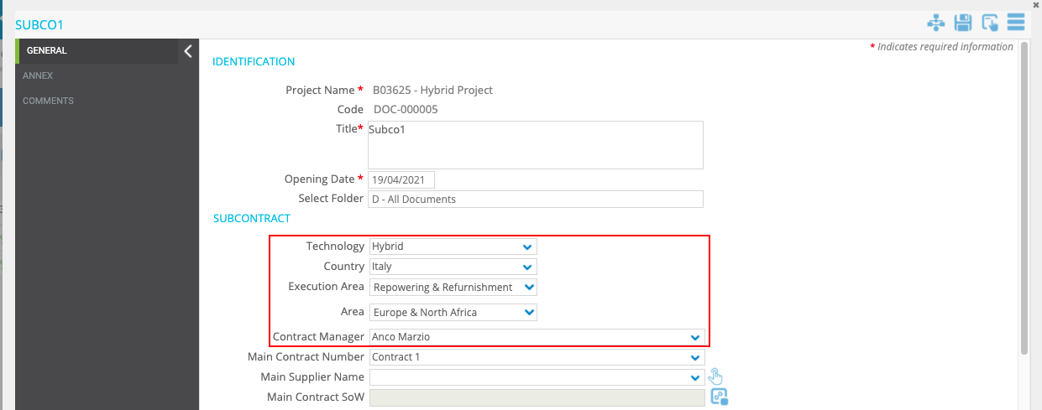

* **General implementation requisite**

These fields must not be editable manually.

# PRJ Subcontract, “main contract number” field logic

* **Implementation logic**

The “Main Contract Number.” field should show the list of “Contract” in PO related to the Main Project.

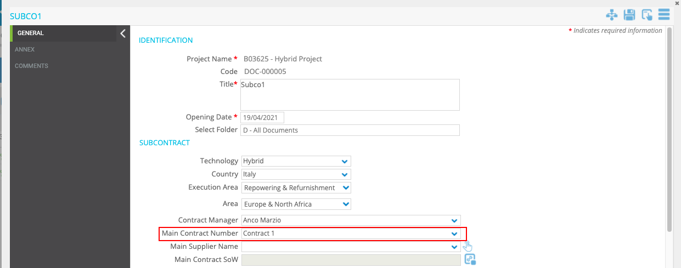

* **General implementation requisite**

Dropdown with search function

# PRJ Subcontract, automatic filling of main Contract details

* **Business Requirement**

Automatically Fill the Contract details in the “PRJ Subcontract” form.

* **Implementation logic**

The fields listed below must receive the value from the related fields within the main Contract (By using for reference the Contract Selected in the “Main Contract Number” dropdown

* **Operational steps**

When a Contract is selected within the “Main Contract Number” dropdown the following fields must be filled in automatically.

Fields that should be retrieved from main contract:

|  |  |
| --- | --- |
| **Fields in Contract form (source) →** | **Fields in Subcontract form** |
| Supplier | Main Supplier Name |
| Scope of Work | Main Contract SoW |
| Overall Amount | Main Contract Overall Amount |
| Currency | Currency |
| Contract Overall Equivalent Amount (€) | Main Contract Overall Equivalent Amount (€) |

# PRJ Subcontract, “Subcontract ID” field logic

* **Implementation logic**
* The “Code” field must be renamed to “Subcontract ID”.
* The numbering of the Subcontract ID should be as follows:

Subcontract ID = [Main contract number] – SUB – [progressive number]

Example

Contract1-SUB-001

Subcontract ID ID

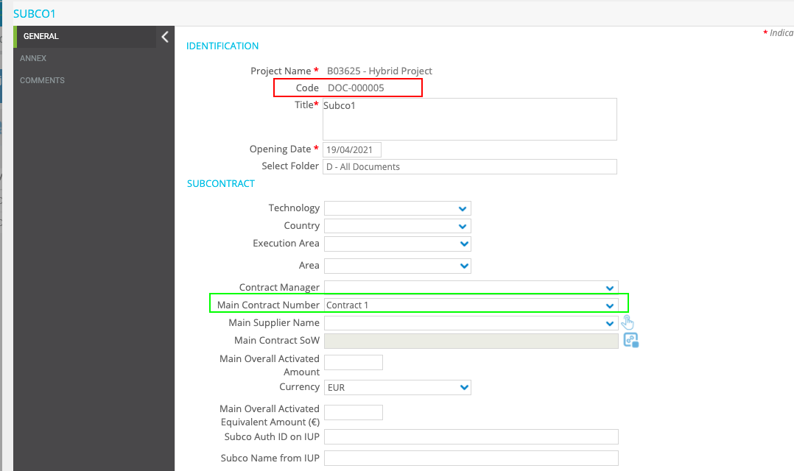

* **General implementation requisite**

The “Subcontract ID” should appear after the first save/apply.

# PRJ Subcontract, “Subcontract % vs Overall Activated amount” field logic

* **Implementation logic**

The “Subcontract % VS Overall Activated Main Contract Amount” field should be calculated as:

(Subcontract Equivalent Amount (€) / Overall Activated Equivalent Amount (€)"from Main Contract") * 100

* “Subcontract Equivalent Amount (€)” is in Subcontract form
* “Overall Activated Equivalent Amount (€)” is in Contract form (refer to the field “Main Contract Number).

Field in Subcontract form

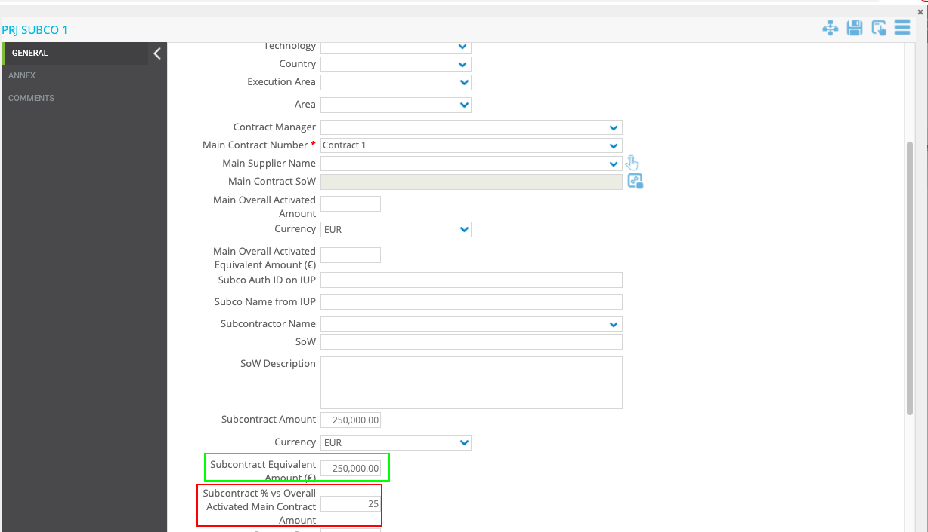

Field in Contract form

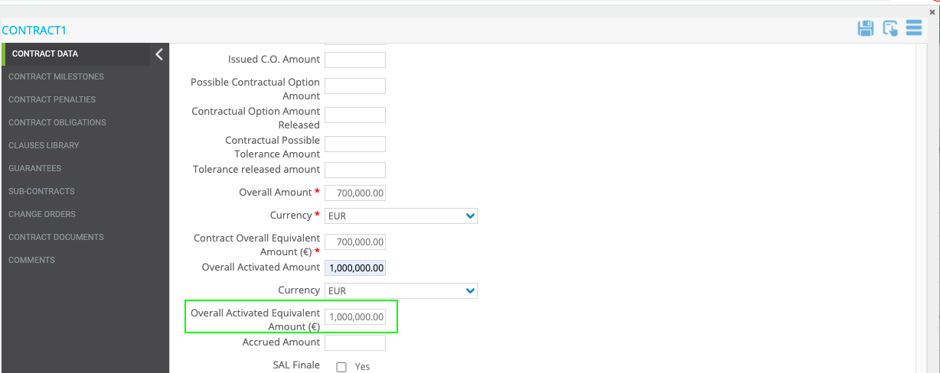

**Example:**

250.000,00= Subcontract Equivalent Amount (€)

1.000.000,00= Overall Activated Equivalent Amount (€)

(250.000,00/1.000.000,00)*100= 25%

* **General implementation requisite**

The field should be manually editable

# PRJ Subcontract, “closure date” field logic

* **Implementation logic**

The “Closure Date” field should show the finalization date of the PRJ Subcontract WF.

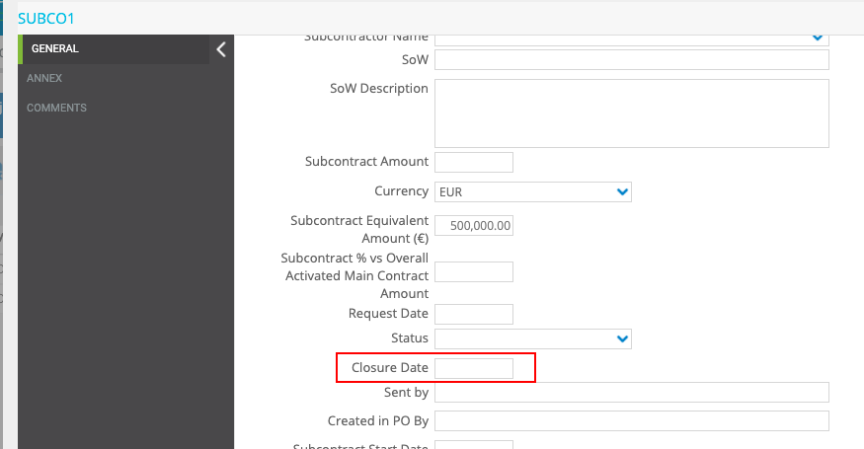

* **General implementation requisite**

This field should appear after the last release (finalization of the PRJ Subcontract).

# PRJ Subcontract, “Created in PO By” field logic

* **Implementation logic**

“Created in PO By” field should show the full name of the User who created the form.

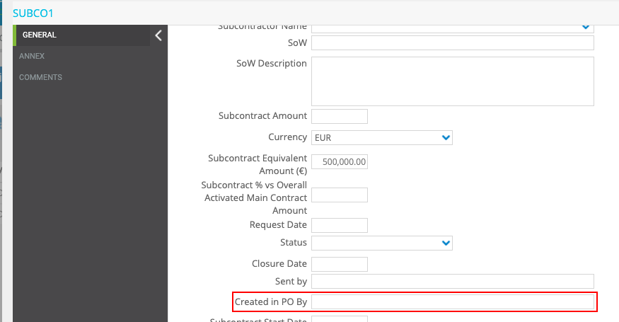

* **General implementation requisite**

The field should not be manually editable

# PRJ Subcontract, “Subcontract End Date” field logic

* **Implementation logic**

The field must show the "End Date" of the main contract (refer to "Main Contract Number" Dropdown)

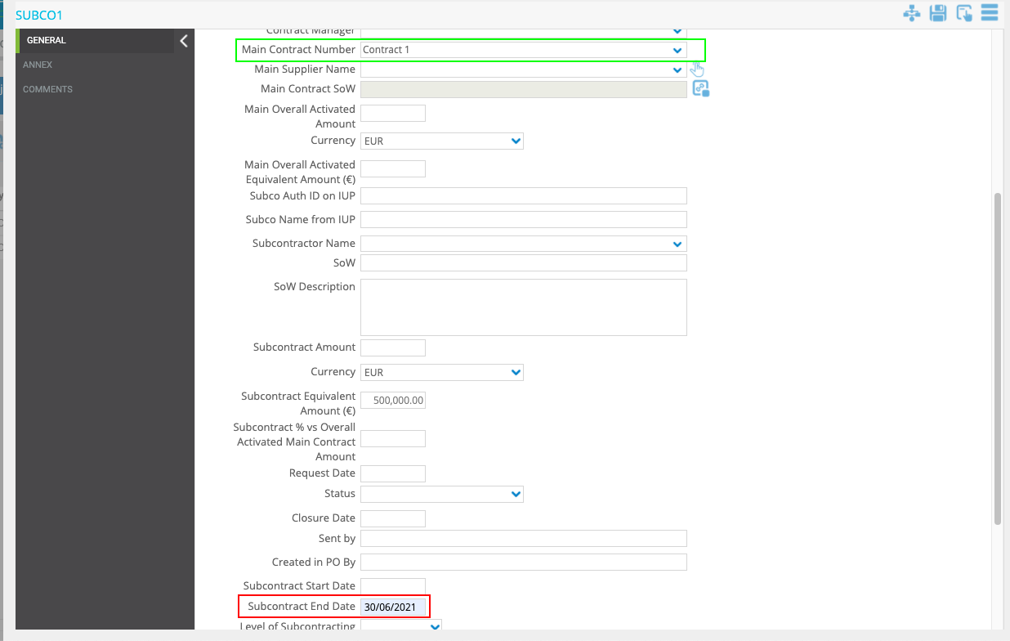

Field from Contract

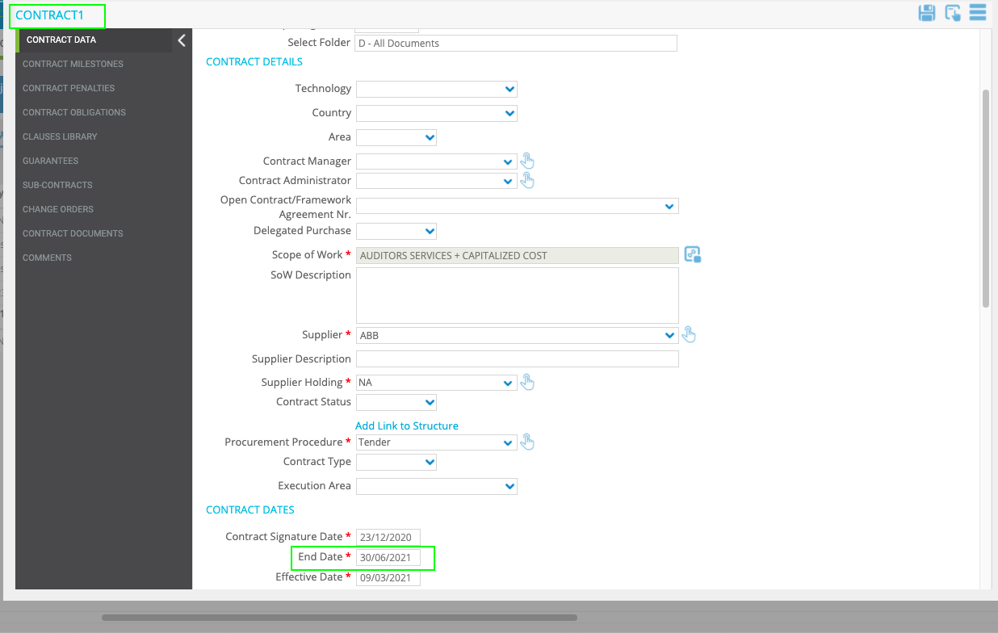

* **General implementation requisite**

The field should not be manually editable

# PRJ Subcontract, “Response for Supplier” field logic

* **Business Requirement**

Have the possibility to save and view the history of responses

* **Implementation logic**

Each time you click on "Apply" or "Save" the text inside the field must be saved in the history box.

Clicking the button next to the "Response for Supplier" field a pop-up will be open. Within the pop-up it will be possible to see the response history.

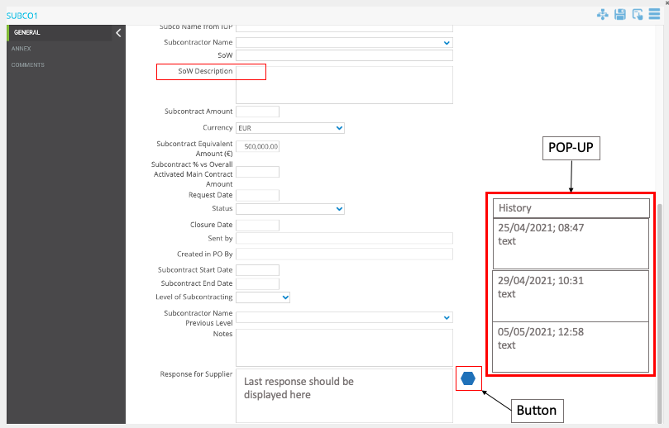

* **General implementation requisite**

The last response must be displayed in the box.

# PRJ Subcontract, “Review” UC

* **Business Requirement**

1. Within the user control "Review" there must be the possibility to make more than one review for each Reviewer.

1. The reviewer must be able to write the review in a pop-up window.

The user should have the possibility to write the review while looking at the form at the same time.

# FWA Subcontract, “FWA Number” field logic

* **Implementation logic**

The “FWA Number.” field should show the list of Framework Agreement in PO.

* **General implementation requisite**

Dropdown with search function

# FWA Subcontract, automatic filling of Framework Agreement details

* **Business Requirement**

Automatically Fill the Framework Agreement details in the “FWA Subcontract” form.

* **Implementation logic**

The fields listed below must receive the value from the related fields within the Framework Agreement (By using for reference the Framework Agreement selected in the “FWA Number” dropdown

* **Operational steps**

When a Framework Agreement is selected within the “FWA Number” dropdown the following fields must be filled in automatically.

Fields that should be retrieved from Framework Agreement:

|  |  |
| --- | --- |
| **Fields in Framework Agreement form (Source)→** | **Fields in FWA Subcontract form** |
| Validity Perimeter | Validity Perimeter |
| Technology | Technology |
| Supplier | Supplier |
| Framework Agreement SOW | FA Scope of work |
| FA Overall Amount | FA Overall Amount |
| Currency | Currency |
| FA Overall Equivalent Amount (€) | FA Overall Equivalent Amount (€) |

# FWA Subcontract, “Subcontract ID” field logic

* **Implementation logic**
* The “Code” field must be renamed to “Subcontract ID”.
* The numbering of the Subcontract ID should be as follows:

Subcontract ID = [Framework Agreement Number (code)] – SUB – [progressive number]

Example

342463 – FA04 -SUB-001

Subcontract ID

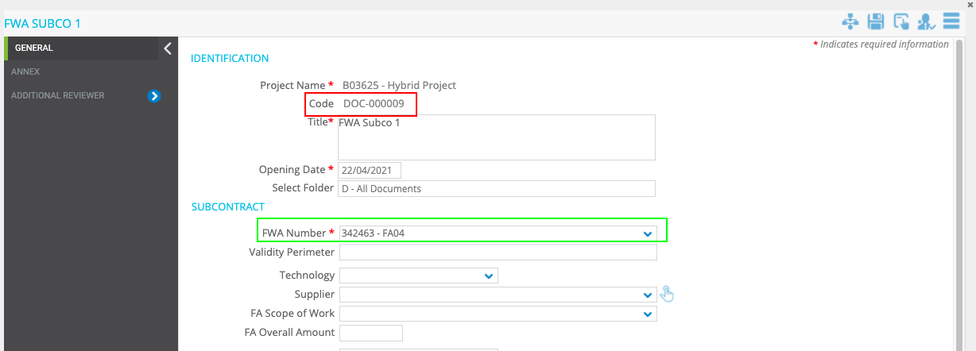

* **General implementation requisite**

The “Subcontract ID” should appear after the first save/apply.

# FWA Subcontract, “Subcontract % vs Overall Activated amount” field logic

* **Implementation logic**

The “Subcontract % VS Overall Activated Amount” field should be calculated as:

(Subcontract Equivalent Amount (€) / FA Overall Equivalent Amount (€) "from Framework Agreement") * 100

* “Subcontract Equivalent Amount (€)” is in FWA Subcontract form
* “FA Overall Equivalent Amount (€)” is in Framework Agreement form (refer to the field “FWA Number).

Field in FWA Subcontract form

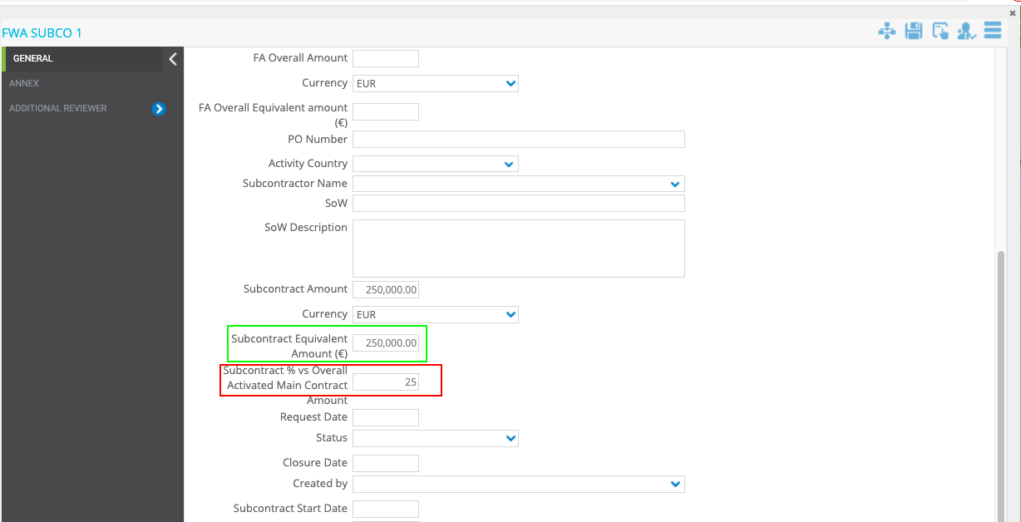

Field in Framework Agreement form

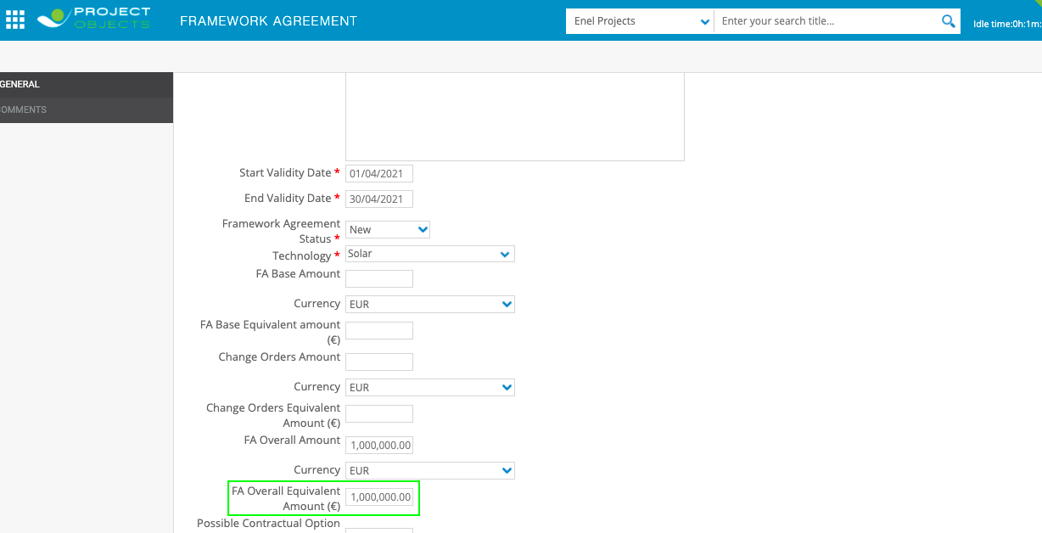

**Example:**

250.000,00= Subcontract Equivalent Amount (€)

1.000.000,00= FA Overall Equivalent Amount (€)

(250.000,00/1.000.000,00)*100= 25%

* **General implementation requisite**

The field should be manually editable

# FWA Subcontract, “closure date” field logic

* **Implementation logic**

The “Closure Date” field should show the finalization date of the FWA Subcontract WF.

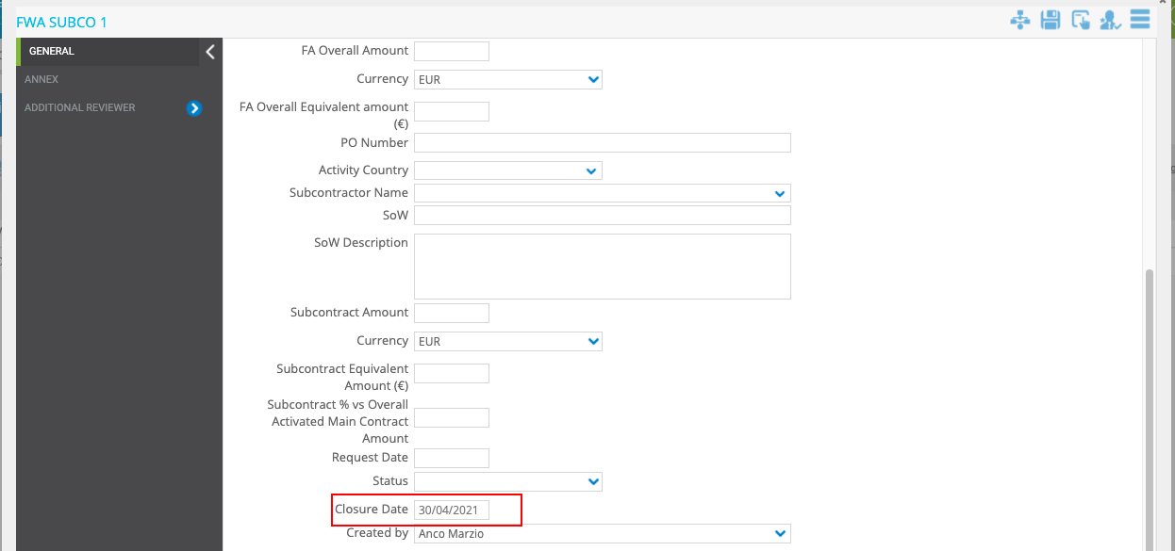

* **General implementation requisite**

This field should appear after the last release (finalization of the FWA Subcontract).

# FWa Subcontract, “Created in PO By” field logic

* **Implementation logic**

“Created in PO By” field should show the full name of the User who created the form.

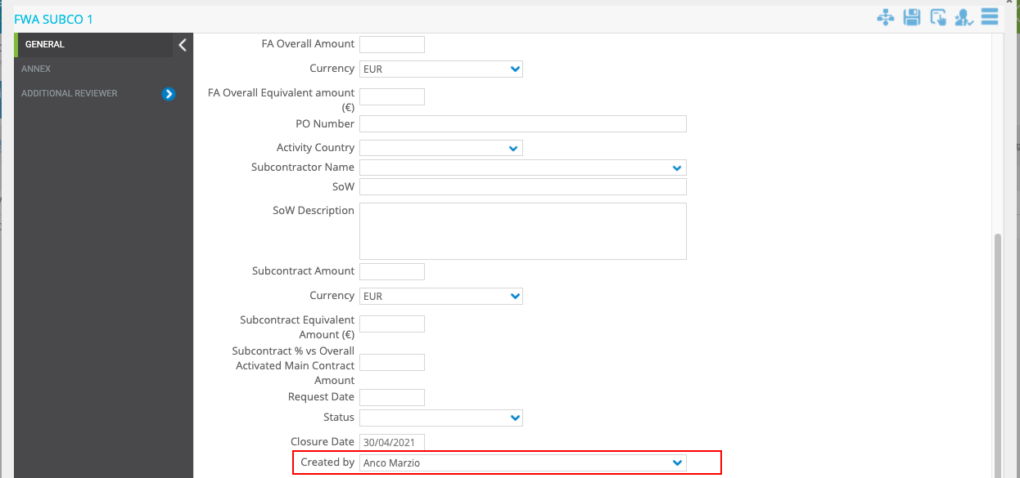

* **General implementation requisite**

The field should not be manually editable

# FWA Subcontract, “Subcontract End Date” field logic

* **Implementation logic**

The field must show the "Validity End Date" of the main contract (refer to "FWA Number" Dropdown)

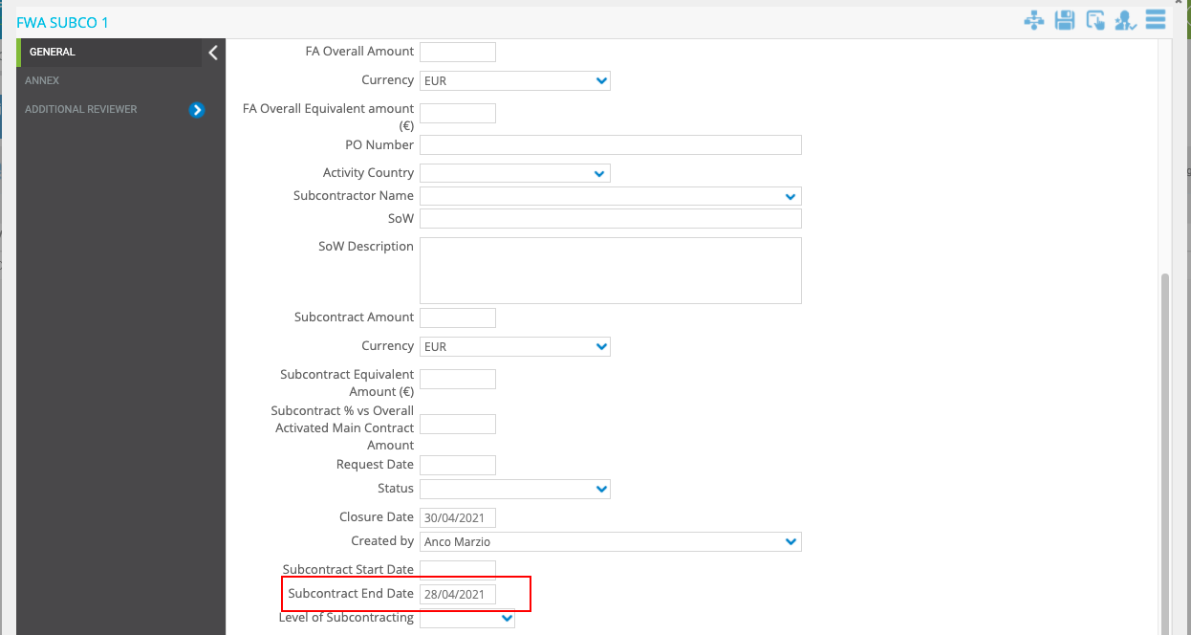

Field from Contract

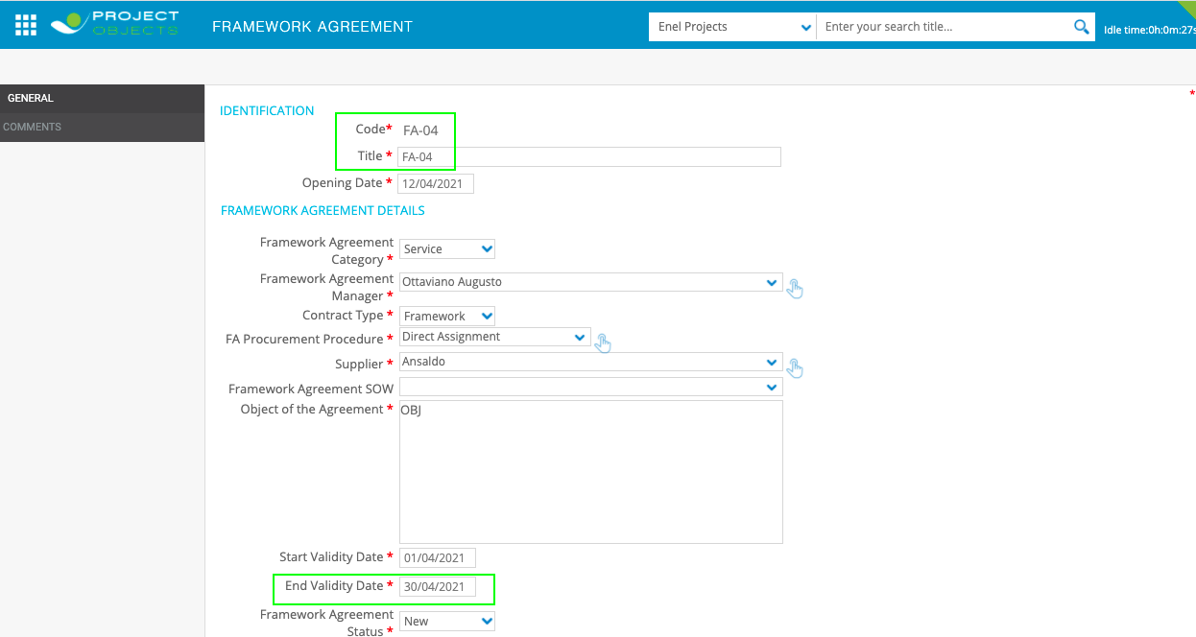

* **General implementation requisite**

The field should not be manually editable

# FWA Subcontract, “Review” UC

* **Business Requirement**

1. Within the user control "Review" there must be the possibility to make more than one review for each Reviewer.

1. The reviewer must be able to write the review in a pop-up window.

The user should have the possibility to write the review while looking at the form at the same time.

# PRJ C.O., Automatic Filling of Project Details fields

* **Business Requirement**

Automatically Fill the project information details in the PRJ Change Order form.

* **Implementation logic**

The fields described below must receive values from the related project.

* **Operational steps**

The project data are automatically filled in when you create a new PRJ Change Order objects.

Fields that should be retrieved from Project:

* Technology
* Country

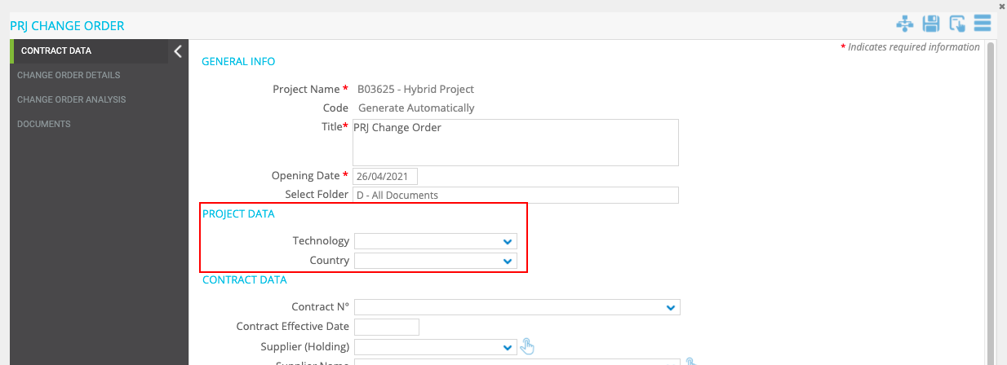

* **General implementation requisite**

These fields must not be editable manually.

# PRJ C.O., “contract N°” field logic

* **Implementation logic**

The “Contract N°” field should show the list of “Contract” in PO related to the Project.

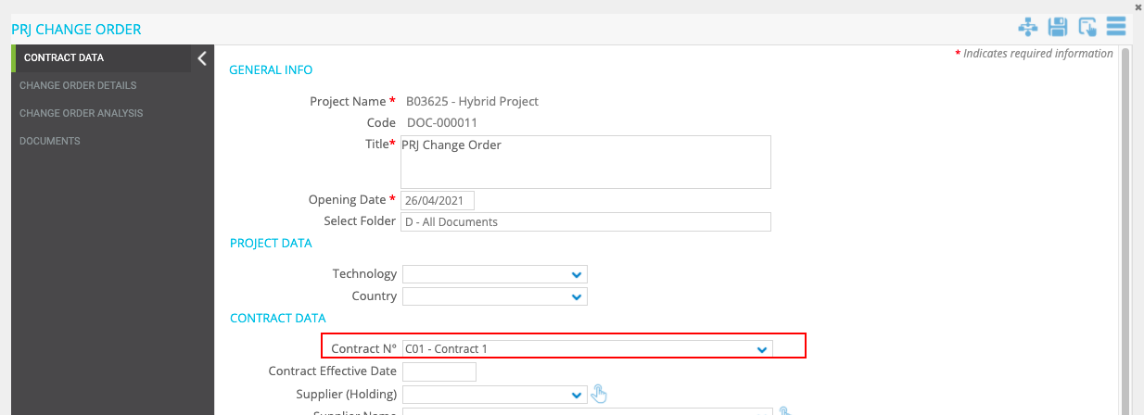

* **General implementation requisite**

Dropdown with search function

# PRJ C.O., automatic filling of Contract details

* **Business Requirement**

Automatically Fill the Contract details in the “PRJ Change Order” form.

* **Implementation logic**

The fields listed below must receive the value from the related fields within the main Contract (By using for reference the Contract Selected in the “Contract N°” dropdown)

* **Operational steps**

When a Contract is selected within the “Contract N°” dropdown the following fields must be filled in automatically.

Fields that should be retrieved from main contract:

|  |  |
| --- | --- |
| **Contract fields (Source) →** | **Change Order fields2** |
| Contract Effective Date | Contract Effective Date |
| Supplier (Holding) | Supplier (Holding) |
| Supplier Name | Supplier Name |
| SoW | SoW |
| Contract Base Amount | Contract Base Amount |
| Currency | Currency |
| Contract Base Equivalent Amount (€) | Equivalent Amount (€) |
| Possible Tolerance | Possible Tolerance |
| Currency | Currency |
| Equivalent Amount (€) | Equivalent Amount (€) |
| Activated Tolerance | Activated Tolerance |
| Currency | Currency |
| Equivalent Amount (€) | Equivalent Amount (€) |
| Possible contract options existing in the contract | Possible contract options existing in the contract |
| Currency | Currency |
| Equivalent Amount (€) | Equivalent Amount (€) |
| Activated Contract Options | Activated Contract Options |
| Currency | Currency |
| Equivalent Amount (€) | Equivalent Amount (€) |
| Total Amount of C.O. already approved | Total Amount of C.O. already approved |
| Currency | Currency |
| Equivalent Amount (€) | Equivalent Amount (€) |

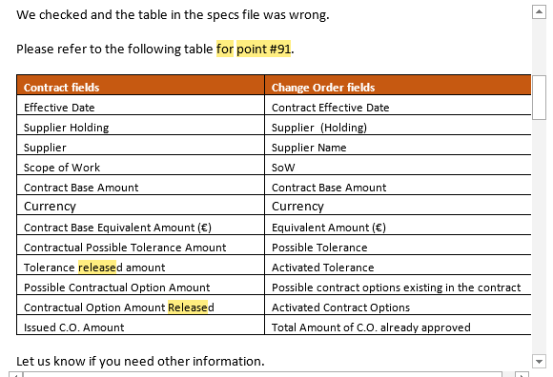

These fields must not be editable manually.

# PRJ C.O. ,“Progressive Number C.O.” field logic

* **Implementation logic**
* The “Code” field must be renamed to “Progressive Number C.O.”.
* The numbering should be as follows:

Progressive Number C.O. = [Main contract number (code)] – C.O. – [progressive number]

Example

Contract1-C.O.-0001

Progressive Number C.O. ID

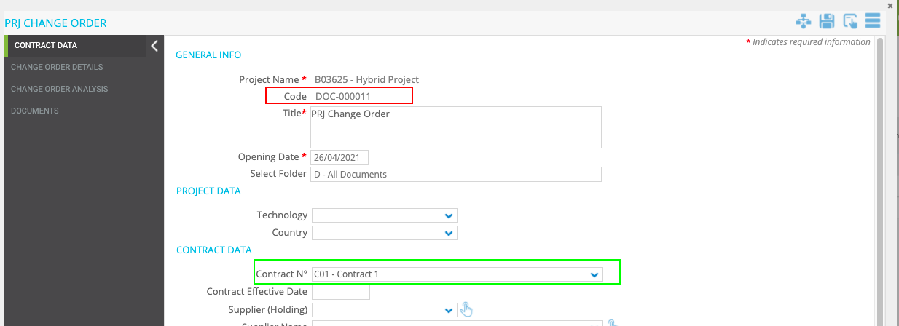

* **General implementation requisite**

The “Progressive Number C.O.” should appear after the first save/apply.

# PRJ C.O. ,“ Contract issued as Direct Awarding” field logic

* **Implementation logic**

If in the Contract (By using as reference the Contract Selected in the “Contract N°” dropdown) the Field "Procurement Procedure" is equal to "Direct Assignment" then the value in the “ Contract issued as Direct Awarding” Dropdown should be "Yes", otherwise the value should be "No"

Contract form

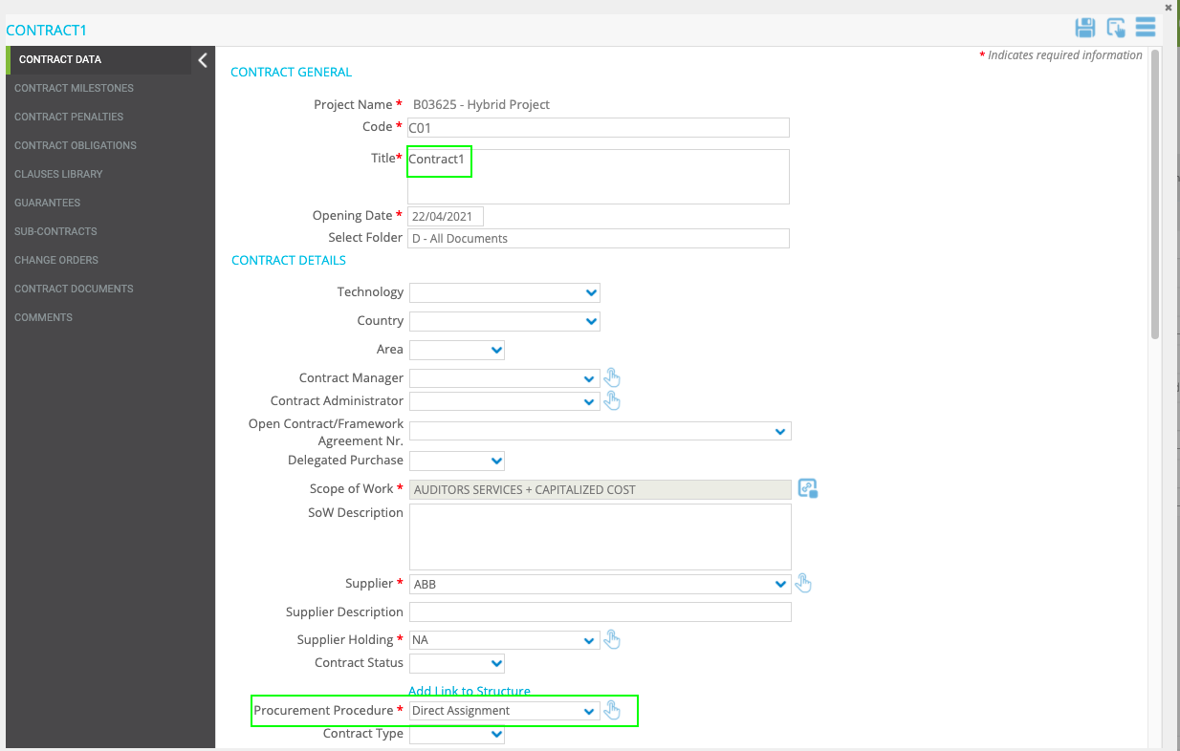

C.O. form

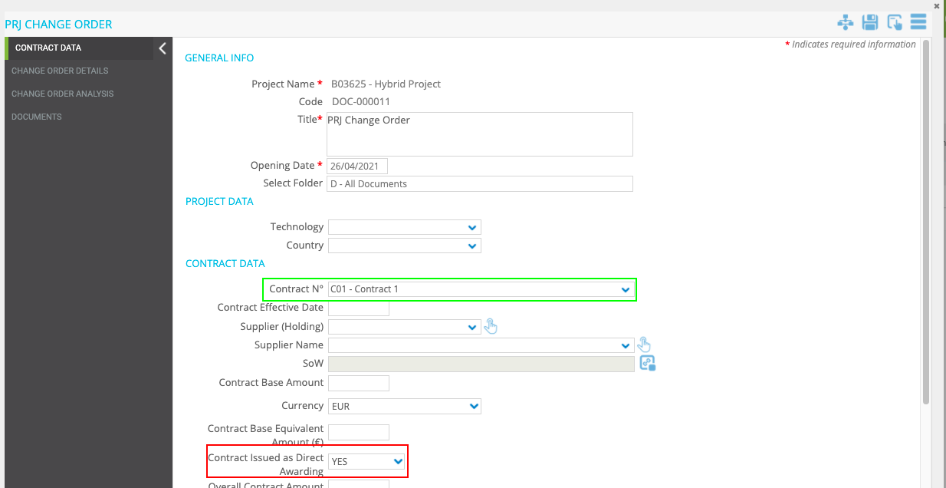

* **General implementation requisite**

These fields must not be editable manually.

# PRJ C.O., “Approver” field logic

* **Implementation logic**

The user selected within the Drop Down “Approver” must be the approver of step 3.

The drop down must show only the users that belong to the group "PRJ C.O. Approver", Owner of step 3.

(As already done for PR- No SAP Countries Point N°32)

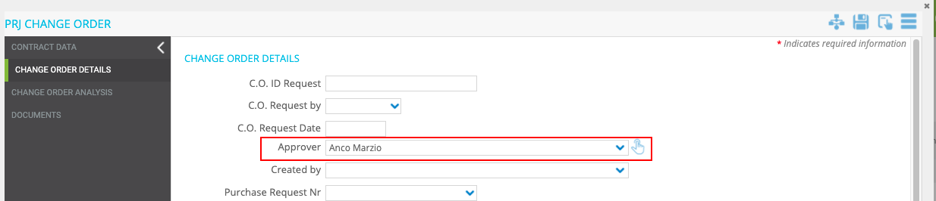

* **General implementation requisite**

Editable only in step1and step2

# PRJ C.O., “Created by” field logic

* **Implementation logic**

The “Created by” field should show the name of the user who created the “PRJ Change Order” form.

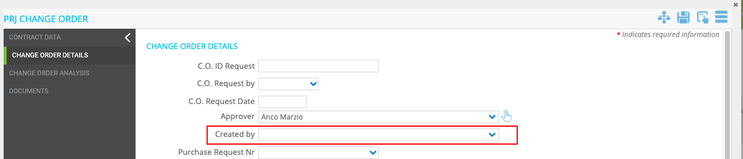

* **General implementation requisite**

The Field must not be manually editable

# PRJ C.O., renaming of “Opening Date” field

* **Implementation logic**

The “Opening Date” field should be renamed in “C.O. Request Date” only for “PRJ Change Order” form.

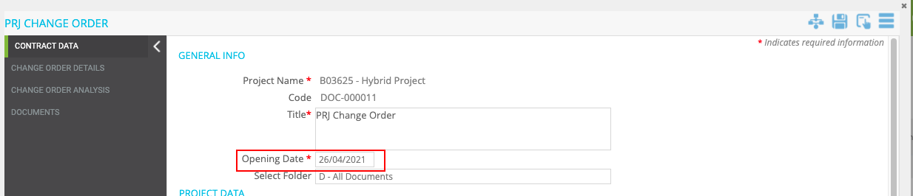

* **General implementation requisite**

The Field must not be manually editable

# PRJ C.O., “By” logic field

* **Implementation logic**

The “by” field should show the name of the user that release the PRJ C.O. from step3 to step4 (Approver of step3).

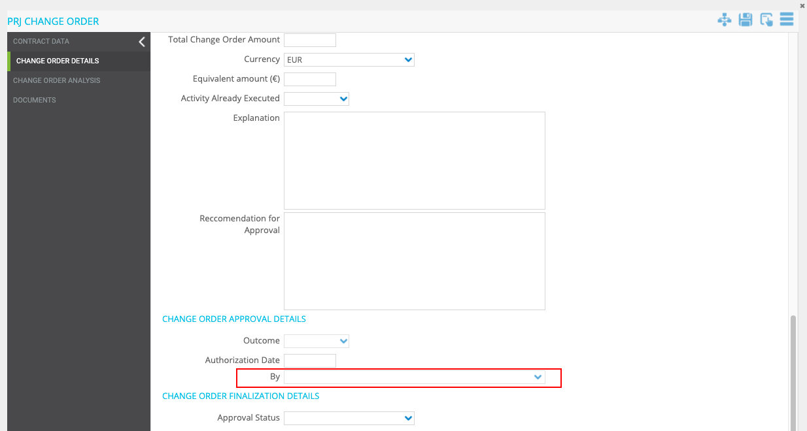

* **General implementation requisite**

The Field must not be manually editable

# PRJ C.O., “Authorization Date” field logic

* **Implementation logic**

The field “Authorization Date” should automatically show the date of the Release from step3.

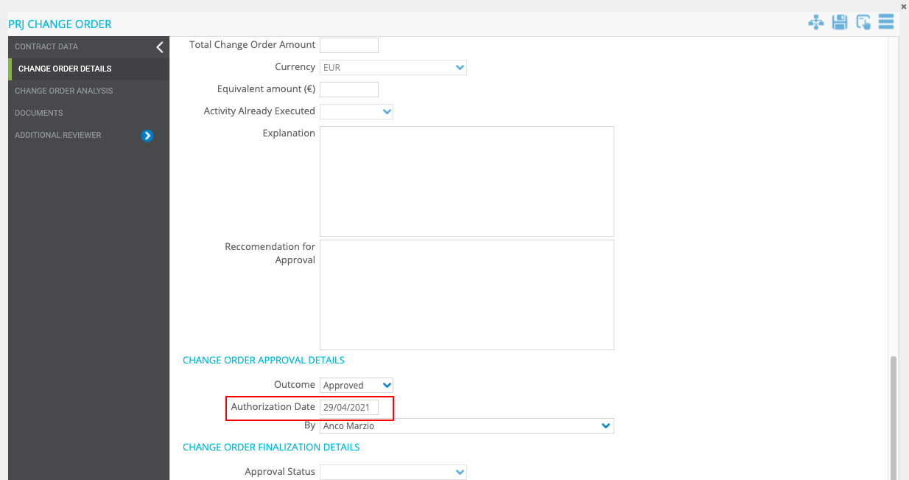

# PRJ C.O., Automatic data Filling from Omnia (Stage Table)

* **Implementation logic**

1. The fields below must be taken from Omnia (Stage Table), when the “Purchase Request Nr” is entered. (Same logic used for the field “Purchase Order N°” inside the form of the Procurement Plan)

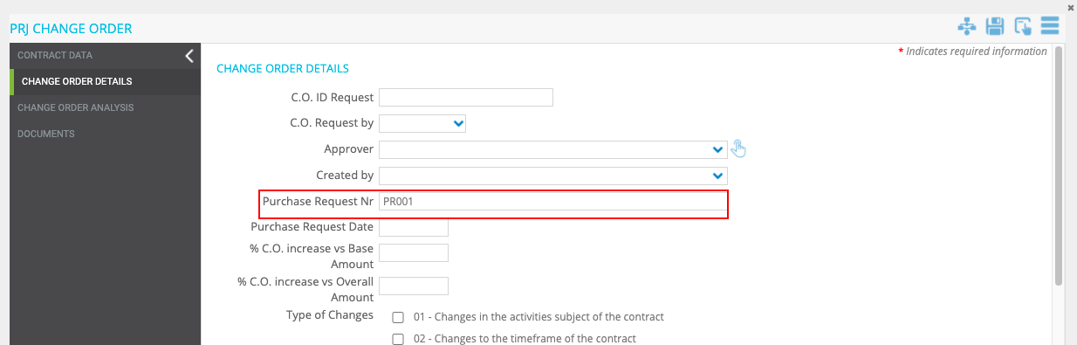

Fields that should be retrieved from main contract:

* Issued C.O. Amount
* Currency
* Equivalent Amount (€)

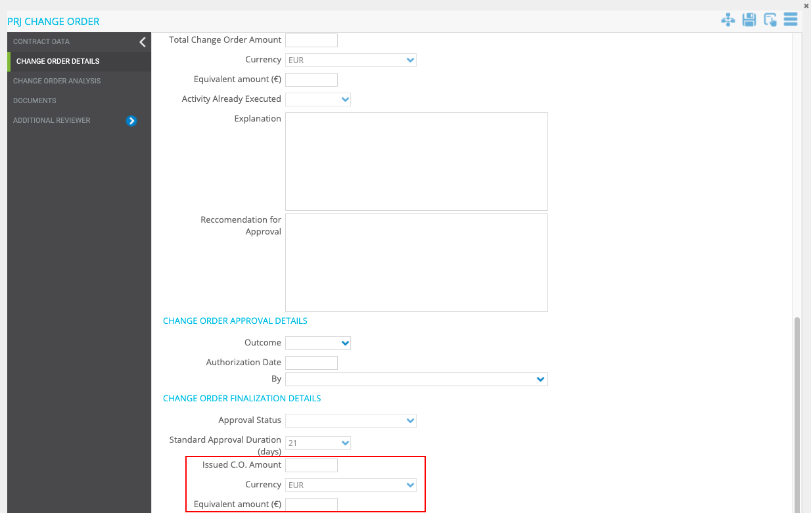

1. Every 24 hours the system must automatically check if there are any changes in the value within the stage table and update the field.

The checking and updating must continue even after the WF is finalised.

* **General implementation requisite**

The Field must not be manually editable

# PRJ C.O., “% C.O. Increase vs Base Amount” field logic

* **Implementation logic**

The “% C.O. Increase vs Base Amount” field should be calculated as:

(Total Change Order Amount (from this Form) / "Contract Base Amount" (from this Form)) * 100

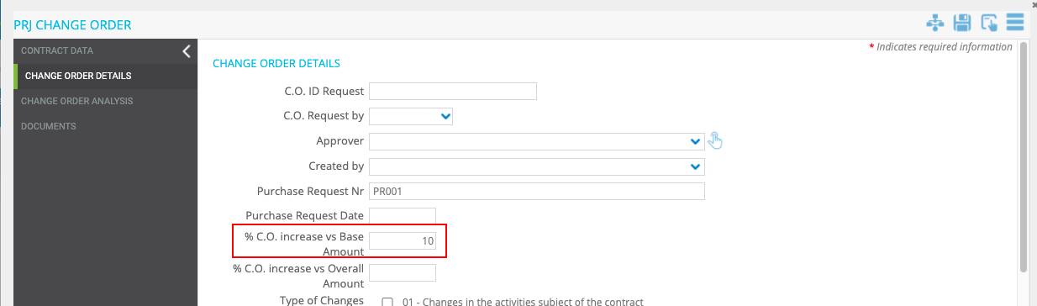

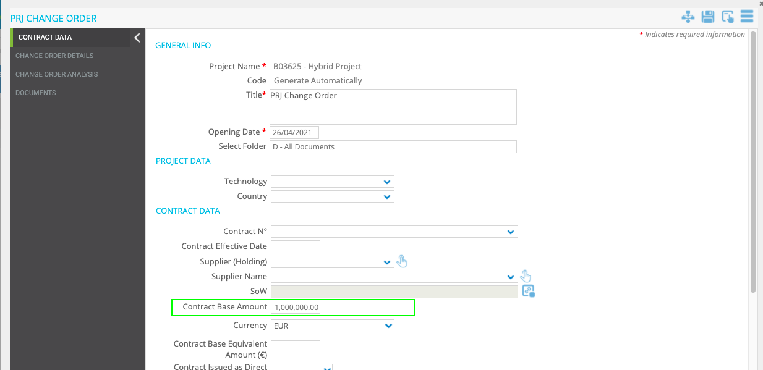

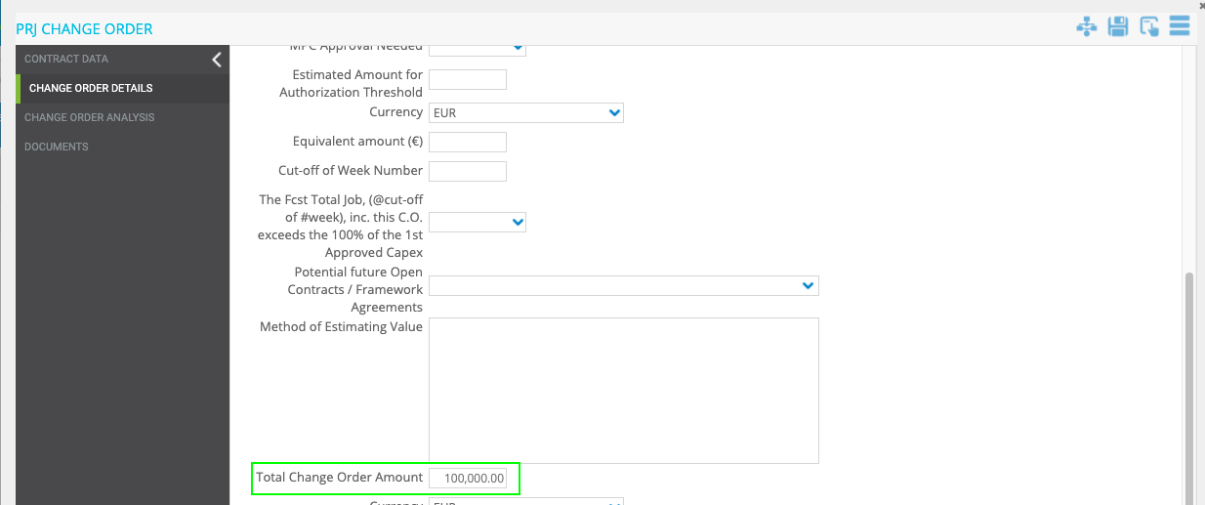

**Example:**

100.000,00= Total Change Order Amount

1.000.000,00= Contract Base Amount

(100.000,00/1.000.000,00)*100= 10% → “% C.O. Increase vs Base Amount”

* **General implementation requisite**

The field should not be manually editable

# PRJ C.O., “% C.O. Increase vs Overall Amount” field logic

* **Implementation logic**

The “% C.O. Increase vs Overall Amount” field should be calculated as:

(Total Change Order Amount (from this Form) / "Overall Contract Amount" (from this Form)) * 100

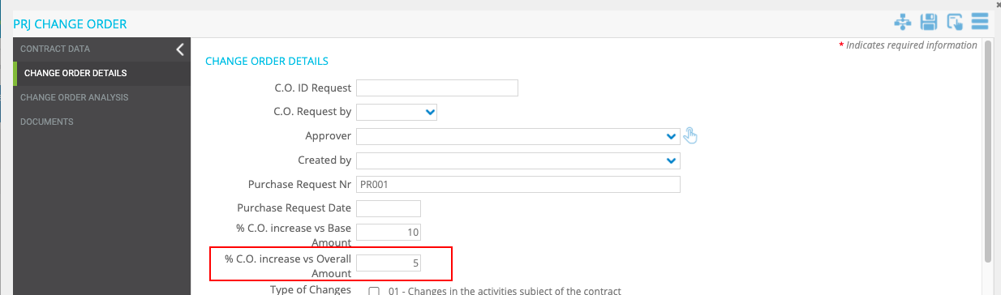

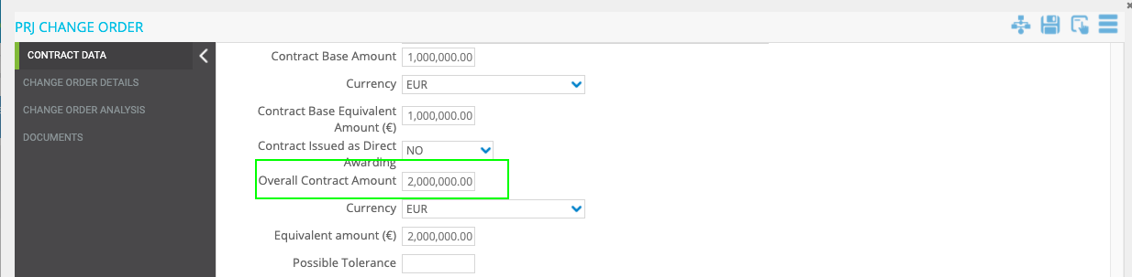



**Example:**

100.000,00= Total Change Order Amount

2.000.000,00= Overall Contract Amount

(100.000,00/2.000.000,00)*100= 5% → “% C.O. Increase vs Overall Amount”

* **General implementation requisite**

The field should not be manually editable

# PRJ C.O., “Overall Contract Amount” field logic

* **Implementation logic**

The “Overall Contract Amount” field should be calculated as:

"Contract base Amount" + "Issued C.O. Amount " + "Possible Tolerance " + "Possible contract options existing in the contract"

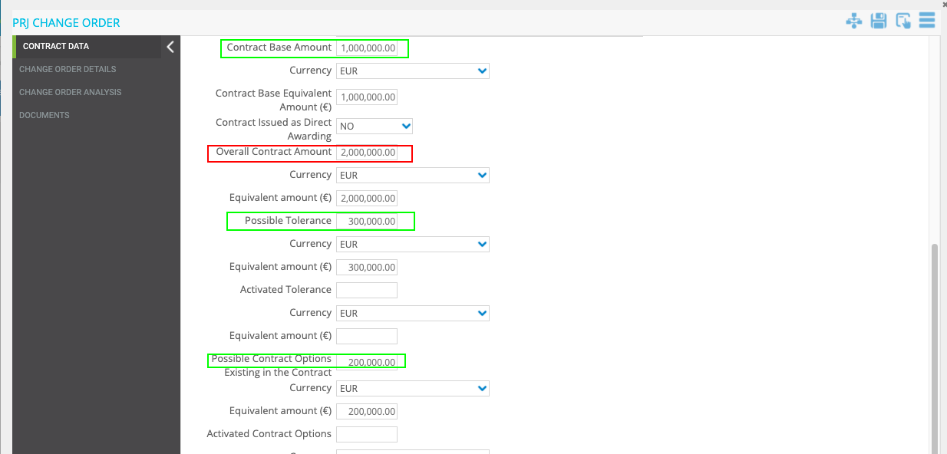

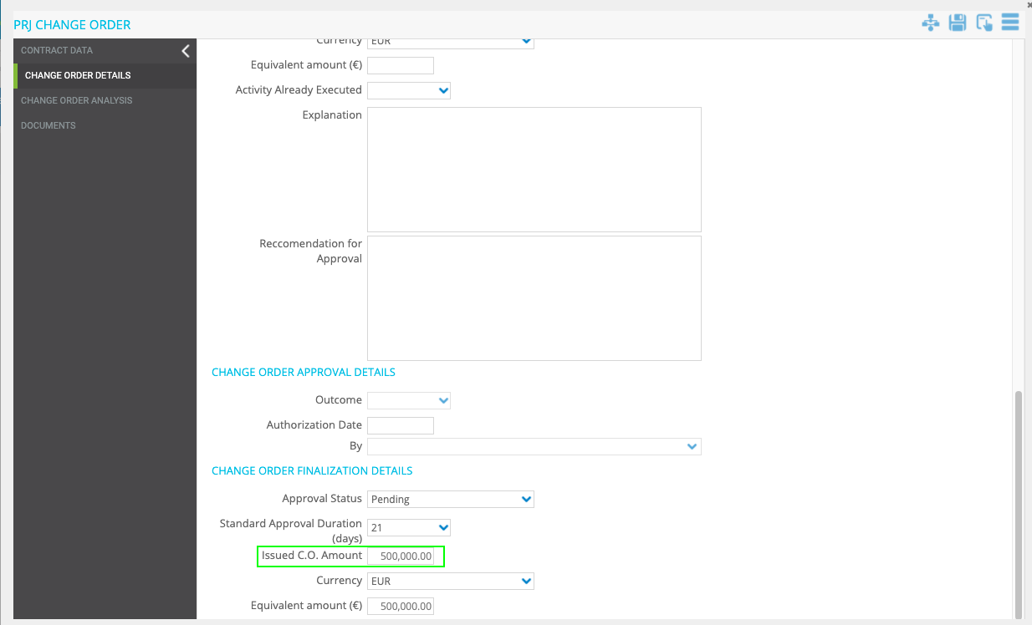

* **General implementation requisite**

The field should not be manually editable.

When one of the fields used for the calculation changes, the value within the field “Overall Contract Amount” must be updated.

# PRJ C.O., “MPC Approval NEEDED” field logic

* **Implementation logic**

Dropdown (MPC Approval Needed)

1. If:

(Issued C.O. Amount (Equivalent Amount (€)) " + "Total Change Order Amount (Equivalent Amount (€))" + "Contract Base Equivalent Amount (€)") > 25 M €

and the Field "C.O. Included in Allocated Contract Contingency" = No

then the value of this Field must be YES

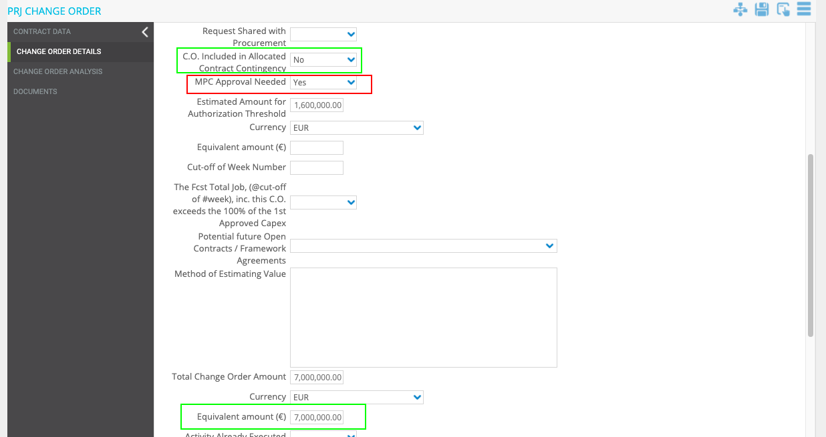

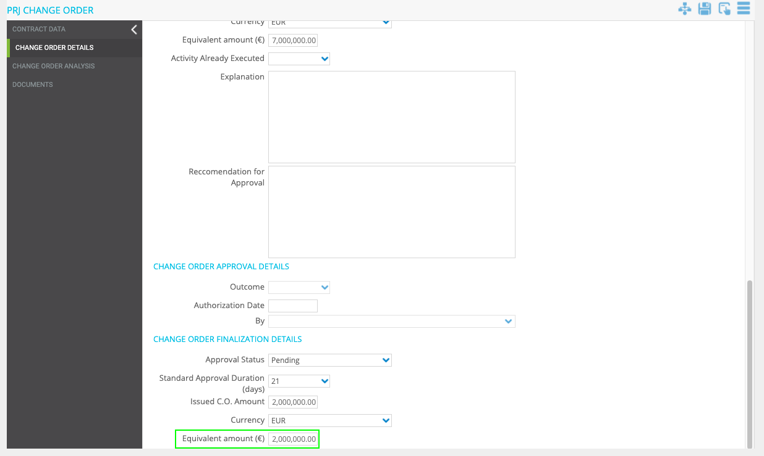

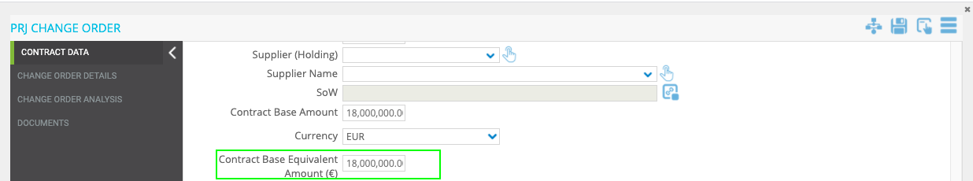

1. Otherwise, the value of this field must be NO

* **General implementation requisite**

The field should not be manually editable.

# PRJ C.O., “Estimated Amount for Authorization Threshold” field logic

* **Implementation logic**

“Estimated amount for authorization threshold” calculation:

1. if Field "Contract issued as Direct Awarding:" is NO

Formula:

"Issued C.O. Amount" + "Total Change Order Amount"(this C.O.Form)

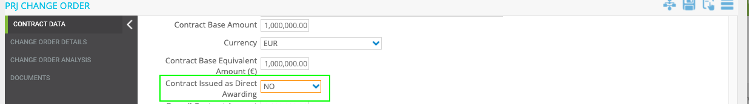

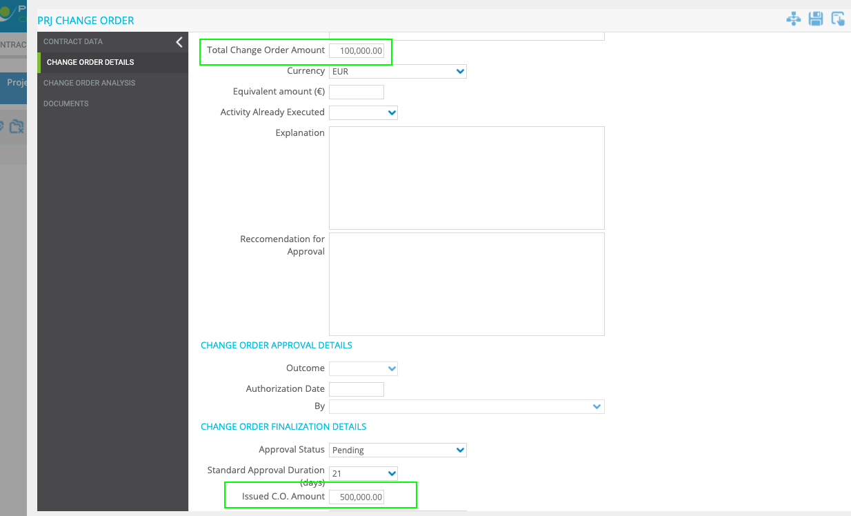

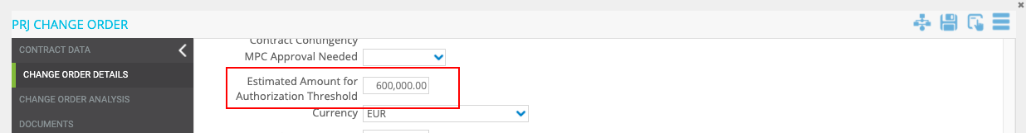

1. if Field"Contract issued as Direct Awarding:" is YES

Formula:

"Issued C.O. Amount" + "Total Change Order Amount"(this C.O.Form) + "Contract base Amount"

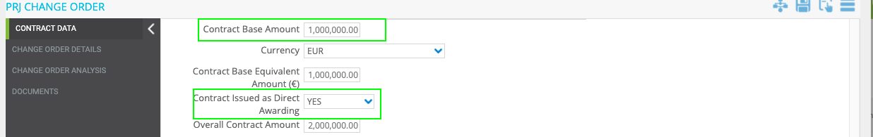





* **General implementation requisite**

The field should not be manually editable.

# PRJ C.O., “Review” UC

* **Business Requirement**

The reviewer must be able to write the review in a pop-up window.

The user should have the possibility to write the review while looking at the form at the same time.

# PRJ C.O., C.O. user Control

* **Business Requirement**

Manage Change Order in a dedicated Tab in the “PRJ Change Order” Form.

Max 10 lines.

* **Implementation logic**

The UC should contain real time Column filtering (as in PR – No SAP Countries UC).

|  |  |  |  |  |
| --- | --- | --- | --- | --- |
| **Field** | **Data Logic** | **Format** | **Table Name in PO** | **Note** |
| Item ID | Progressive numbering (not editable) | Number |  | 01,02,03....10 |
| Main Cause | Manually selected (Logic in point N°107) | Drop Down |  | 1000 characters |
| Detailed Cause | Manually selected (Logic in point N°107) | Drop Down |  |  |
| C.O. Estimated Amount | Manually entered | Amount |  |  |
| C.O. Estimated Equivalent Amount (€) | Manually entered | Amount |  |  |
| Cost Item Impacted | Manually selected (Logic in point N°108) | Drop Down |  |  |
| Cost Type | Manually entered | Drop Down | C.O. COST TYPE |  |
| Included or Not in Original Contract SoW | Manually selected | Drop Down | C.O. INCLUDED IN ALLOCATED CONTRACT CONTINGENCY |  |
| Cost Item Estimated Amount after E&C Negotiation | Manually entered | Amount |  |  |
| Cost Item Estimated Equivalent Amount after E&C Negotiation (€) | Manually entered | Amount |  |  |
| C.O. Cost Item Amount | Manually entered | Amount |  |  |
| C.O. Cost Item Equivalent Amount (€) | Manually entered | Amount |  |  |
| Explanation of Contract Amendment | Manually entered | Note |  | Note field as in contract "Clauses Library" User Control |

* **Operational steps**

The User will be able to Add items from the tab “Change Order Analysis” in the PRJ Change Order form.

To create a line, the user should be able to:

1) For the specific project, access the project workspaces

1. Select the PRJ Change Order form
2. Select the tab “Change Order Analysis” Click the add icon and enter the fields
3. Save the new line

2) Once saved the items will be available for editing/delete

3) The User will have the possibility to expand the view full screen and to export to Excel the Items table/register.

ITEMS UC Mockup

The UC should contain real time Column filtering (as in PR – No SAP Countries UC).

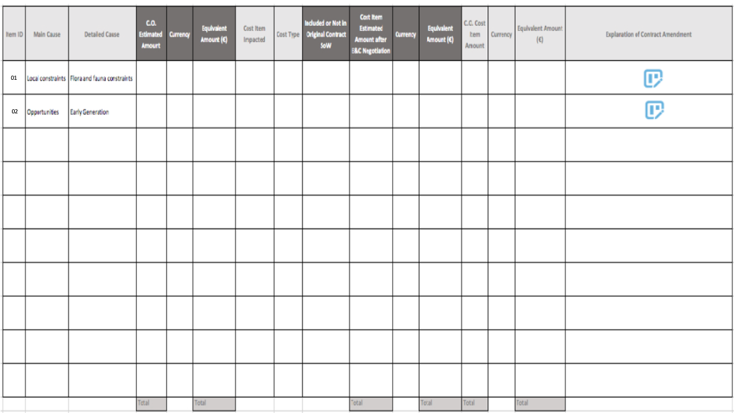

Some columns must have the "total" field as shown in the Mockup.(As already done for PR - No SAP Countries).

The columns for which the total should be calculated are:

* C.O. Estimate Amount
* C.O. Estimated Equivalent Amount (€)
* Cost Item Estimated Amount after E&C Negotiation
* Cost Item Estimated Equivalent Amount after E&C Negotiation (€)
* C.O. Cost Item Amount
* C.O. Cost Item Equivalent Amount (€)
* **General implementation requisite**
* EXCEL Export functionality
* Full Screen Functionality
* Real time Column filtering

# PRJ C.O., “Main Cause” and “Detailed Cause” fields logic (UC fields)

* **Implementation logic**

“Main Cause” field

Selecting a value from this Dropdown filter the value of the next dropdown (Detailed Cause)

(This Function Must be available also for the FA Change Order Form - Using the same Data Table, and **Data Table can be customized as other Standard Tables**)

“Detailed Cause” field

The value available in this Dropdown must depend on the selection of the previous Dropdown (Main Cause)

(This Function Must be available also for the FA Change Order Form - Using the same Data Table, and **Data Table can be customized as other Standard Tables**)

|  |  |
| --- | --- |
| **Main Cause (Risk Analysis Cause Group)** | **Detailed Cause** |
| Contractors management | Inadequate contractor/sub-contractor and related interfaces management |
| Contractors management | Inadequate/insufficient manpower and/or heavy equipment |
| Contractors management | Missing/Incomplete/Unclear information received/submitted from/to contractor(s) |
| Contractors management | Unreliability/inexperience/unknown/not qualified contractor |
| Development Strategy | Interference with projects/plants in cascade hydropower plant or cluster |
| Development Strategy | PPA contract not finalized |
| Development Strategy | Tightness of the time schedule for project development |
| Development Strategy | Uncertainties on the Financial Close achievement date |
| Internal Know_How And Performances | Changing in procedures and/or digital tool |
| Internal Know_How And Performances | Communication difficulties (e.g. linguistic) inside/outside the Team |
| Internal Know_How And Performances | Inadequate internal stakeholders management |
| Internal Know_How And Performances | Interference with O&M maintenance activities |
| Internal Know_How And Performances | Lack of knowledge in components market |
| Internal Know_How And Performances | Lack of knowledge in local job market |
| Internal Know_How And Performances | Lack of knowledge in/unclear local law and regulation |
| Internal Know_How And Performances | Lack of knowledge in/unclear local technical legislation/regulation or not in line with GPG standards |
| Internal Know_How And Performances | Lack of knowledge of implemented component/technology |
| Internal Know_How And Performances | Lack of/incomplete historical data |
| Internal Know_How And Performances | Project Team members excessive workload |
| Local Authorities Management | Changing in law and regulation |
| Local Authorities Management | Demanding local labor union |
| Local Authorities Management | Unreliability/inexperience/unknown local authority (TSO/DSO, municipality…) |
| Local Authorities Management | Unreliable/unknown custom clearance agency/process |
| Local constraints | Adverse/unknown local communities |
| Local constraints | Catastrophic events (natural disasters or social economic events or health diseases) |
| Local constraints | Flora and fauna constraints |
| Local constraints | Hydraulic constraints and disputes with third parties |
| Local constraints | Local content constraints/job market regulation issues |
| Local constraints | Local traditions constraints |
| Local constraints | Workers strike |
| Market characteristics job e equipment | Lack of skilled workers/qualified professionals |
| Market characteristics job e equipment | Shortage of manpower and/or heavy equipment |
| Market characteristics job e equipment | Shortage of suppliers/contractors |
| Opportunities | Early Generation |
| Permitting And Land Management | Building permitting phase not finalized |
| Permitting And Land Management | Crossing permitting phase not finalized |
| Permitting And Land Management | Environmental permitting phase not finalized |
| Permitting And Land Management | Grid connection permitting phase not finalized |
| Permitting And Land Management | Land agreements not finalized |
| Preliminary Studies And Activities | Basic design or project layout not completed or not performed |
| Preliminary Studies And Activities | Lack of knowledge of the site area |
| Preliminary Studies And Activities | Preliminary surveys not completed or not performed (Topography, Geotechnical, Hydrological…) |
| Procurement Strategy | Contractor capacity saturated |
| Procurement Strategy | Contracts with indexed prices (inflation, FEX…) |
| Procurement Strategy | High level of subcontracting |
| Procurement Strategy | High number of tenders to manage in tight time |
| Procurement Strategy | High/unclear fragmentation of contracts |
| Procurement Strategy | Lack of knowledge/Usage of framework contracts already in place |
| Procurement Strategy | Missing/incomplete/not binding offers received/submitted from/to contractors |
| Procurement Strategy | Procurement strategy management |
| Site area characteristics | Robbery during construction |
| Site area characteristics | Shortage of construction resources (e.g. water, aggregates)/power supply |
| Site area characteristics | Site area located far from near hospitals and/or telecommunication networks unavailable |
| Site area characteristics | Site area subject to adverse weather conditions |
| Site area characteristics | Site area subject to fire hazard |
| Site area characteristics | Site area subject to flood hazard |
| Site area characteristics | Site area subject to landslip hazard |
| Site area characteristics | Site logistic/accessibility external constraints |
| Site area characteristics | Uncertain availability of the primary resource |
| Technology characteristics | Elevate number interfaces to be managed |
| Technology characteristics | High complexity of the documentation to be analyzed |
| Technology characteristics | High technical complexity of the implemented technology |
| Technology characteristics | Lack of knowledge of plant component status |
| Technology characteristics | Missing/unclear/incomplete documents regarding the as is plant/site status |

# PRJ C.O., “Cost Item Impacted” field logic (UC field)

* **Implementation logic**

The value available in this Dropdown must depend on the selection of the Project Technology.

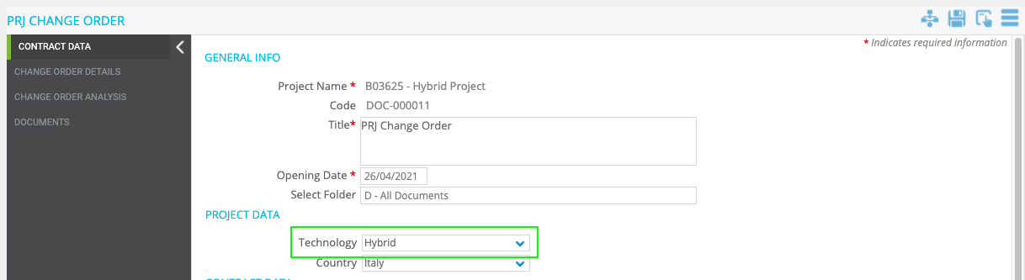

Data to be inserted in the Table are in the File "Cost Item List per Tech".

<https://projectobjects.sharepoint.com/:x:/s/EnelECContractManagement/EX5nS-REmmxJqYXhLaPM86sBLYtGynnTvBGy5b3XPe3q-A?e=Tb1HYx>

* **General implementation requisite**

Data Table can be customized as other Standard Tables

# PRJ C.O., “Total Change Order Amount” field logic (UC field)

* **Implementation logic**

The "Total Change Order Amount" field must show the value of the field highlighted in the mockup below (sum of the “C.O. Cost Item Amount” of all items).

UC Mockup

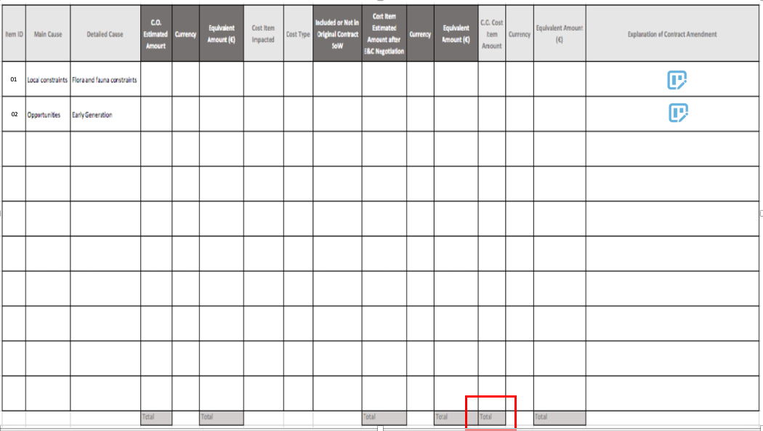

* **General implementation requisite**

Field not editable

# PRJ C.O., alert pop up

* **Implementation logic**

When the user clicks on Save or Apply in step1the system has to perform a check:

1. Alert

Condition 1

"Issued C.O. Amount (Equivalent Amount (€)) " + "Total Change Order Amount(Equivalent Amount (€))" + ""Contract base Amount (Equivalent Amount (€))" > 25 M €

Condition 2

Change order included in contract contingency YES

Condition 3

MPC Approval Needed = YES

Text message: “Please double check info on contract contingency”

1. Alert

Condition 1

"Issued C.O. Amount (Equivalent Amount (€)) " + "Total Change Order Amount(Equivalent Amount (€))" + ""Contract base Amount (Equivalent Amount (€))" > 25 M €

Condition 2

Change order included in contract contingency= No

Condition 3

MPC Approval Needed = No

Text message: “Please double check info on contract contingency”

1. Alert

Condition 1

"Issued C.O. Amount (Equivalent Amount (€)) " + "Total Change Order Amount(Equivalent Amount (€))" + ""Contract base Amount (Equivalent Amount (€))" < 25 M €

Condition 2

MPC Approval Needed = YES

Text message: “Please double check Base Amount + C.O. Amount”

* **General implementation requisite**

User must click “OK” to dismiss the notification

Mockup

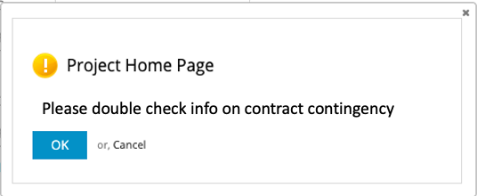

# FWA C.O., “Framework Agreement N°” field logic

* **Implementation logic**

The “Framework Agreement N°” field should show the list of “Framework Agreement” in PO.

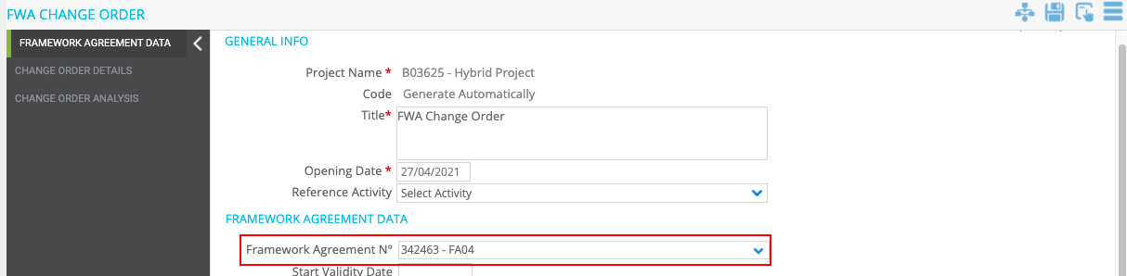

* **General implementation requisite**

Dropdown with search function

# FWA C.O., Automatic Filling of Framework Agreement Details fields

* **Business Requirement**

Automatically Fill the Framework Agreement information details in the FWA Change Order form.

* **Implementation logic**

The fields described below must receive values from the related Framework Agreement.

(By using for reference the Framework Agreement Selected in the “Framework Agreement N°” dropdown)



* **Operational steps**

When a Contract is selected within the “Framework Agreement N°” dropdown the following fields must be filled in automatically.

Fields that should be retrieved from Framework Agreement:

* Start Validity Date
* Framework Agreement Manager
* Supplier Name
* Object of the Agreement
* "Framework Agreement SOW"
* FA Base Amount
* Currency
* FA Base Equivalent Amount (€)
* Framework Agreement Category
* Overall FA Amount
* Currency
* Overall FA Equivalent Amount (€)
* Possible Tolerance
* Activated Tolerance
* Possible contract options existing in the contract
* Activated Contract Options
* Total Amount of C.O. already approved
* **General implementation requisite**

These fields must not be editable manually.

# FWA C.O.,“Progressive Number C.O.” field logic

* **Implementation logic**
* The “Code” field must be renamed to “Progressive Number C.O.”.
* The numbering should be as follows:

Progressive Number C.O. = [Framework Agreement N° (code)] – C.O. – [progressive number]

Example

FA04-C.O.-0001

Progressive Number C.O. ID

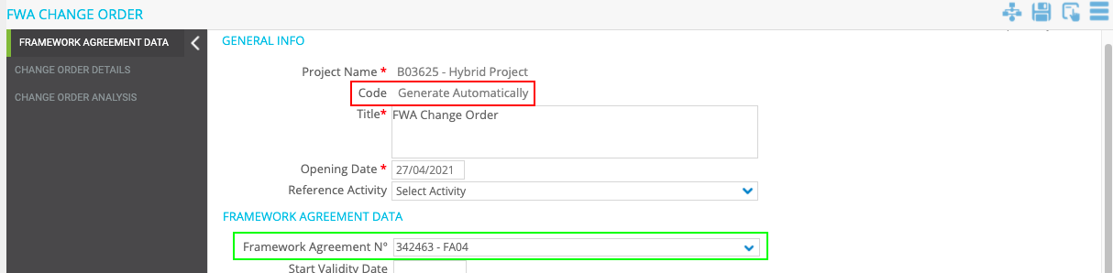

* **General implementation requisite**

The “Progressive Number C.O.” should appear after the first save/apply.

# FWA C.O.,“ Contract issued as Direct Awarding” field logic

* **Implementation logic**

If in the Framework Agreement (By using as reference the Framework Agreement Selected in the “Framework Agreement N°” dropdown) the Field "FA Procurement Procedure" is equal to "Direct Assignment" then the value in the “ Contract issued as Direct Awarding” Dropdown should be "Yes", otherwise the value should be "No"

Contract form

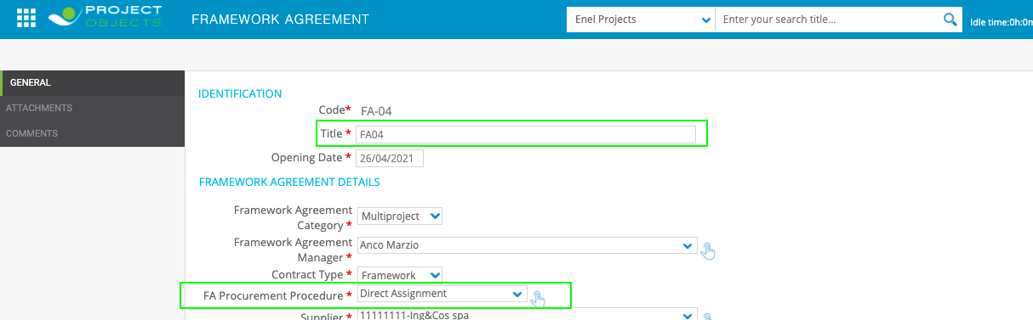

C.O. form

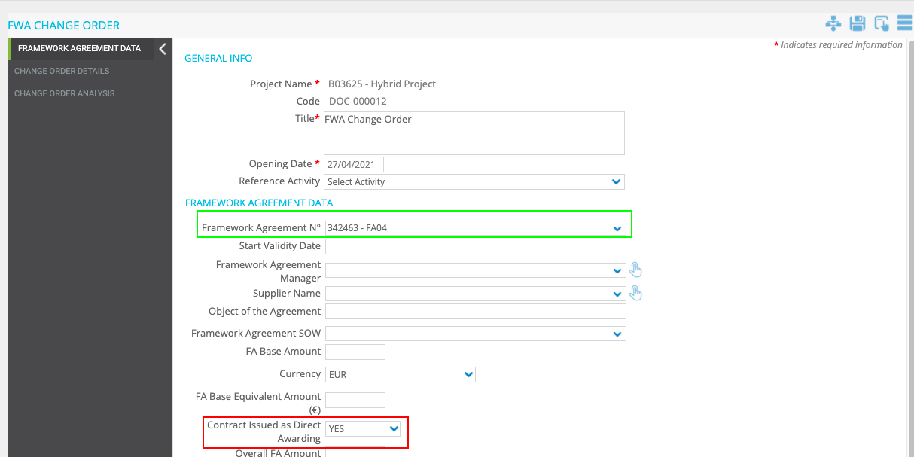

* **General implementation requisite**

These fields must not be editable manually.

# FWA C.O., “Approver” field logic

* **Implementation logic**

The user selected within the Drop Down “Approver” must be the approver of step 3.

The drop down must show only the users that belong to the group "FWA C.O. Approver", Owner of step 3.

(As already done for PR- No SAP Countries Point N°32)

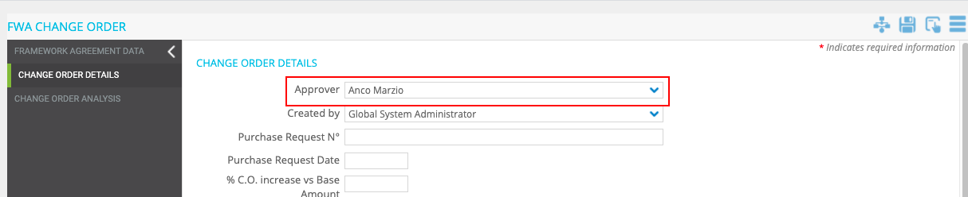

* **General implementation requisite**

Editable only in step

# FWA C.O., “Created by” field logic

* **Implementation logic**

The “Created by” field should show the name of the user who created the “FWA Change Order” form.

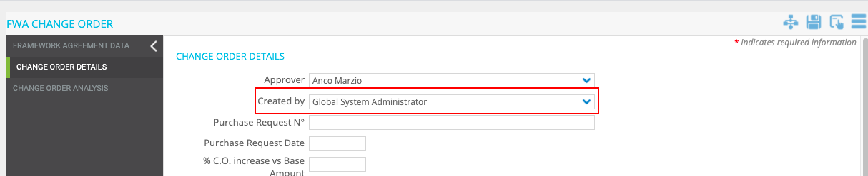

* **General implementation requisite**

The Field must not be manually editable

# FWA C.O., renaming of “Opening Date” field

* **Implementation logic**

The “Opening Date” field should be renamed in “C.O. Request Date” only for “PRJ Change Order” form.

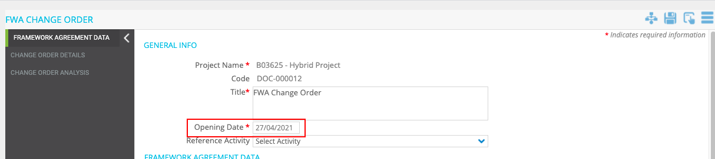

* **General implementation requisite**

The Field must not be manually editable

# FWA C.O., “By” logic field

* **Implementation logic**

The “by” field should show the name of the user that release the PRJ C.O. from step3 to step4 (Approver of step3).

* **General implementation requisite**

The Field must not be manually editable

# FWA C.O., “C.O. E&C Authorization Date” field logic

* **Implementation logic**

The field “C.O. E&C Authorization Date” should automatically show the date of the Release from step3.

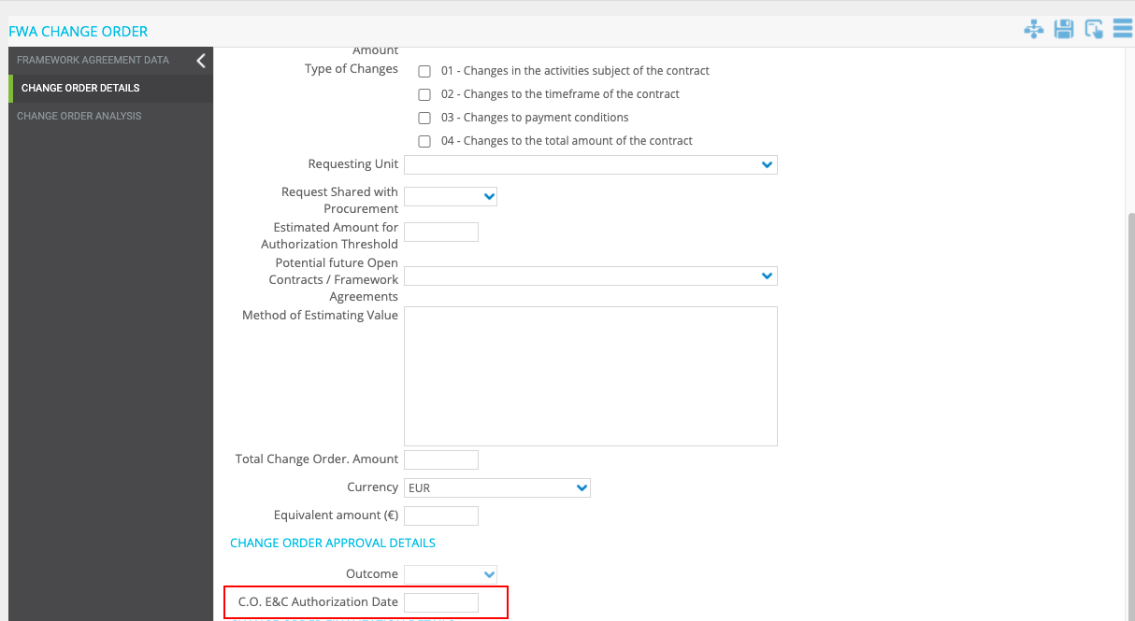

# FWA C.O., Automatic data Filling from Omnia (Stage Table)

* **Implementation logic**

1. The fields below must be taken from Omnia (Stage Table), when the “Purchase Request Nr” is entered. (Same logic used for the field “Purchase Order N°” inside the form of the Procurement Plan)

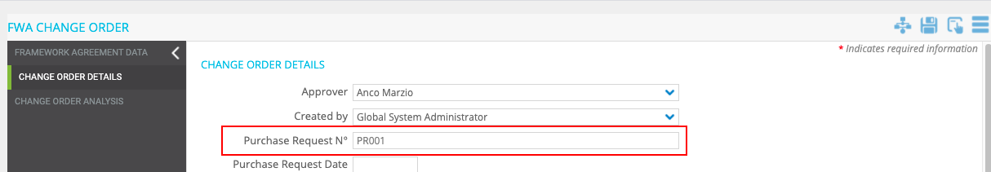

Fields that should be retrieved from main contract:

* Issued C.O. Amount
* Currency
* Issued C.O.Equivalent Amount (€)

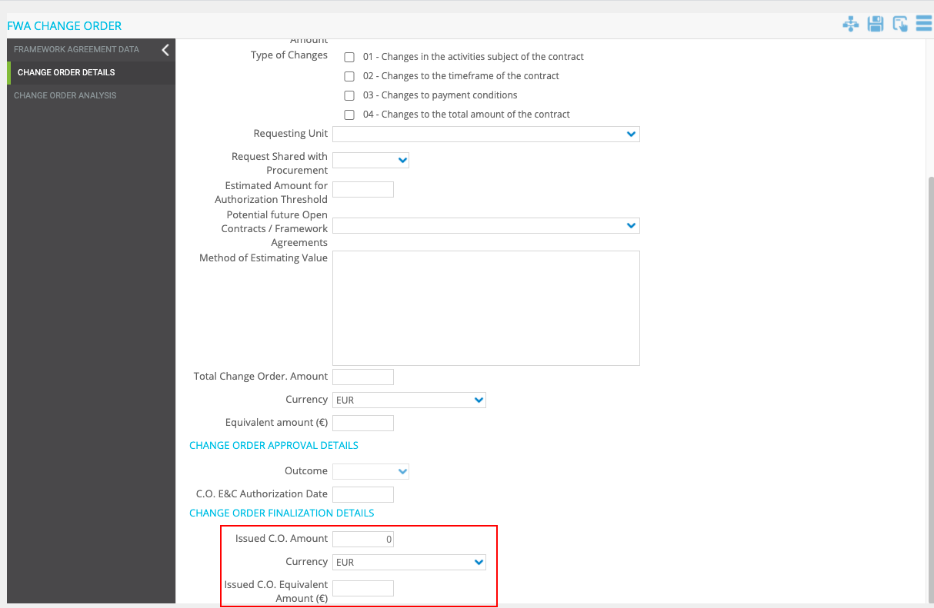

1. Every 24 hours the system must automatically check if there are any changes in the value within the stage table and update the field.

The checking and updating must continue even after the WF is finalised.

* **General implementation requisite**

The Field must not be manually editable

# fWA C.O., “% C.O. Increase vs Base Amount” field logic

* **Implementation logic**

The “% C.O. Increase vs Base Amount” field should be calculated as:

(Total Change Order Amount (from this Form) / "FA Base Amount" (from this Form)) * 100

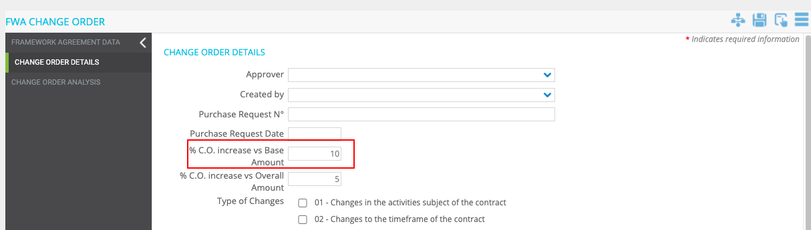

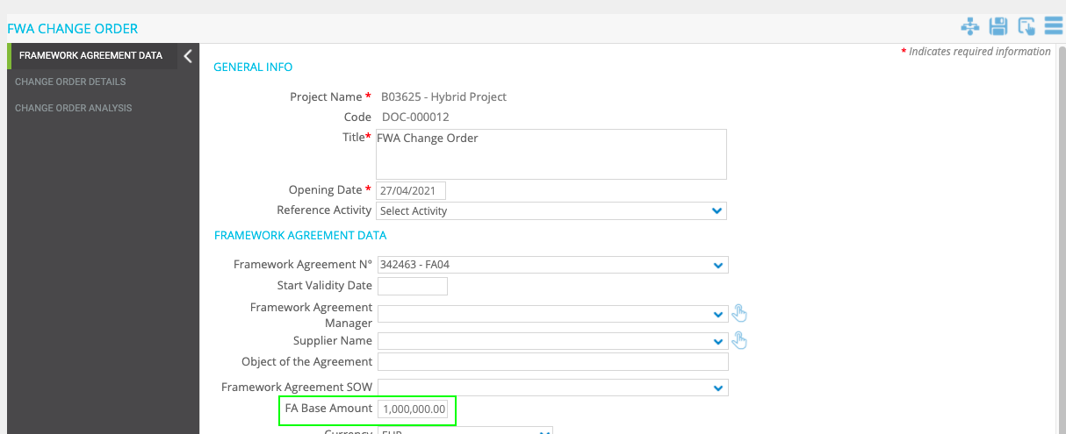

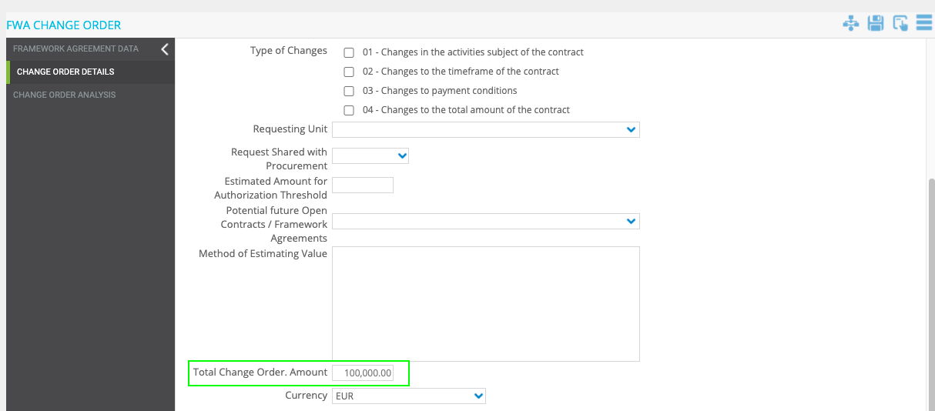

**Example:**

100.000,00= Total Change Order Amount

1.000.000,00= FA Base Amount

(100.000,00/1.000.000,00)*100= 10% → “% C.O. Increase vs Base Amount”

* **General implementation requisite**

The field should not be manually editable

# FWA C.O., “% C.O. Increase vs Overall Amount” field logic

* **Implementation logic**

The “% C.O. Increase vs Overall Amount” field should be calculated as:

(Total Change Order Amount (from this Form) / "Overall FA Amount" (from this Form)) * 100

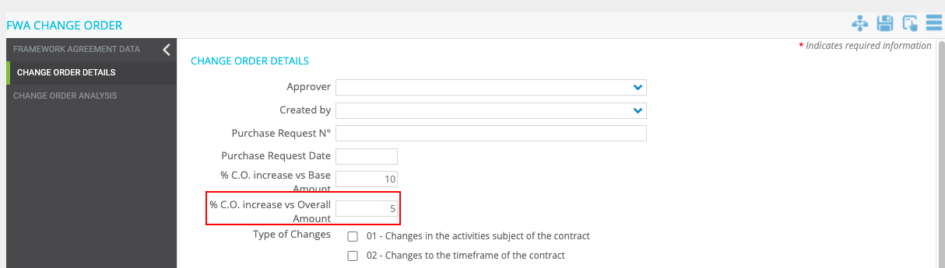

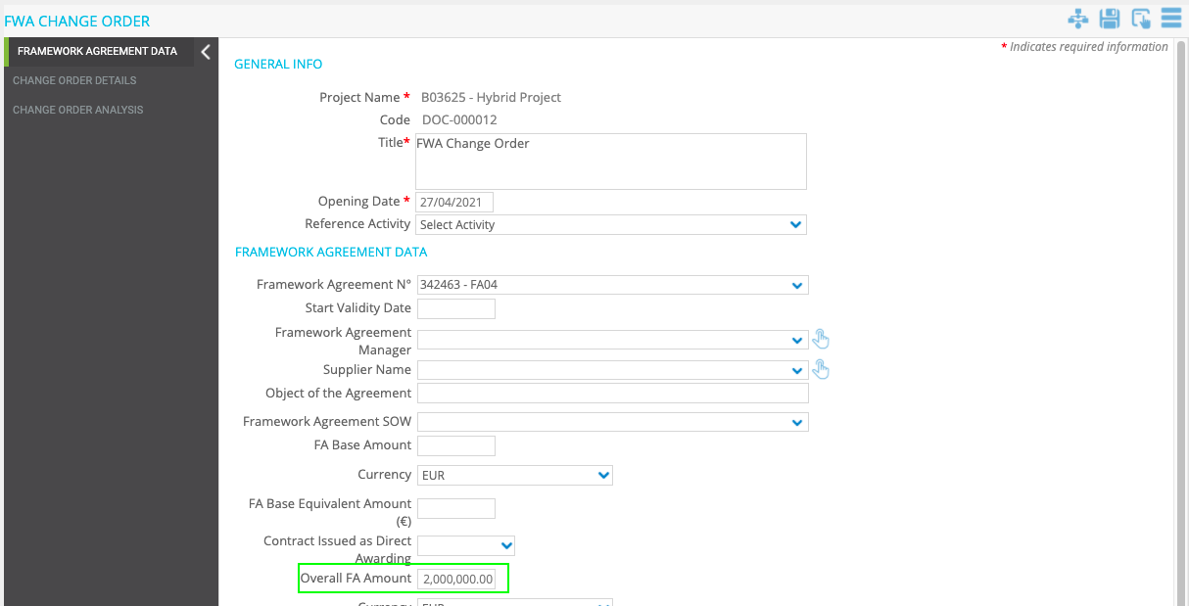

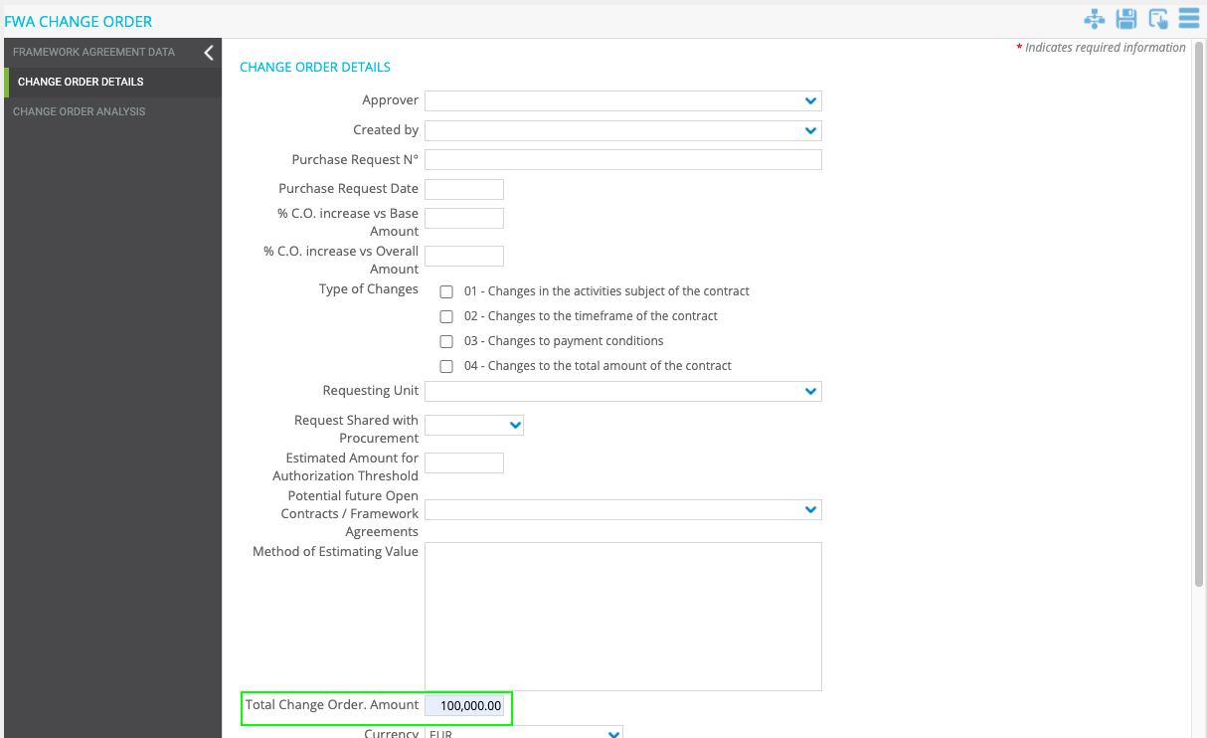

**Example:**

100.000,00= Total Change Order Amount

2.000.000,00= Overall FA Amount

(100.000,00/2.000.000,00)*100= 5% → “% C.O. Increase vs Overall Amount”

* **General implementation requisite**

The field should not be manually editable

# FWA C.O., “Estimated Amount for Authorization Threshold” field logic

* **Implementation logic**

“Estimated amount for authorization threshold” calculation:

1. if Field "Contract issued as Direct Awarding:" is NO

Formula:

"Issued C.O. Amount" + "Total Change Order Amount"(this C.O.Form)

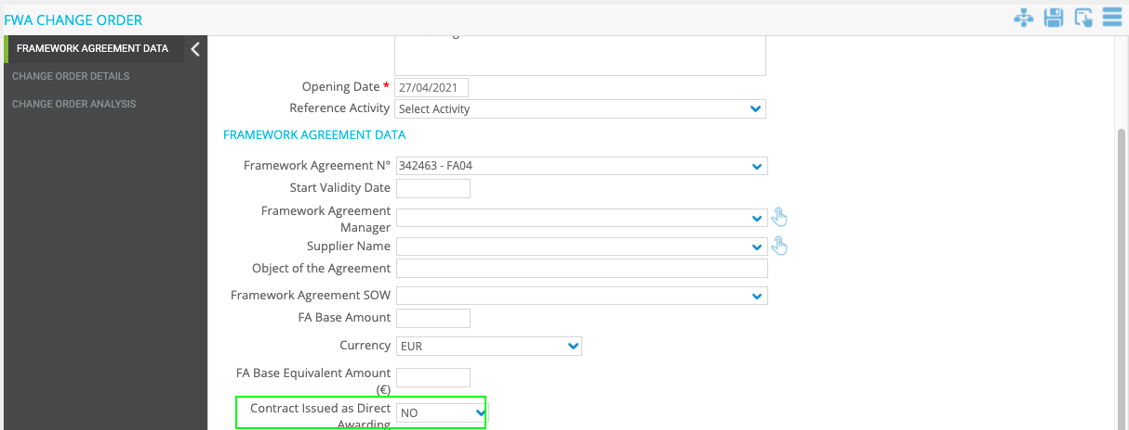

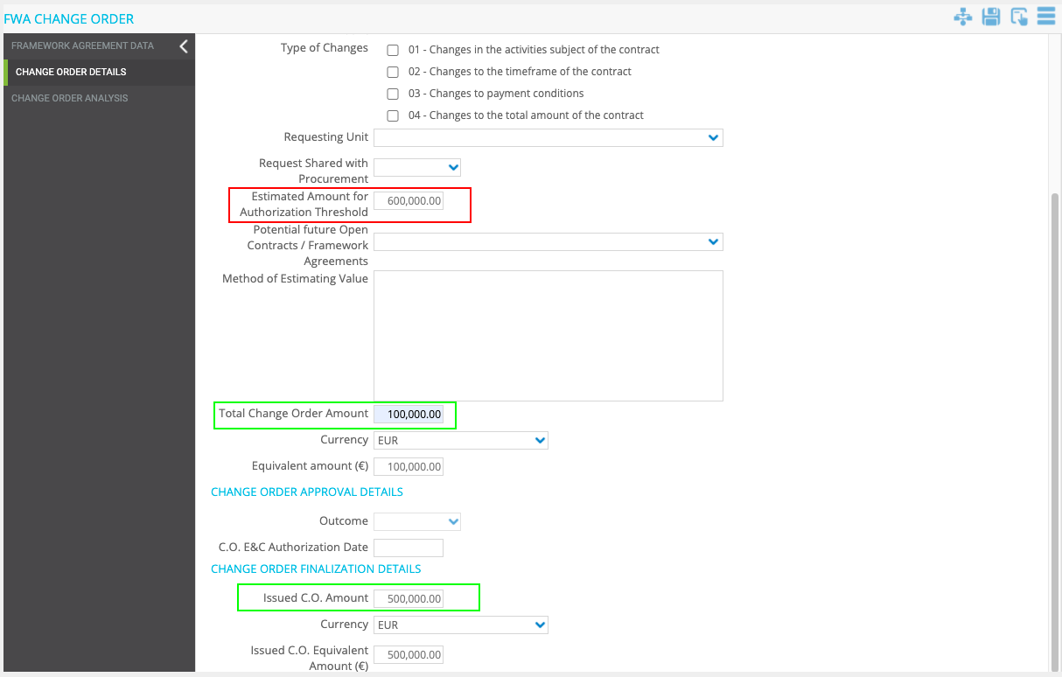

1. if Field "Contract issued as Direct Awarding:" is YES

Formula:

"Issued C.O. Amount" + "Total Change Order Amount"(this C.O.Form) + "FA Base Amount"

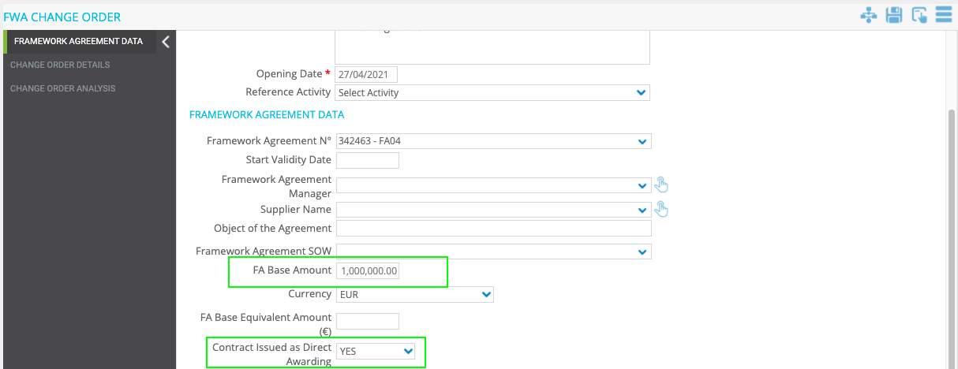

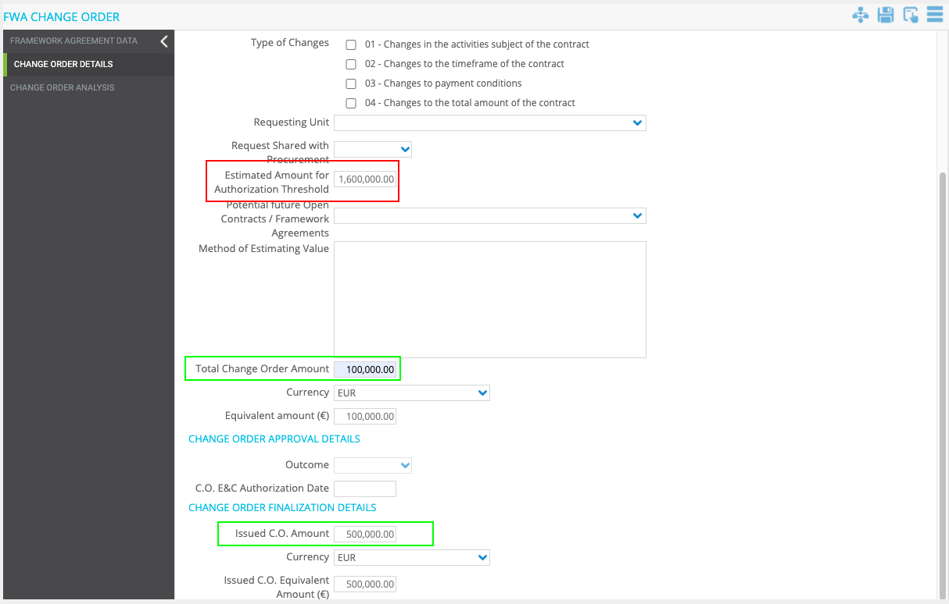

* **General implementation requisite**

The field should not be manually editable.

# FWA C.O., C.O. user Control

* **Business Requirement**

Manage Change Order in a dedicated Tab in the “FWA Change Order” Form.

Max 3 lines.

* **Implementation logic**

The UC should contain real time Column filtering (as in PR – No SAP Countries UC).

|  |  |  |  |  |
| --- | --- | --- | --- | --- |
| **Field** | **Data Logic** | **Format** | **Table Name in PO** | **Note** |
| Item ID | Progressive numbering (not editable) | Number |  | 01,02,03....10 |
| Main Cause | Manually selected (Logic in point N°125) | Drop Down |  | 1000 characters |
| Detailed Cause | Manually selected (Logic in point N°125) | Drop Down |  |  |
| Included or Not in Original Contract SoW | Manually selected | Drop Down | C.O. INCLUDED IN ALLOCATED CONTRACT CONTINGENCY |  |
| C.O. Type | Manually entered | Drop Down | C.O. TYPE |  |
| C.O. Cost Item Amount | Manually entered | Amount |  |  |
| C.O. Cost Item Equivalent Amount (€) | Manually entered | Amount |  |  |
| Explanation of Contract Amendment | Manually entered | Note |  | Note field as in contract "Clauses Library" User Control |

* **Operational steps**

The User will be able to Add items from the tab “Change Order Analysis” in the FWA Change Order form.

To create a line, the user should be able to:

1) For the specific project, access the project workspaces

1. Select the FWA Change Order form
2. Select the tab “Change Order Analysis” Click the add icon and enter the fields
3. Save the new line

2) Once saved the items will be available for editing/delete

3) The User will have the possibility to expand the view full screen and to export to Excel the Items table/register.

ITEMS UC Mockup

The UC should contain real time Column filtering (as in PR – No SAP Countries UC).

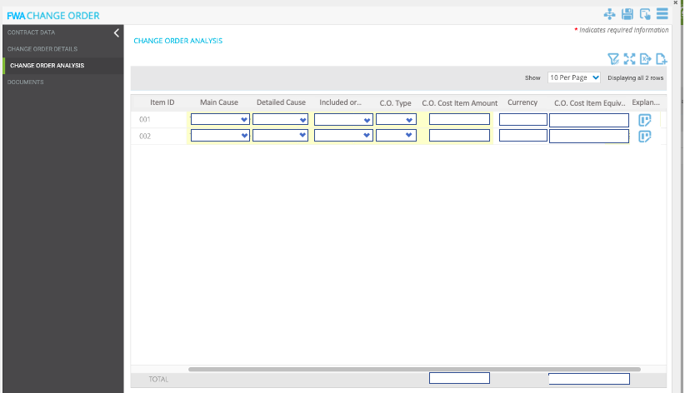

Some columns must have the "total" field as shown in the Mockup.(As already done for PR - No SAP Countries).

The columns for which the total should be calculated are:

* C.O. Cost Item Amount
* C.O. Cost Item Equivalent Amount (€)
* **General implementation requisite**
* EXCEL Export functionality
* Full Screen Functionality
* Real time Column filtering

# FWA C.O., “Main Cause” and “Detailed Cause” fields logic (UC fields)

* **Implementation logic**

“Main Cause” field

Selecting a value from this Dropdown filter the value of the next dropdown (Detailed Cause)

(This Function Must be available also for the PRJ Change Order Form - Using the same Data Table, and **Data Table can be customized as other Standard Tables**)

“Detailed Cause” field

The value available in this Dropdown must depend on the selection of the previous Dropdown (Main Cause)

(This Function Must be available also for the PRJ Change Order Form - Using the same Data Table, and **Data Table can be customized as other Standard Tables**)

(Data table is the same used for the “Main Cause” and “Detailed Cause” fields in PRJ Change Order)

# FWA C.O., “Total Change Order Amount” field logic (UC field)

* **Implementation logic**

The "Total Change Order Amount" field must show the value of the field highlighted in the mockup below (sum of the “C.O. Cost Item Amount” of all items).

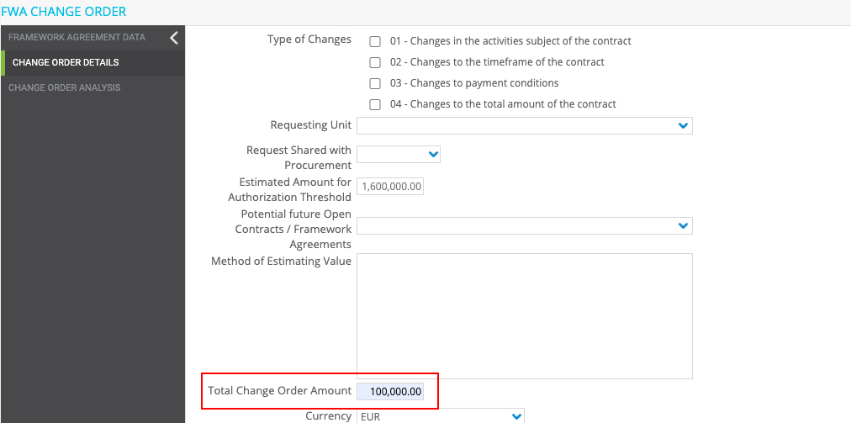

UC Mockup

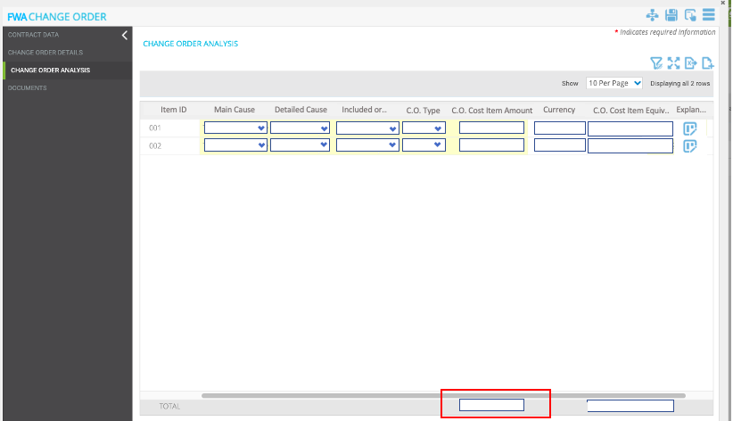

* **General implementation requisite**

Field not editable

# FWA C.O., alert pop up

* **Implementation logic**

When the user clicks on Save or Apply in step1 the system has to perform a check:

1. Alert

Condition 1

"Issued C.O. Amount (Equivalent Amount (€)) " + "Total Change Order Amount (Equivalent Amount (€))" + "FA Base Equivalent Amount (€)" > 25 M €

Condition 2

Change order included in contract contingency YES

Condition 3

MPC Approval Needed = YES

Text message: “Please double check info on contract contingency”

1. Alert

Condition 1

"Issued C.O. Amount (Equivalent Amount (€)) " + "Total Change Order Amount(Equivalent Amount (€))" + "FA Base Equivalent Amount (€)" > 25 M €

Condition 2

Change order included in contract contingency= No

Condition 3

MPC Approval Needed = No

Text message: “Please double check info on contract contingency”

1. Alert

Condition 1

"Issued C.O. Amount (Equivalent Amount (€)) " + "Total Change Order Amount(Equivalent Amount (€))" + "FA Base Equivalent Amount (€)" < 25 M €

Condition 2

MPC Approval Needed = YES

Text message: “Please double check Base Amount + C.O. Amount”

* **General implementation requisite**

User must click “OK” to dismiss the notification

Mockup



# New Supplier holding table (STANDARD CODES)

* **Business Requirement**

Have a table to manage Supplier Holding.

* **Implementation logic**

Within the TAB general in the Standard Codes a Sub-TAB called “Supplier Holding” should be added.

The table should have 2 columns: Code and Description editable by the administrator user.

mockup

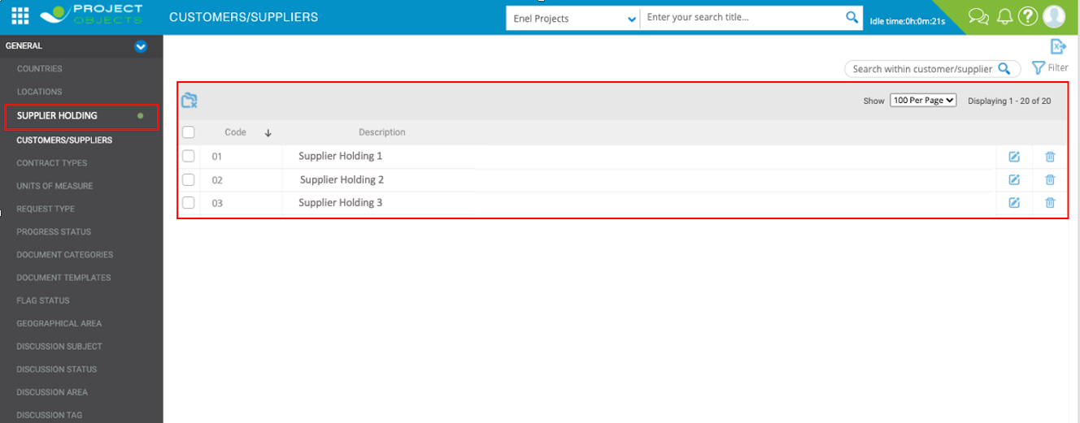

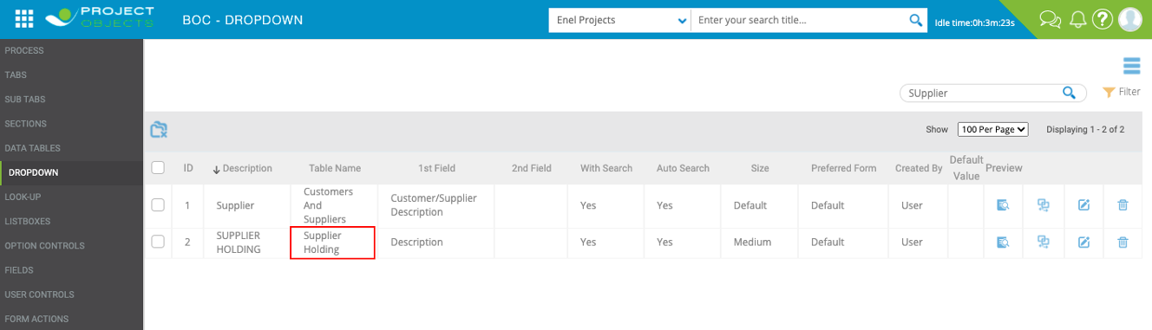This new table should be set as the source of the SUPPLIER HOLDING dropdown.

* **General implementation requisite**

“Description” field max 150 characters

# Customer/Suppliers table (STANDARD CODES)

* **Implementation logic**
* 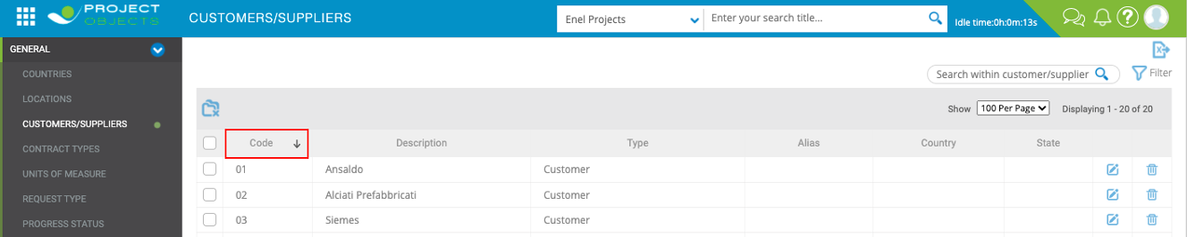“Code” column should be renamed in “SAP Code”.
* Add 2 new fields in suppliers details

|  |  |  |  |  |  |
| --- | --- | --- | --- | --- | --- |
| **Field/Data** | **Type** | **Data Logic** | **Format** | **DropDown List Content** | **Note** |
| CUI Code | See Data Logic --> | Text | Alphanumeric | - | 20 characters |
| Supplier Holding | See Data Logic --> | Dropdown | - | “Supplier Holding” table (see point 128) | 150 characters |

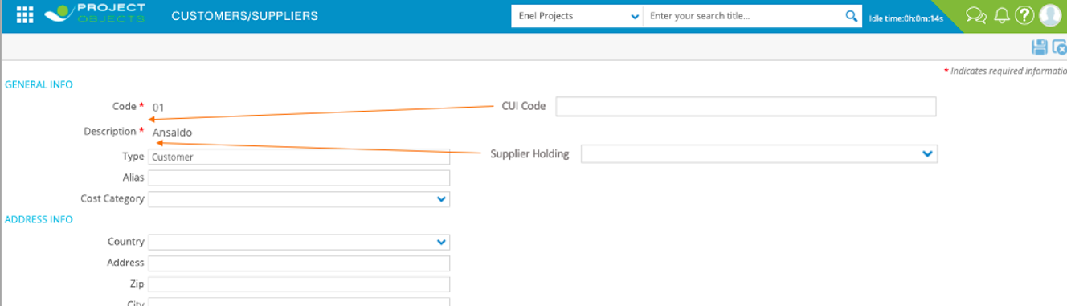

# Change table source for country fields

* **Implementation logic**

The source table of the Dropdown “Country” should be replaced.

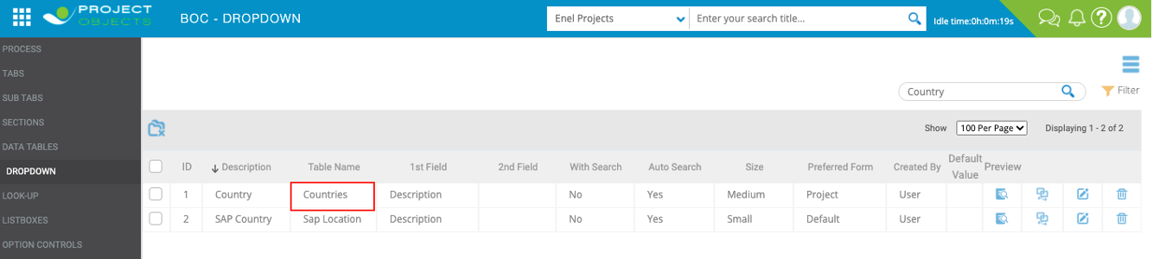The new source should be the "Country" Table (Standard Codes Table).

# ATTACHMENT AND COMMENTS USER CONTROL

* **Implementation logic**

Make available attachments and comments user control for the framework agreement form.

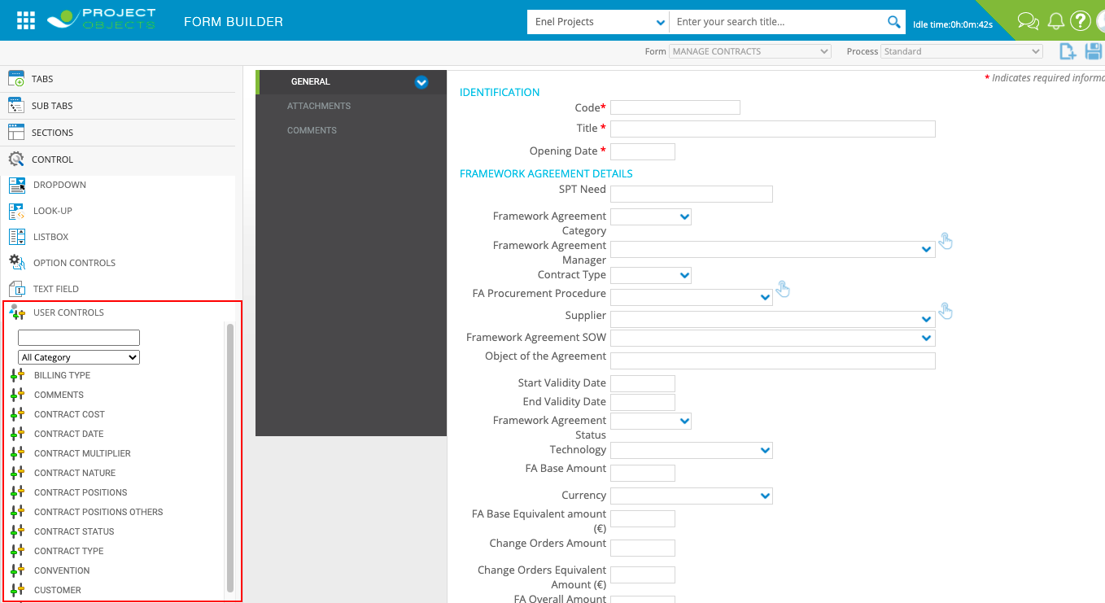(Currently not available)

# Contract form, total c.o. amount field logic

* **Implementation logic**

The "Total C.O. Amount" field must be calculated as the sum of the "Total Change Order Amount" fields of all Change Orders (finalized) in PO for this contract.

(Should not be imported from OMNIA as specified in point 48)

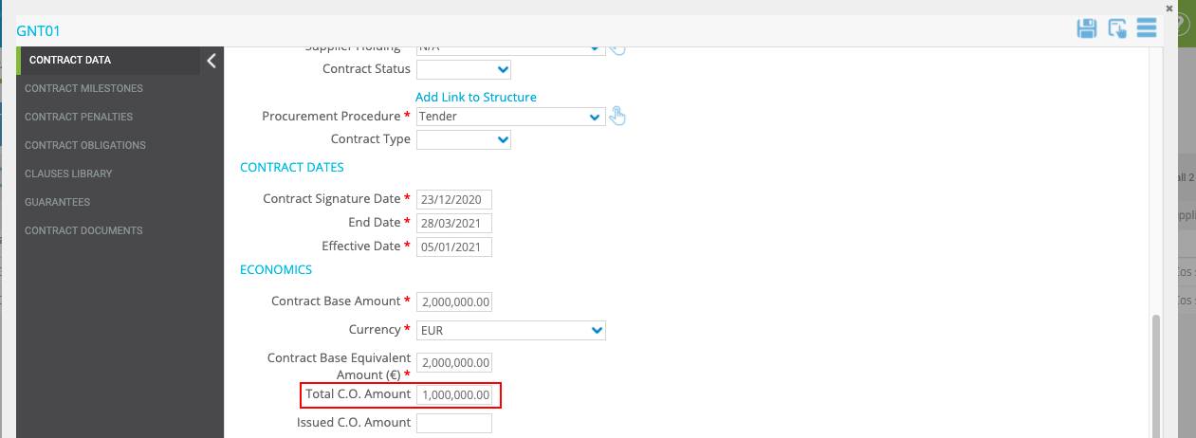Contract Form

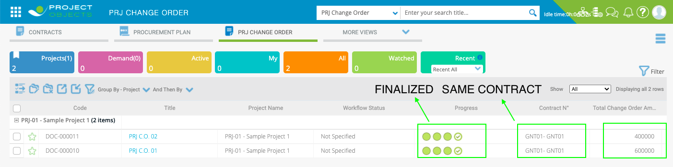PRJ Change Order form

# Guarantees (Contract form), Enel legal Entity field logic

* **Implementation logic**

Change the "Enel Legal Entity" field from text field to drop down.

The Dropdown must have as source the table "Enel Entity/SPV" (already created).

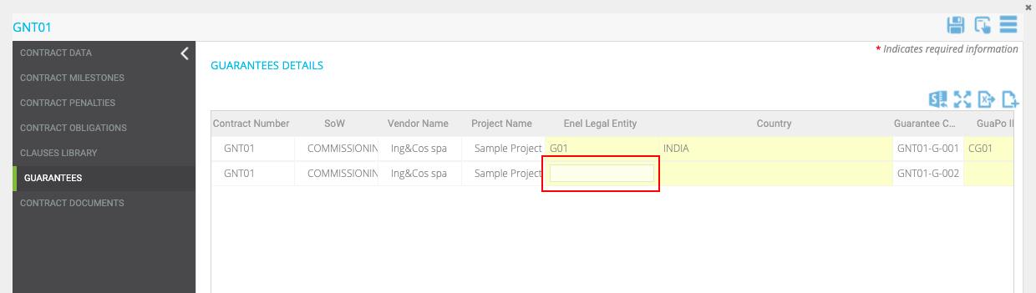

* **General implementation requisite**

If the guarantees are imported from GuaPo also the "Enel Legal Entity" field must be imported and not editable (as per current implementation).

# Procurement Plan form, PR description field logic

* **Implementation logic**

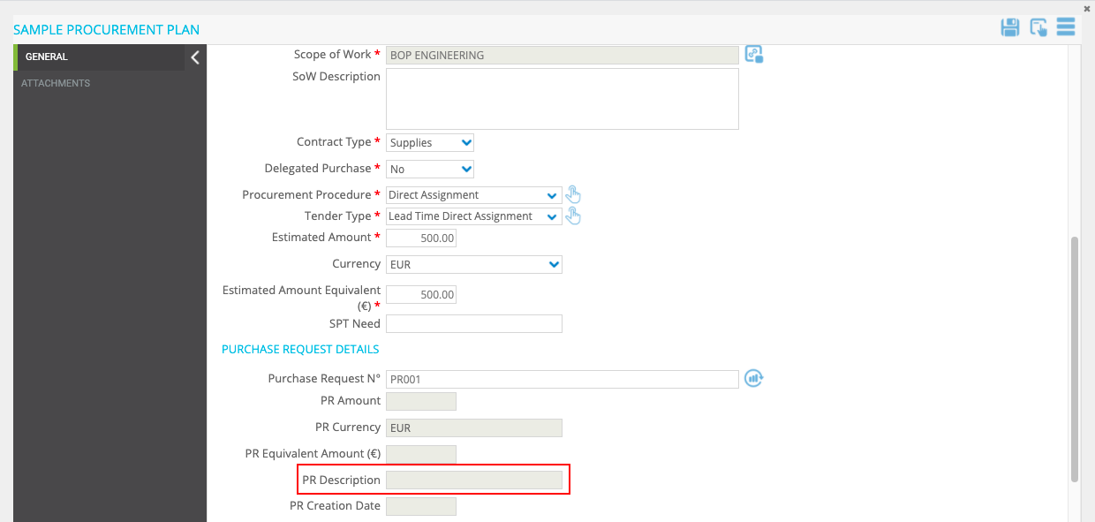In Procurement Plan form, “PR Description” field must not come from the stage table but should be a manual text field.

# Contract form, Automatic filling of fields

* **Implementation logic**

When a contract is created from Procurement Plan the fields "PP Code" and "Job Code" of the contract must be filled automatically.

|  |  |
| --- | --- |
| **Procurement Plan fields (Source) →** | **Contract fields** |
| Code | PP Code |
| Job Code | Job Code |

* **General implementation requisite**

Should not be editable in contract form.

# Contract form, Rename code field

* **Implementation logic**

The field "Code" must be renamed to "Contract number/ Purchase Order Number"

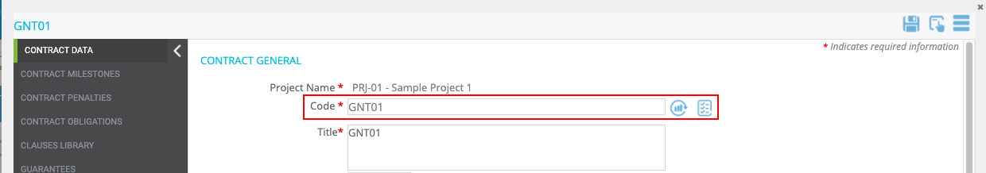

# 

# PRJ C.O., “approval status” Field Logic

* **Business Requirement**

When the PRJ C.O. is finalized the text inside the "Workflow Status" (Column in the register), must be filled with the value present in the "Approval Status" dropdown.

(same development done for PRJ Direct Assignment - point #63)

* **Implementation logic**

When the user finalizes the PRJ C.O., by the release of the object from step 4, the value selected in the "Approval Status" dropdown should show in the "Workflow Status" register column."

* **Operational steps**

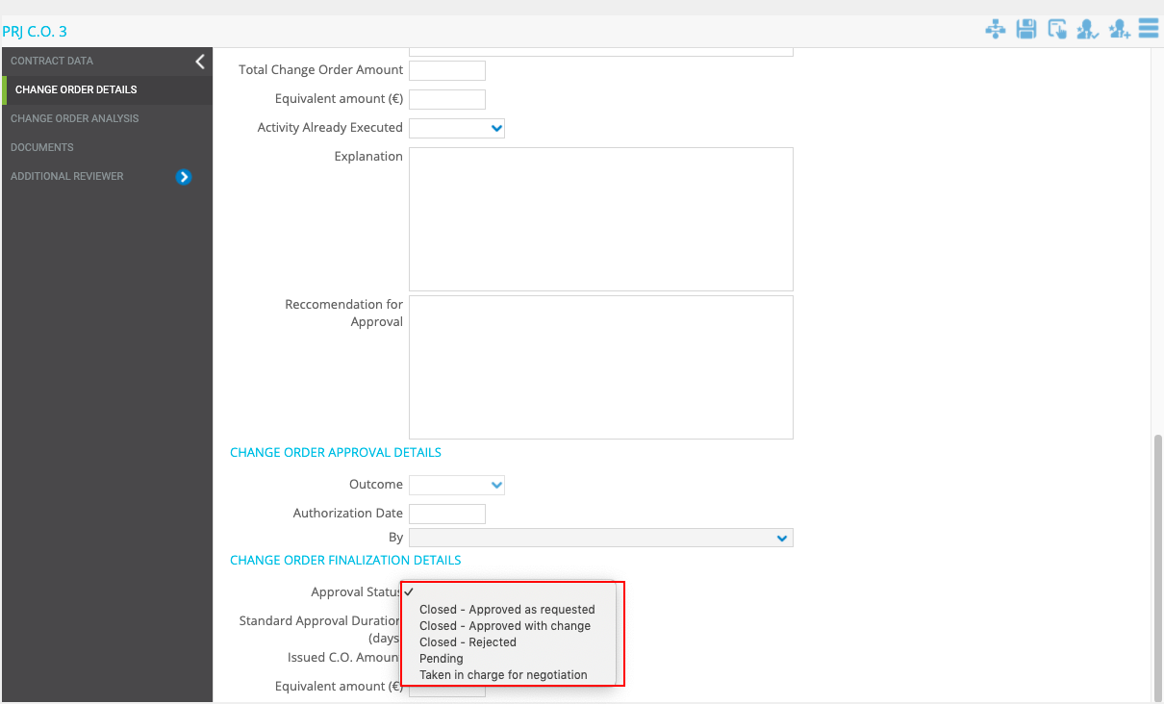The owner of step3 selects one of the following in the “Approval Status” dropdown.

User finalises the PRJ C.O., by the release of the object from step 4.

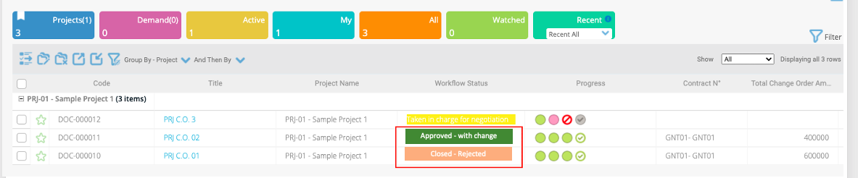The “Workflow Status” should show the value selected in the ”Approval Status” field

# FWA C.O., “Outcome” Field Logic

* **Business Requirement**

When the FWA C.O. is finalized the "Workflow Status" (Column in the register) must show one of the following values according to the logic described below.

- Closed Approved as requested

- Closed Rejected

* **Implementation logic**

When the user finalizes the FWA C.O., by the release of the object from step 4, if "Approved" is selected in the "Outcome" dropdown, the "Workflow Status" must show "Closed Approved as requested ". If "Rejected" is selected in the "Outcome" dropdown, the "Workflow Status" must show the text " Closed Rejected ".

* **Operational steps**

The owner of step3 selects “Approved” or “Rejected” in the “Outcome” dropdown.

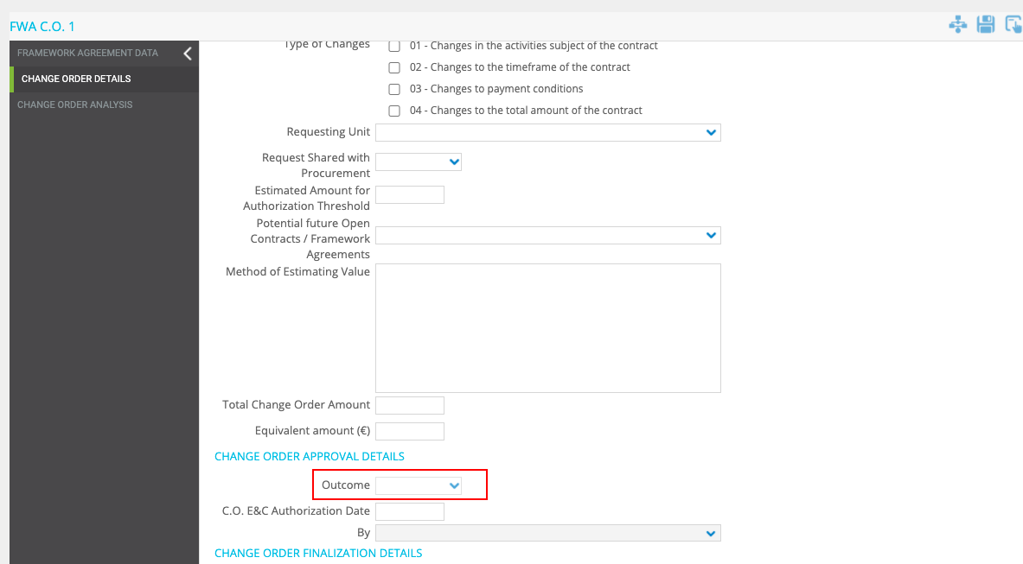User finalises the FWA C.O., by the release of the object from step 4.

The “Workflow Status” should show the value following this logic:

|  |  |
| --- | --- |
| Outcome field | Workflow Status |
| Approved → | Closed Approved as requested |
| Rejected → | Closed Rejected |

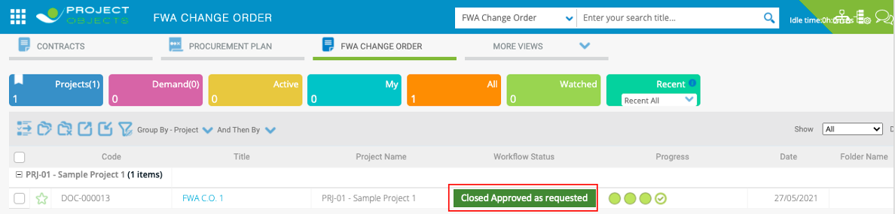

# Supplier holding logic field

* **Business Requirement**

The field "Supplier Holding" should be automatically filled in.

* **Implementation logic**

When the user selects the "Supplier" field, the "Supplier Holding" field should be automatically filled in according to the standard table “Customers/Suppliers”.

This logic must be implemented within the forms of:

* Procurement Plan
* Contract
* PRJ Change Order

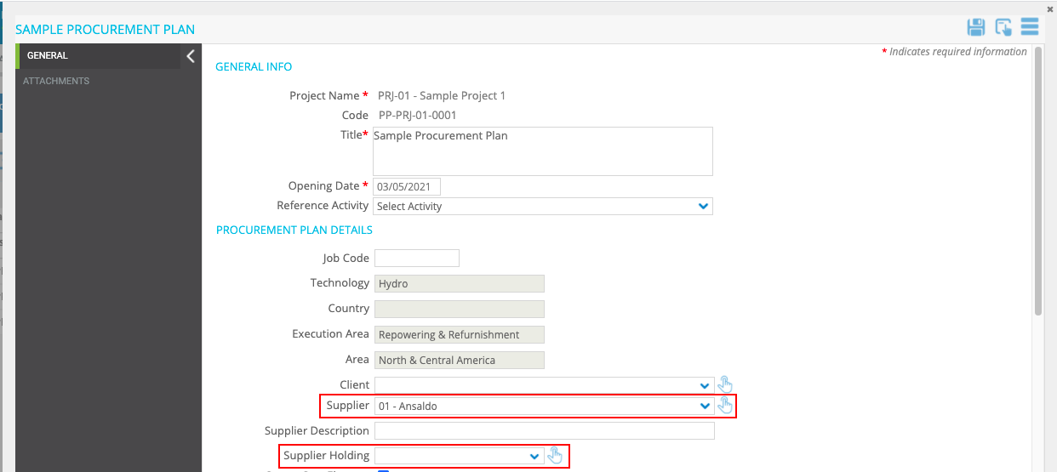

Supplier Holding test

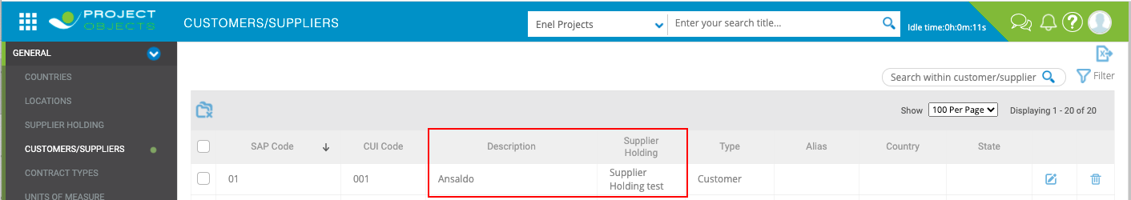

# Supplier field, autosearch

* **Implementation logic**

Enable the "autosearch" feature for the "Supplier" dropdown

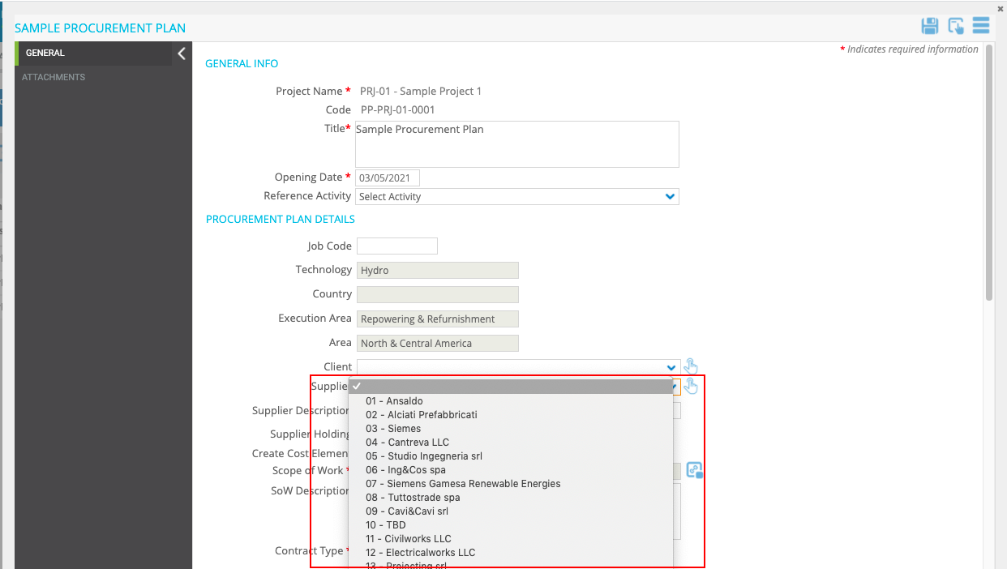

# XXXXXX

* **Business Requirement**

xxxxxxxxxx xxxxxxxxxx xxxxxxxxxx

* **Implementation logic**

xxxxxxxxxx xxxxxxxxxx xxxxxxxxxx

* **Operational steps**

xxxxxxxxxx xxxxxxxxxx xxxxxxxxxx

* **General implementation requisite**

xxxxxxxxxx xxxxxxxxxx xxxxxxxxxx

# XXXXXX

* **Business Requirement**

xxxxxxxxxx xxxxxxxxxx xxxxxxxxxx

* **Implementation logic**

xxxxxxxxxx xxxxxxxxxx xxxxxxxxxx

* **Operational steps**

xxxxxxxxxx xxxxxxxxxx xxxxxxxxxx

* **General implementation requisite**

xxxxxxxxxx xxxxxxxxxx xxxxxxxxxx

# XXXXXX

* **Business Requirement**

xxxxxxxxxx xxxxxxxxxx xxxxxxxxxx

* **Implementation logic**

xxxxxxxxxx xxxxxxxxxx xxxxxxxxxx

* **Operational steps**

xxxxxxxxxx xxxxxxxxxx xxxxxxxxxx

* **General implementation requisite**

xxxxxxxxxx xxxxxxxxxx xxxxxxxxxx

# Framework agreement Calculations (Work in Progress please Ignore this point)

* **Business Requirement**

To have the possibility to choose if **Automatically** Fill some FA Fields details in the Framework Agreement Form once inserted the Framework Agreement Number (Code) and **on demand** with a new button, or **Manually** fill the fields.

* **Implementation logic**

The User will be able inserting the Framework Agreement Number in the “Code” Field, to automatically fill the fields with data from Stage Table and have the possibility to update the fields pressing a **new button** (in case the data in the stage table have been updated and user need to retrieve latest data), and if no data present in the stage table user should be able to manually fill the fields.

This is the List of Fields:

* **Operational steps**

xxxxxxxxxx xxxxxxxxxx xxxxxxxxxx

* **General implementation requisite**

xxxxxxxxxx xxxxxxxxxx xxxxxxxxxx

# Call-offs Calculations

* **Business Requirement**

xxxxxxxxxx xxxxxxxxxx xxxxxxxxxx

* **Implementation logic**

xxxxxxxxxx xxxxxxxxxx xxxxxxxxxx

* **Operational steps**

xxxxxxxxxx xxxxxxxxxx xxxxxxxxxx

* **General implementation requisite**

xxxxxxxxxx xxxxxxxxxx xxxxxxxxxx

# (Multple Forms) UC to calculate amount converted in currency

* **Business Requirement**

xxxxxxxxxx xxxxxxxxxx xxxxxxxxxx

* **Implementation logic**

xxxxxxxxxx xxxxxxxxxx xxxxxxxxxx

* **Operational steps**

xxxxxxxxxx xxxxxxxxxx xxxxxxxxxx

* **General implementation requisite**

xxxxxxxxxx xxxxxxxxxx xxxxxxxxxx

# XXXXXX

* **Business Requirement**

xxxxxxxxxx xxxxxxxxxx xxxxxxxxxx

* **Implementation logic**

xxxxxxxxxx xxxxxxxxxx xxxxxxxxxx

* **Operational steps**

xxxxxxxxxx xxxxxxxxxx xxxxxxxxxx

* **General implementation requisite**

xxxxxxxxxx xxxxxxxxxx xxxxxxxxxx

# XXXXXX

* **Business Requirement**

xxxxxxxxxx xxxxxxxxxx xxxxxxxxxx

* **Implementation logic**

xxxxxxxxxx xxxxxxxxxx xxxxxxxxxx

* **Operational steps**

xxxxxxxxxx xxxxxxxxxx xxxxxxxxxx

* **General implementation requisite**

xxxxxxxxxx xxxxxxxxxx xxxxxxxxxx